UNITED STATES

SECURITIES AND EXCHANGE COMMISSION

WASHINGTON, D.C. 20549

FORM 10-Q

(Mark One)

- QUARTERLY REPORT PURSUANT TO SECTION 13 OR 15(d) OF THE SECURITIES EXCHANGE ACT OF 1934 For the quarterly period ended September 30, 2026

OR

- TRANSITION REPORT PURSUANT TO SECTION 13 OR 15(d) OF THE SECURITIES EXCHANGE ACT OF 1934

For the transition period from to

Commission file number: 1-07183


TEJON RANCH CO.

(Exact name of registrant as specified in its charter)

Delaware

(State or other jurisdiction of incorporation or organization)

77-0196136

(I.R.S. Employer Identification No.)

4436 Lebec Road, P.O. Box 1000, Tejon Ranch, California 93243

(Address of principal executive offices) (Zip Code)

(661) 248-3000

(Registrant’s telephone number, including area code)

 | Securities registered pursuant to Section 12(b) of the Act:
Title of each class |  |  | Trading symbol(s) |  |  | Name of each exchange on which registered
Common Stock, $0.50 par value |  |  | TRC |  |  | New York Stock Exchange

Indicate by check mark whether the registrant (1) has filed all reports required to be filed by Section 13 or 15(d) of the Securities Exchange Act of 1934 during the preceding 12 months (or for such shorter period that the registrant was required to file such reports), and (2) has been subject to such filing requirements for the past 90 days. Yes ☒ No ☐

Indicate by check mark whether the registrant has submitted electronically every Interactive Data File required to be submitted pursuant to Rule 405 of Regulation S-T (§232.405 of this chapter) during the preceding 12 months (or for such shorter period that the registrant was required to submit such files). Yes ☒ No ☐

Indicate by check mark whether the registrant is a large accelerated filer, an accelerated filer, a non-accelerated filer, a smaller reporting company, or an emerging growth company. See the definitions of “large accelerated filer,” “accelerated filer,” “smaller reporting company,” and “emerging growth company” in Rule 12b-2 of the Exchange Act.

Large accelerated filer ☐

Accelerated filer ☐

Non-accelerated filer ☒

Smaller reporting company ☒

Emerging growth company ☐

If an emerging growth company, indicate by check mark if the registrant has elected not to use the extended transition period for complying with any new or revised financial accounting standards provided pursuant to Section 13(a) of the Exchange Act. ☐

Indicate by check mark whether the registrant is a shell company (as defined in Rule 12b-2 of the Exchange Act). Yes ☐ No ☒

The number of the Company’s outstanding shares of Common Stock on November 3, 2026 was 27,034,253.

TEJON RANCH CO. AND SUBSIDIARIES

TABLE OF CONTENTS

PART I. | FINANCIAL INFORMATION | Page
Item 1. | Financial Statements | 4
 | Consolidated Balance Sheets as of September 30, 2026 (unaudited) and December 31, 2025 | 4
 | Unaudited Consolidated Statements of Operations for the Three and Nine Months Ended September 30, 2026 and 2025 | 5
 | Unaudited Consolidated Statements of Comprehensive Income (Loss) for the Three and Nine Months Ended September 30, 2026 and 2025 | 6
 | Unaudited Consolidated Statements of Cash Flows for the Nine Months Ended September 30, 2026 and 2025 | 7
 | Unaudited Consolidated Statements of Changes in Equity for the Three and Nine Months Ended September 30, 2026 and 2025 | 9
 | Notes to Unaudited Consolidated Financial Statements | 11
Item 2. | Management’s Discussion and Analysis of Financial Condition and Results of Operations | 30
Item 3. | Quantitative and Qualitative Disclosures About Market Risk | 54
Item 4. | Controls and Procedures | 56
PART II. | OTHER INFORMATION
Item 1. | Legal Proceedings | 57
Item 1A. | Risk Factors | 57
Item 2. | Unregistered Sales of Equity Securities and Use of Proceeds | 57
Item 3. | Defaults Upon Senior Securities | 57
Item 4. | Mine Safety Disclosures | 57
Item 5. | Other Information | 57
Item 6. | Exhibits | 57
SIGNATURES |  | 58
 | 2

Glossary

The following initialisms or acronyms may be used in this document and shall be defined as set forth below:

AKIP | Advance Kern Incentive Program
ASC | Accounting Standards Codification
ASU | Accounting Standards Update
AVEK | Antelope Valley East Kern Water Agency
CFL | Centennial Founders, LLC
CBD | Center for Biological Diversity
CEQA | California Environmental Quality Act
CFD | Community Facilities District
CNPS | California Native Plant Society
EBITDA | Earnings Before Interest Taxes Depreciation and Amortization
EIR | Environmental Impact Report
FASB | Financial Accounting Standards Board
FTZ | Foreign Trade Zone
GAAP | Generally Accepted Accounting Principles
GHG | Greenhouse Gas
GSP | Groundwater Sustainability Plan
MV | Mountain Village at Tejon Ranch
NOI | Net Operating Income
NLER | Net Liabilities to Equity Ratio
PEF | Pastoria Energy Facility, LLC
RCL | Revolving Credit Line
RWA | Tejon Ranch Conservation and Land Use Agreement, a.k.a. Ranch Wide Agreement
SEC | Securities and Exchange Commission
SOFR | Secured Overnight Financing Rate
SWP | State Water Project
TA/Petro | Petro Travel Plaza Holdings, LLC
TCWD | Tejon-Castac Water District
TRC | Tejon Ranch Co.
TRCC | Tejon Ranch Commerce Center
TRPFFA | Tejon Ranch Public Facilities Financing Authority
WRMWSD | Wheeler Ridge Maricopa Water Storage District
 | 3

PART I - FINANCIAL INFORMATION

ITEM 1. FINANCIAL STATEMENTS

TEJON RANCH CO. AND SUBSIDIARIES

CONSOLIDATED BALANCE SHEETS

($ in thousands, except per share data)

 |  | September 30, 2026 |  |  | December 31, 2025
ASSETS |  | (unaudited)
Current Assets:
Cash and cash equivalents | $ | 2,605 |  | $ | 9,524
Marketable securities - available-for-sale |  | 6,187 |  |  | 15,370
Accounts receivable |  | 14,509 |  |  | 9,389
Inventories |  | 5,768 |  |  | 3,347
Prepaid expenses and other current assets |  | 1,128 |  |  | 1,632
Total current assets |  | 30,197 |  |  | 39,262
Real estate and improvements - held for lease, net |  | 79,232 |  |  | 79,177
Real estate development (includes $132,227 at September 30, 2026 and $128,549 at December 31, 2025, attributable to CFL
(Note 14)) |  | 366,853 |  |  | 356,567
Property and equipment, net |  | 60,847 |  |  | 59,311
Investments in unconsolidated joint ventures |  | 42,941 |  |  | 29,986
Net investment in water assets |  | 64,366 |  |  | 62,593
Other assets |  | 2,902 |  |  | 3,573
TOTAL ASSETS | $ | 647,338 |  | $ | 630,469
LIABILITIES AND EQUITY
Current Liabilities:
Trade accounts payable | $ | 7,462 |  | $ | 5,240
Accrued liabilities and other |  | 4,635 |  |  | 2,188
Deferred income |  | 3,384 |  |  | 2,062
Income taxes payable |  | 847 |  |  | —
Total current liabilities |  | 16,328 |  |  | 9,490
Revolving line of credit |  | 94,442 |  |  | 93,942
Long-term deferred gains |  | 13,934 |  |  | 10,935
Deferred tax liability |  | 9,834 |  |  | 9,849
Other liabilities |  | 15,951 |  |  | 15,697
Total liabilities |  | 150,489 |  |  | 139,913
Commitments and contingencies (Note 11)
Equity:
Tejon Ranch Co. stockholders’ equity
Common stock, $0.50 par value per share:
Authorized shares - 50,000,000
Issued and outstanding shares - 27,021,444 at September 30, 2026 and 26,916,837 at December 31, 2025 |  | 13,510 |  |  | 13,460
Additional paid-in capital |  | 350,444 |  |  | 350,242
Accumulated other comprehensive loss |  | (218) |  |  | (177)
Retained earnings |  | 117,759 |  |  | 111,673
Total Tejon Ranch Co. stockholders’ equity |  | 481,495 |  |  | 475,198
Non-controlling interest |  | 15,354 |  |  | 15,358
Total equity |  | 496,849 |  |  | 490,556
TOTAL LIABILITIES AND EQUITY | $ | 647,338 |  | $ | 630,469

See accompanying notes.

4

TEJON RANCH CO. AND SUBSIDIARIES

UNAUDITED CONSOLIDATED STATEMENTS OF OPERATIONS

($ in thousands, except per share amounts)

 | Three Months Ended September 30, |  |  |  |  |  |  | Nine Months Ended September 30,
Revenues: | 2026 |  |  | 2025 |  |  |  | 2026 |  |  | 2025
Real estate - Commercial/Industrial | $ | 3,244 |  | $ | 2,943 |  | $ | 15,669 |  | $ | 10,789
Multifamily |  | 924 |  |  | 181 |  |  | 2,477 |  |  | 196
Mineral resources |  | 3,963 |  |  | 3,172 |  |  | 9,285 |  |  | 7,277
Farming |  | 12,628 |  |  | 4,335 |  |  | 14,273 |  |  | 6,498
Ranch operations |  | 1,853 |  |  | 1,338 |  |  | 4,670 |  |  | 3,725
Total revenues |  | 22,612 |  |  | 11,969 |  |  | 46,374 |  |  | 28,485
Costs and expenses:
Real estate - Commercial/Industrial |  | 1,527 |  |  | 1,498 |  |  | 9,417 |  |  | 6,369
Multifamily |  | 1,227 |  |  | 650 |  |  | 3,279 |  |  | 1,162
Real estate - Resort/Residential |  | 427 |  |  | 318 |  |  | 1,146 |  |  | 1,008
Mineral resources |  | 2,308 |  |  | 2,121 |  |  | 5,686 |  |  | 4,996
Farming |  | 11,184 |  |  | 5,362 |  |  | 14,459 |  |  | 9,407
Ranch operations |  | 1,324 |  |  | 1,176 |  |  | 3,830 |  |  | 3,784
Corporate expenses |  | 2,242 |  |  | 2,868 |  |  | 6,967 |  |  | 12,004
Total costs and expenses |  | 20,239 |  |  | 13,993 |  |  | 44,784 |  |  | 38,730
Operating income (loss) |  | 2,373 |  |  | (2,024) |  |  | 1,590 |  |  | (10,245)
Other income:
Investment income |  | 97 |  |  | 177 |  |  | 350 |  |  | 749
Other loss, net |  | (67) |  |  | (9) |  |  | (241) |  |  | (89)
Total other income, net |  | 30 |  |  | 168 |  |  | 109 |  |  | 660
Income (loss) before equity in earnings of unconsolidated joint ventures and
income tax expense (benefit) |  | 2,403 |  |  | (1,856) |  |  | 1,699 |  |  | (9,585)
Equity in earnings of unconsolidated joint ventures, net |  | 2,332 |  |  | 2,555 |  |  | 6,722 |  |  | 6,268
Income (loss) before income tax expense (benefit) |  | 4,735 |  |  | 699 |  |  | 8,421 |  |  | (3,317)
Income tax expense (benefit) |  | 1,437 |  |  | (972) |  |  | 2,339 |  |  | (1,809)
Net income (loss) |  | 3,298 |  |  | 1,671 |  |  | 6,082 |  |  | (1,508)
Net (loss) income attributable to non-controlling interest |  | (2) |  |  | 1 |  |  | (4) |  |  | (2)
Net income (loss) attributable to common stockholders | $ | 3,300 |  | $ | 1,670 |  | $ | 6,086 |  | $ | (1,506)
Net income (loss) per share attributable to common stockholders, basic
 | $ | 0.12 |  | $ | 0.06 |  | $ | 0.23 |  | $ | (0.06)
Net income (loss) per share attributable to common stockholders, diluted | $ | 0.12 |  | $ | 0.06 |  | $ | 0.22 |  | $ | (0.06)

See accompanying notes.

5

TEJON RANCH CO. AND SUBSIDIARIES

UNAUDITED CONSOLIDATED STATEMENTS OF COMPREHENSIVE INCOME (LOSS)

(In thousands)

 | Three Months Ended September 30, |  |  |  |  |  | Nine Months Ended September 30,
 | 2026 |  |  | 2025 |  |  | 2026 |  |  | 2025
Net income (loss) | $ | 3,298 |  | $ | 1,671 | $ | 6,082 |  | $ | (1,508)
Other comprehensive (loss) income:
Unrealized (loss) gain on available-for-sale securities |  | (9) |  |  | 14 |  | (56) |  |  | —
Other comprehensive (loss) income before taxes |  | (9) |  |  | 14 |  | (56) |  |  | —
Income tax benefit (expense) related to other comprehensive loss items |  | 2 |  |  | (4) |  | 15 |  |  | —
Other comprehensive (loss) income |  | (7) |  |  | 10 |  | (41) |  |  | —
Comprehensive income (loss) |  | 3,291 |  |  | 1,681 |  | 6,041 |  |  | (1,508)
Comprehensive (loss) income attributable to non-controlling interests |  | (2) |  |  | 1 |  | (4) |  |  | (2)
Comprehensive income (loss) attributable to common stockholders | $ | 3,293 |  | $ | 1,680 | $ | 6,045 |  | $ | (1,506)

See accompanying notes.

6

TEJON RANCH CO. AND SUBSIDIARIES

UNAUDITED CONSOLIDATED STATEMENTS OF CASH FLOWS

(In thousands) |  | Nine Months Ended September 30,
Operating Activities |  | 2026 |  |  | 2025
Net income (loss) | $ | 6,082 |  | $ | (1,508)
Adjustments to reconcile net income (loss) to net cash provided by (used in) operating activities:
Depreciation and amortization |  | 4,992 |  |  | 3,800
Amortization of discount of marketable securities |  | (22) |  |  | (154)
Equity in earnings of unconsolidated joint ventures, net |  | (6,722) |  |  | (6,268)
Non-cash retirement plan expense |  | 313 |  |  | 321
Non-cash profits recognized from land contribution ² |  | (1,999) |  |  | —
Deferred income taxes |  | — |  |  | (31)
Stock compensation expense |  | 1,243 |  |  | 1,157
Excess tax provision from stock-based compensation |  | — |  |  | 31
Distribution of earnings from unconsolidated joint ventures |  | 3,318 |  |  | 2,815
Changes in operating assets and liabilities:
Receivables, inventories, prepaids and other assets, net |  | (3,841) |  |  | (1,381)
Current liabilities |  | 3,895 |  |  | (2,888)
Net cash provided by (used in) operating activities |  | 7,259 |  |  | (4,106)
Investing Activities
Maturities and sales of marketable securities |  | 14,566 |  |  | 29,508
Funds invested in marketable securities |  | (5,416) |  |  | (32,387)
Real estate development expenditures ¹ |  | (8,505) |  |  | (6,714)
Real estate expenditures - to be held for lease ¹ |  | (6,585) |  |  | (37,149)
Property and equipment expenditures ¹ |  | (4,557) |  |  | (5,530)
Reimbursement proceeds from Community Facilities District |  | — |  |  | 5,559
Proceeds from sale of property, plant and equipment |  | — |  |  | 44
Investment in unconsolidated joint ventures |  | (2,947) |  |  | (1,278)
Distribution of equity from unconsolidated joint ventures |  | 3,689 |  |  | 773
Investments in water assets |  | (4,420) |  |  | (8,926)
Other |  | 44 |  |  | —
Net cash used in investing activities |  | (14,131) |  |  | (56,100)
Financing Activities
Borrowings on line of credit |  | 9,000 |  |  | 25,000
Repayments on line of credit |  | (8,500) |  |  | —
Taxes on vested stock grants |  | (1,047) |  |  | (490)
Net cash (used in) provided by financing activities |  | (547) |  |  | 24,510
Decrease in cash, cash equivalents, and restricted cash |  | (7,419) |  |  | (35,696)
Cash, cash equivalents, and restricted cash at beginning of period |  | 10,024 |  |  | 39,767
Cash, cash equivalents, and restricted cash at end of period | $ | 2,605 |  | $ | 4,071
Reconciliation to amounts on consolidated balance sheets:
Cash and cash equivalents | $ | 2,605 |  | $ | 3,571
Restricted cash (Shown in prepaid expenses and other current assets) |  | — |  |  | 500
Total cash, cash equivalents, and restricted cash | $ | 2,605 |  | $ | 4,071
7

Non-cash investing activities
Accrued capital expenditures included in current liabilities | $ | 2,561 |  | $ | 2,054
Accrued long-term water assets included in current liabilities | $ | 903 |  | $ | 852
Contribution of land to unconsolidated joint venture²
Contribution of land to unconsolidated joint venture² | $ | 9,852 |  | $ | —
Long term deferred profit on land contribution² | $ | 2,999 |  | $ | —

- Prior year amounts have been reclassified to conform to the current year presentation. Amounts previously presented as “Real estate and equipment expenditures” are now presented separately as “Real estate development expenditures,” “Real estate expenditures – to be held for lease,” and “Property and equipment expenditures.” These reclassifications had no impact on total net cash used in investing activities or the net change in cash and cash equivalents.

- During the second quarter of 2026, the Company contributed land to TRC-DP 1, LLC, an unconsolidated joint venture, at a fair value of $9.9 million in a non-cash transaction. The Company recognized $2.0 million of the resulting profit and deferred $3.0 million representing its retained interest in the venture.

See accompanying notes.

8

TEJON RANCH CO. AND SUBSIDIARIES

UNAUDITED CONSOLIDATED STATEMENTS OF CHANGES IN EQUITY

(In thousands, except shares outstanding)

 | Common Stock |  |  | Common |  |  | Additional |  | Accumulated Other |  |  |  | Retained |  |  | Total |  |  | Non-controlling
 | Shares |  |  |  |  |  | Paid-In |  |  | Comprehensive |  |  |  |  |  | Stockholders'
 | Outstanding |  |  | Stock |  |  | Capital |  |  | (Loss) Income |  |  | Earnings |  |  | Equity |  |  | Interest |  |  | Total Equity
Balance, June 30, 2026 | 27,004,897 |  |  | 13,504 |  | $ | 349,805 |  | $ | (211) |  | $ | 114,459 |  | $ | 477,557 |  | $ | 15,356 |  | $ | 492,913
Net income (loss) | — |  |  | — |  |  | — |  |  | — |  |  | 3,300 |  |  | 3,300 |  |  | (2) |  |  | 3,298
Other comprehensive loss | — |  |  | — |  |  | — |  |  | (7) |  |  | — |  |  | (7) |  |  | — |  |  | (7)
Restricted stock issuance | 16,547 |  |  | 6 |  |  | (6) |  |  | — |  |  | — |  |  | — |  |  | — |  |  | —
Stock compensation | — |  |  | — |  |  | 645 |  |  | — |  |  | — |  |  | 645 |  |  | — |  |  | 645
Balance, September 30, 2026 | 27,021,444 |  | $ | 13,510 |  | $ | 350,444 |  | $ | (218) |  | $ | 117,759 |  | $ | 481,495 |  | $ | 15,354 |  | $ | 496,849
Balance, June 30, 2025 | 26,880,668 |  | $ | 13,441 |  | $ | 349,592 |  | $ | 77 |  | $ | 108,422 |  | $ | 471,532 |  | $ | 15,359 |  | $ | 486,891
Net income | — |  |  | — |  |  | — |  |  | — |  |  | 1,670 |  |  | 1,670 |  |  | 1 |  |  | 1,671
Other comprehensive income | — |  |  | — |  |  | — |  |  | 10 |  |  | — |  |  | 10 |  |  | — |  |  | 10
Restricted stock issuance | 13,287 |  |  | 6 |  |  | (6) |  |  | — |  |  | — |  |  | — |  |  | — |  |  | —
Stock compensation | — |  |  | — |  |  | 18 |  |  | — |  |  | — |  |  | 18 |  |  | — |  |  | 18
Balance, September 30, 2025 | 26,893,955 |  | $ | 13,447 |  | $ | 349,604 |  | $ | 87 |  | $ | 110,092 |  | $ | 473,230 |  | $ | 15,360 |  | $ | 488,590

See accompanying notes.

9

 | Common Stock |  |  | Common |  |  | Additional |  | Accumulated Other |  |  |  | Retained |  |  | Total |  |  | Non-controlling
 | Shares |  |  |  |  |  | Paid-In |  |  | Comprehensive |  |  |  |  |  | Stockholders'
 | Outstanding |  |  | Stock |  |  | Capital |  |  | (Loss) Income |  |  | Earnings |  |  | Equity |  |  | Interest |  |  | Total Equity
Balance, December 31, 2025 | 26,916,837 |  | $ | 13,460 |  | $ | 350,242 |  | $ | (177) |  | $ | 111,673 |  | $ | 475,198 |  | $ | 15,358 |  | $ | 490,556
Net income (loss) | — |  |  | — |  |  | — |  |  | — |  |  | 6,086 |  |  | 6,086 |  |  | (4) |  |  | 6,082
Other comprehensive loss | — |  |  | — |  |  | — |  |  | (41) |  |  | — |  |  | (41) |  |  | — |  |  | (41)
Restricted stock issuance | 161,229 |  |  | 78 |  |  | (78) |  |  | — |  |  | — |  |  | — |  |  | — |  |  | —
Stock compensation | — |  |  | — |  |  | 1,299 |  |  | — |  |  | — |  |  | 1,299 |  |  | — |  |  | 1,299
Shares withheld for taxes and tax benefit of
vested shares | (56,622) |  |  | (28) |  |  | (1,019) |  |  | — |  |  | — |  |  | (1,047) |  |  | — |  |  | (1,047)
Balance, September 30, 2026 | 27,021,444 |  | $ | 13,510 |  | $ | 350,444 |  | $ | (218) |  | $ | 117,759 |  | $ | 481,495 |  | $ | 15,354 |  | $ | 496,849
Balance, December 31, 2024 | 26,822,768 |  | $ | 13,412 |  | $ | 348,497 |  | $ | 87 |  | $ | 111,598 |  | $ | 473,594 |  | $ | 15,362 |  | $ | 488,956
Net loss | — |  |  | — |  |  | — |  |  | — |  |  | (1,506) |  |  | (1,506) |  |  | (2) |  |  | (1,508)
Other comprehensive loss | — |  |  | — |  |  | — |  |  | — |  |  | — |  |  | — |  |  | — |  |  | —
Restricted stock issuance | 102,690 |  |  | 51 |  |  | (51) |  |  | — |  |  | — |  |  | — |  |  | — |  |  | —
Stock compensation | — |  |  | — |  |  | 1,632 |  |  | — |  |  | — |  |  | 1,632 |  |  | — |  |  | 1,632
Shares withheld for taxes and tax benefit of
vested shares | (31,503) |  |  | (16) |  |  | (474) |  |  | — |  |  | — |  |  | (490) |  |  | — |  |  | (490)
Balance, September 30, 2025 | 26,893,955 |  | $ | 13,447 |  | $ | 349,604 |  | $ | 87 |  | $ | 110,092 |  | $ | 473,230 |  | $ | 15,360 |  | $ | 488,590

See accompanying notes.

10

TEJON RANCH CO. AND SUBSIDIARIES

NOTES TO UNAUDITED CONSOLIDATED FINANCIAL STATEMENTS

1. BASIS OF PRESENTATION

The summarized information of Tejon Ranch Co. and its subsidiaries (the Company, TRC or Tejon), provided pursuant to Part I, Item 1 of Form 10-Q, is unaudited and reflects all adjustments which are, in the opinion of the Company’s management, necessary for a fair statement of the results for the interim period. All such adjustments are of a normal, recurring nature. The Company has evaluated subsequent events through the date of issuance of its consolidated financial statements.

The periods ended September 30, 2026 and 2025 include the consolidation of CFL’s statements of operations within the Resort/Residential real estate development segment, statements of changes in equity, and statements of cash flows. The Company’s September 30, 2026 and December 31, 2025 balance sheets are presented on a consolidated basis, including the consolidation of CFL.

The Company has identified six reportable segments: Commercial/Industrial real estate development, Multifamily, Resort/Residential real estate development, Mineral Resources, Farming, and Ranch Operations. Information for the Company’s reportable segments is presented in its Consolidated Statements of Operations. The Company’s reportable segments follow the same accounting policies used for the Company’s consolidated financial statements. The Company uses segment operating income (loss), including equity in earnings (losses) of unconsolidated joint ventures attributable to each segment, for its Commercial/Industrial real estate development, Resort/Residential real estate development, Mineral resources, Farming, and Ranch Operations segments, and net operating income ("NOI") for its Multifamily segment, as the primary measures of profitability to evaluate operating performance and to allocate capital resources.

The results of the period reported herein are not indicative of the results to be expected for the full year due to the seasonal nature of the Company’s agricultural activities, water activities, and timing of real estate sales and leasing activities. Historically, the Company’s largest percentages of farming revenues are recognized during the third and fourth quarters of the fiscal year.

For further information and a summary of significant accounting policies, refer to the Consolidated Financial Statements and notes thereto included in the Company’s Annual Report on Form 10-K for the year ended December 31, 2025.

Financial Instruments

Certain financial instruments are carried on the consolidated balance sheets at cost or amortized cost basis, which approximates fair value due to their short-term and highly liquid nature. These instruments include cash and cash equivalents, restricted cash, time deposits, accounts receivable, security deposits held for customers, accounts payable, and other accrued liabilities. The fair value of the revolving line of credit also approximates its carrying value, as the interest rate is variable and approximates prevailing market interest rates for similar debt arrangements.

Restricted Cash

Restricted cash is included in Prepaid expenses and other current assets within the Consolidated Balance Sheets and primarily relates to funds held in escrow. The Company had no restricted cash as of September 30, 2026, compared to $500,000 as of December 31, 2025.

New Accounting Pronouncements Effective in Future Periods

Expense Disaggregation Disclosures

In November 2024, the FASB issued ASU No. 2024-03, "Income Statement - Reporting Comprehensive Income - Expense Disaggregation Disclosures (Subtopic 220-40)". This ASU requires public business entities to disclose specified information about certain costs and expenses, including the amounts of purchases of inventory, employee compensation, depreciation, intangible asset amortization and depreciation, depletion and amortization recognized as part of oil- and gas-producing activities included in each relevant expense caption. The ASU also requires disclosure of a qualitative description of the amounts remaining in relevant expense captions that are not separately disaggregated quantitatively. This ASU is effective for annual reporting periods beginning after December 15, 2026. The Company is currently evaluating the impact the adoption of this standard will have on its consolidated financial statements and related disclosures.

11

2. EQUITY

Earnings Per Share (EPS)

Basic net income (loss) per share attributable to common stockholders is based upon the weighted-average number of shares of common stock outstanding during reporting periods. Diluted net income (loss) per share attributable to common stockholders is based upon the weighted-average number of shares of common stock outstanding and the weighted-average number of shares outstanding assuming the issuance of common stock upon exercise of stock options, warrants to purchase common stock, and the vesting of restricted stock grants per ASC Topic 260, “Earnings Per Share.”

 | Three Months Ended September 30, |  |  |  | Nine Months Ended September 30,
Weighted-average number of shares outstanding: | 2026 |  | 2025 |  | 2026 |  | 2025
Common stock | 27,020,385 |  | 26,890,979 |  | 26,987,782 |  | 26,874,211
Common stock equivalents¹ | 51,721 |  | 48,881 |  | 76,163 |  | — | 1
Diluted shares outstanding | 27,072,106 |  | 26,939,860 |  | 27,063,945 |  | 26,874,211
  - For the nine months ended September 30, 2025, 75,335 shares of restricted stock were excluded from the calculation of diluted net loss per share as the shares were antidilutive.

- MARKETABLE SECURITIES

ASC Topic 320, “Investments – Debt and Equity Securities,” requires that an enterprise classify all debt securities as either held-to-maturity, trading or available-for-sale. The Company has elected to classify its securities as available-for-sale and therefore is required to adjust securities to fair value at each reporting date. All costs and both realized and unrealized gains and losses on securities are determined on a specific identification basis. The following is a summary of available-for-sale securities at:

($ in thousands) | Fair Value |  | September 30, 2026 |  |  |  |  |  | December 31, 2025
Marketable Securities: | Hierarchy |  | Cost |  |  | Fair Value |  |  | Cost |  |  | Fair Value
Certificates of deposit
with unrealized losses for less than 12 months | $ |  | 496 |  | $ | 496 |  | $ | — |  | $ | —
with unrecognized gains |  |  | — |  |  | — |  |  | 921 |  |  | 923
Total Certificates of deposit | Level 1 |  | 496 |  |  | 496 |  |  | 921 |  |  | 923
U.S. Treasury and agency notes
with unrecognized losses for less than 12 months |  |  | 5,672 |  |  | 5,631 |  |  | 1,000 |  |  | 999
with unrecognized gains |  |  | — |  |  | — |  |  | 12,731 |  |  | 12,745
Total U.S. Treasury and agency notes | Level 2 |  | 5,672 |  |  | 5,631 |  |  | 13,731 |  |  | 13,744
Corporate notes
with unrecognized gains |  |  | — |  |  | — |  |  | 190 |  |  | 190
Total Corporate notes | Level 2 |  | — |  |  | — |  |  | 190 |  |  | 190
Municipal notes
with unrecognized losses for less than 12 months |  |  | 60 |  |  | 60 |  |  | — |  |  | —
with unrecognized losses |  |  | — |  |  | — |  |  | 514 |  |  | 513
Total Municipal notes | Level 2 |  | 60 |  |  | 60 |  |  | 514 |  |  | 513
 | $ |  | 6,228 |  | $ | 6,187 |  | $ | 15,356 |  | $ | 15,370
 | 12

The Company uses an allowance approach when recognizing credit losses for available-for-sale debt securities, measured as the difference between the security's amortized cost basis and the amount expected to be collected over the security's lifetime. Under this approach, at each reporting date, the Company records impairment related to credit losses through earnings offset with an allowance for credit losses, or ACL. At September 30, 2026, the Company has not recorded any credit losses.

As of September 30, 2026, the fair market value of investment securities had a fair market value that was $41,000 below cost, consisting of gross unrealized holding losses. For the three months ended September 30, 2026, the adjustment to accumulated other comprehensive loss reflected a decrease in market value of $9,000, before the impact of a tax benefit of $2,000. For the nine months ended September 30, 2026, the adjustment to accumulated other comprehensive loss reflected a decline in market value of $56,000 before the impact of an estimated tax benefit of $15,000.

The Company elected to exclude applicable accrued interest from both the fair value and the amortized cost basis of the available-for-sale debt securities, and separately present the accrued interest receivable balance. The accrued interest receivables balance totaled $48,000 as of September 30, 2026 and was included within the Prepaid expenses and other current assets line item of the Consolidated Balance Sheets. The Company elected not to measure an allowance for credit losses on accrued interest receivable, as an allowance on possible uncollectible accrued interest is not warranted.

U.S. Treasury and agency notes

The unrealized losses on the Company's investments in U.S. Treasury and agency notes at September 30, 2026 and December 31, 2025 were caused by relative changes in interest rates since the time of purchase and not changes in credit quality. The contractual cash flows for these securities are guaranteed by U.S. government agencies. The Company intends to hold these securities to maturity and expects to recover their entire amortized cost basis. Accordingly, no allowance for credit losses was recorded as of September 30, 2026 or December 31, 2025.

Corporate notes

As of September 30, 2026, the Company held no corporate notes. The corporate notes held as of December 31, 2025 were issued by companies with investment-grade credit ratings from Standard & Poor's.

The following tables summarize the maturities, at par, of marketable securities as of:
 |  |  |  |  | September 30, 2026
($ in thousands) | 2026 |  |  |  |  | 2027 |  |  |  |  |  |  | Total
Certificates of deposit | $ |  | 248 |  | $ | 248 |  |  |  | $ |  |  | 496
U.S. Treasury and agency notes |  |  | 250 |  |  | 5,450 |  |  |  |  |  |  | 5,700
Municipal notes |  |  | — |  |  | 60 |  |  |  |  |  |  | 60
Total | $ |  | 498 |  | $ | 5,758 |  |  |  | $ |  |  | 6,256
 |  |  |  |  |  | December 31, 2025
($ in thousands) |  |  | 2026 |  |  | 2027 |  |  |  |  |  |  | Total
Certificates of deposit |  | $ |  |  | 425 |  | $ |  | 496 |  |  | $ | 921
U.S. Treasury and agency notes |  |  |  |  | 13,750 |  |  |  |  | — |  |  | 13,750
Corporate notes |  |  |  |  | 191 |  |  |  |  | — |  |  | 191
Municipal notes |  |  |  |  | 250 |  |  |  | 260 |  |  |  | 510
Total |  | $ |  |  | 14,616 |  | $ |  | 756 |  |  | $ | 15,372

13

- REAL ESTATE

Our accumulated real estate development costs by project consisted of the following:

($ in thousands) |  | September 30, 2026 |  |  | December 31, 2025
Real estate development
Mountain Village | $ | 163,610 |  | $ | 161,388
Centennial |  | 132,227 |  |  | 128,549
Grapevine |  | 48,641 |  |  | 45,801
Tejon Ranch Commerce Center |  | 22,375 |  |  | 20,829
Real estate development | $ | 366,853 |  | $ | 356,567
Real estate and improvements - held for lease
Tejon Ranch Commerce Center
- Commercial | $ | 20,645 |  | $ | 20,644
- Multifamily |  | 66,012 |  |  | 64,170
Real estate and improvements - held for lease, gross |  | 86,657 |  |  | 84,814
Less accumulated depreciation
- Commercial |  | (4,917) |  |  | (4,677)
- Multifamily |  | (2,508) |  |  | (960)
Real estate and improvements - held for lease, net | $ | 79,232 |  | $ | 79,177

14

- LONG-TERM WATER ASSETS

Long-term water assets consist of water and water purchase contracts held for future use or sale. The water is held at cost, which includes the price paid for the water and the cost to pump and deliver the water from the California Aqueduct into a water bank. Water is currently held in a water bank on Company land in southern Kern County and by TCWD in Kern County Water Banks.

The Company has secured SWP water purchase contracts from the Tulare Lake Basin Water Storage District and the Dudley-Ridge Water District, totaling 3,444 acre-feet of SWP water annually, subject to SWP allocations. These contracts extend through 2085 and have been transferred to AVEK for the Company's use in the Antelope Valley. In 2013, the Company acquired a contract to purchase water that obligates the Company to purchase 6,693 acre-feet of water each year from the Nickel Family, LLC, or Nickel, a California limited liability company that is located in Kern County.

The initial term of the water purchase agreement with Nickel runs to 2044 and includes a Company option to extend the contract for an additional 35 years. The purchase cost of water in 2026 is $1,021 per acre-foot. The purchase cost is subject to annual cost increases based on the greater of the Consumer Price Index or 3%.

The water purchased above will ultimately be used in the development of the Company’s land for commercial/industrial real estate development, resort/residential real estate development, and farming. Interim uses may include the sale of portions of this water to third-party users on an annual basis until this water is fully allocated to Company uses, as just described.

Water revenues and cost of sales were as follows for the nine months ended ($ in thousands):

 | September 30, 2026 |  |  |  | September 30, 2025
Acre-Feet Sold |  | 3,624 |  |  | 2,362
Revenues | $ | 4,165 |  | $ | 3,156
Cost of sales |  | 3,180 |  |  | 2,548
Profit | $ | 985 |  | $ | 608

Costs assigned to water assets held for future use were as follows ($ in thousands):

 |  |  |  |  |  |  | September 30, 2026 |  |  |  |  |  | December 31, 2025
 | Banked water and water for future delivery |  |  |  |  |  | $ |  |  | 45,338 |  | $ |  |  | 44,681
 | Transferable water |  |  |  |  |  |  |  |  | 2,405 |  |  |  |  | 266
 | Total water held for future use at cost |  |  |  |  |  | $ |  |  | 47,743 |  | $ |  |  | 44,947
Intangible Water Assets
The Company’s carrying amounts of its purchased water contracts were as follows ($ in thousands):
 |  |  | September 30, 2026 |  |  |  |  |  |  |  |  | December 31, 2025
 |  | Costs |  |  |  | Accumulated Depreciation |  |  |  | Costs |  |  |  | Accumulated Depreciation
 | Dudley-Ridge water purchase contract * | $ | 11,581 |  | $ | (7,600) |  |  | $ |  |  | 11,581 |  | $ | (7,237)
 | Nickel water purchase contract * |  | 18,740 |  |  | (8,299) |  |  |  |  |  | 18,740 |  |  | (7,817)
 | Tulare Lake Basin water purchase contract * |  | 6,479 |  |  | (4,278) |  |  |  |  |  | 6,479 |  |  | (4,100)
 |  | $ | 36,800 |  | $ | (20,177) |  |  | $ |  |  | 36,800 |  | $ | (19,154)
 | Net cost of purchased water contracts |  | 16,623 |  |  |  |  |  |  |  |  | 17,646
 | Total cost of water held for future use |  | 47,743 |  |  |  |  |  |  |  |  | 44,947
 | Net investments in water assets | $ | 64,366 |  |  |  |  |  | $ |  |  | 62,593
 | *All water purchase contracts were acquired from third parties.

15

Water contracts with WRMWSD and TCWD are also in place, but were entered into with each district at inception of the contract and not purchased later from third parties, and do not have a related financial value on the books of the Company. Therefore, there is no amortization expense related to these contracts. Total water resources, including both recurring and one-time usage are:

(in acre-feet, unaudited) |  |  |  | September 30, 2026 |  |  |  | December 31, 2025
Water held for future use
 | TCWD - Banked water owned by the Company |  |  | 64,884 |  |  |  | 65,199
 | Company water bank |  |  | 54,728 |  |  |  | 54,728
 | Transferable water |  |  | 2,887 |  |  |  | 265
 | Recharged water |  |  | 6,797 |  |  |  | 6,797
 | Total water held for future use |  |  | 129,296 |  |  |  | 126,989
Purchased water contracts
 | Water Contracts (Dudley-Ridge, Nickel and Tulare) |  |  | 10,137 |  |  |  | 10,137
 | WRMWSD - Contracts with the Company |  |  | 15,547 |  |  |  | 15,547
 | TCWD - Contracts with the Company |  |  | 5,749 |  |  |  | 5,749
 | Total purchased water contracts |  |  | 31,433 |  |  |  | 31,433
Total water held for future use and purchased water contracts |  |  |  | 160,729 |  |  |  | 158,422
6. ACCRUED LIABILITIES AND OTHER CURRENT LIABILITIES
Accrued liabilities and other current liabilities consisted of the following:
 | ($ in thousands) |  |  | September 30, 2026 |  |  |  | December 31, 2025
 | Accrued vacation |  | $ | 563 |  |  | $ | 543
 | Accrued paid personal leave |  |  | 160 |  |  |  | 153
 | Accrued bonus |  |  | 1,846 |  |  |  | 1,060
 | Property tax payable¹ |  |  | 1,571 |  |  |  | —
 | Other |  |  | 495 |  |  |  | 432
 |  |  | $ | 4,635 |  |  | $ | 2,188
- California property taxes are accrued throughout the year and are paid every April and December.

- LINE OF CREDIT AND LONG-TERM DEBT

Debt consisted of revolving line of credit balance of $94,442,000 as of September 30, 2026, and $93,942,000 as of December 31, 2025.

On November 17, 2023, the Company entered into a Credit Agreement with AgWest Farm Credit, PCA and certain other lenders. The Revolving Credit Facility provides TRC a RCL in the amount of $160,000,000. The RCL requires interest only payments and has a maturity date of January 1, 2029. As of September 30, 2026, the outstanding balance under the RCL was $94,442,000, and the interest rate was one-month term SOFR plus a margin of 2.25% for an effective rate of 5.95% before patronage. The Company received patronage credit from the participating lenders of 116 basis points in 2026 and 2025.

- OTHER LIABILITIES

Other liabilities consisted of the following:

 | ($ in thousands) |  |  | September 30, 2026 |  |  | December 31, 2025
 | Supplemental executive retirement plan liability (See Note 12) |  | $ | 5,556 |  | $ | 5,743
 | Excess joint venture distributions and other (See Note 14) |  |  | 10,395 |  |  | 9,954
 | Total |  | $ | 15,951 |  | $ | 15,697
 |  | 16

- STOCK COMPENSATION - RESTRICTED STOCK AND PERFORMANCE SHARE GRANTS

The Company's stock incentive plans provide for the making of awards to employees based upon a service condition or through the achievement of performance-related objectives. The Company has issued three types of stock grant awards under these plans: restricted stock that vests based upon a service condition; performance share grants that vest based upon the achievement of a market condition (Market Condition Grants); and performance share grants that include threshold, target, and maximum achievement levels based upon the achievement of specific performance measures (Performance Milestone Grants). Market Condition Grants consist of awards that vest based upon the Company's total shareholder return relative to a designated peer group (rTSR Grants) and awards that vest upon the achievement of a target share price (Price Vesting Unit Awards). The grant date fair value of Market Condition Grants is determined using a Monte Carlo simulation. Failure to achieve the market condition results in the forfeiture of the shares. Forfeiture of awards with service conditions or performance conditions results in a reversal of previously recognized share-based compensation expense, while forfeiture of awards with market conditions does not.

The following is a summary of the Company’s stock grant activity, both time and performance unit grants, assuming target achievement for outstanding performance grants for the nine months ended

September 30, 2026:

 | September 30, 2026
Stock grants outstanding beginning of period at target achievement | 364,798
New stock grants/additional shares | 158,199
Vested grants | (135,643)
Expired/forfeited grants | (74,802)
Stock grants outstanding end of period at target achievement | 312,552

As of September 30, 2026, stock grants outstanding at target achievement consisted of 138,861 shares of restricted stock that vest based upon a service condition and 173,691 performance share grants (Market Condition Grants and Performance Milestone Grants). The following summarizes the shares issuable under outstanding performance share grants at each achievement level:

 | Performance Share Grants
Threshold performance | 6,523
Target performance | 173,691
Maximum performance | 259,674

Price Vesting Units Awards

The following is a summary of the assumptions used to determine the grant date fair value of the Company's Price Vesting Units Awards outstanding as of September 30, 2026:

 | ($ in thousands except for share prices)
 | Grant date | 12/16/2023 | 03/13/2024 |  |  | 12/11/2024 |  | 03/06/2025 |  | 06/20/2025
 | Vesting end | 12/31/2026 | 03/22/2027 |  |  | 12/10/2027 |  | 03/06/2028 |  | 06/20/2028
 | Target share price to achieve award | $19.65 | $18.93 |  |  | $18.59 |  | $18.56 |  | $19.01
 | Expected volatility | 25.91% | 25.56% |  |  | 26.90% |  | 27.04% |  | 26.82%
 | Risk-free interest rate | 4.02% | 4.31% |  |  | 4.01% |  | 3.9% |  | 3.8%
 | Simulated Monte Carlo share price | $19.74 | $18.36 |  |  | $18.55 |  | $13.54 |  | $18.53
 | Shares granted | 4,828 | 15,225 |  |  | 2,315 |  | 13,046 |  | 18,351
 | Total fair value of award | $95 |  | $280 |  | $43 |  | $177 |  | $340
 |  |  | 17

Relative Total Shareholder Return Awards

The following rTSR awards were outstanding as of the nine months ended September 30, 2026. The Company granted performance stock unit awards for which vesting is contingent upon the Company's total shareholder return ("TSR") relative to the constituents of the S&P 600 SmallCap Real Estate Index over a performance period ending December 29, 2028 (the "rTSR awards"). Because the number of shares that ultimately vest depends on the Company's stock price performance relative to a peer group, the rTSR awards contain a market condition as defined in ASC Topic 718, Compensation — Stock Compensation.

The payout of the rTSR awards ranges from 0% to 150% of the target number of units based on the Company's relative TSR percentile ranking against the peer group: 0% for performance below the 25th percentile, 50% (threshold) at the 25th percentile, 100% (target) at the 50th percentile, and 150% (maximum) at or above the 75th percentile, with straight-line interpolation between levels. If the Company's absolute TSR over the performance period is negative, the payout is capped at 100% of target.
The grant-date fair value of the rTSR awards was estimated using a Monte Carlo simulation, which incorporates the correlated stock-price movements of the Company and each peer company. The following rTSR awards were outstanding as of September 30, 2026:

($ in thousands except for share
prices)

Grant date | 12/09/2025 |  | 03/17/2026 |  | 04/21/2026
Vesting end | 12/29/2028 |  | 12/29/2028 |  | 12/29/2028
Expected volatility | 25.90% |  | 25.90% |  | 25.90%
Risk-free interest rate | 3.56% |  | 3.61% |  | 3.73%
Simulated Fair Value Per Share | $17.04 |  | $19.87 |  | $20.12
Shares granted | 9,569 |  | 43,266 |  | 637
Total fair value of award | $163 |  | $860 |  | $13

The unamortized cost associated with unvested stock grants and the weighted average period over which it is expected to be recognized as of September 30, 2026 were $3,010,000 and 22 months, respectively.

The following table summarizes stock compensation costs for the Company's 2023 Stock Incentive Plan, 1998 Stock Incentive Plan, and the prior Non-Employee Director Stock Incentive Plan for the following periods:

($ in thousands) |  | Nine Months Ended September 30,
Employee |  | 2026 |  |  | 2025
Expensed | $ | 581 | 1 | $ | 519 | 2
Capitalized |  | 56 | 1 |  | 475
 |  | 637 |  |  | 994
Director |  | 662 |  |  | 638
Total stock compensation costs | $ | 1,299 |  | $ | 1,632
- Stock compensation costs during the nine months ended September 30, 2026 include a reversal of $741,000 of previously recorded amounts due to a change in estimate.

² A $642,800 forfeiture in July 2025, reduced 2025 stock compensation expense, affecting the year-over-year comparison.

18

- INCOME TAXES

The Company’s provision for income taxes has been calculated by applying an estimate of the annual effective tax rate for the full year to “ordinary” income or loss (pre-tax income or loss excluding

unusual or infrequently occurring discrete items). For the nine months ended September 30, 2026, the Company’s income tax expense was $2,339,000 compared to an income tax benefit of

$1,809,000 for the nine months ended September 30, 2025. Effective tax rates were 28% and 55% for the nine months ended September 30, 2026 and 2025, respectively. As of September 30, 2026,

the Company had income tax payable of $847,000. The Company classifies interest and penalties incurred on tax payments as income tax expense.

For the nine months ended September 30, 2026, the Company’s effective tax rate differed from the statutory tax rates primarily due to permanent differences related to limitations on the deductibility of executive compensation under Internal Revenue Code Section 162(m), state taxes and mineral depletion.

- COMMITMENTS AND CONTINGENCIES Water Contracts
The Company's water contracts are secured by the Company's land and require minimum annual payments. During the nine months ended September 30, 2026, the Company made payments totaling $12,894,000 under its WRMWSD, TCWD and Nickel water contracts, as summarized below. Each contract serves a different operational or strategic purpose, and the related payments may be expensed, capitalized to crop costs or recorded as investments in long-term water assets depending on the nature and intended use of the water.

Water Contract Payments

Nine Months Ended September 30, 2026, ($ in thousands)

Water Contract | Primary Purpose |  | Amount
WRMWSD | Supplies water to the Company's farming operations and planned residential development at Grapevine North. | $ | 4,391
 | Supports commercial development at TRCC, the Company's farming operations, and planned residential
TCWD | development at Mountain Village. |  | 1,100
Nickel | Supports third-party water sales and future Grapevine residential development. |  | 7,403
Total |  | $ | 12,894

The WRMWSD and TCWD contracts run through 2085, and the Nickel water contract runs through 2044, with an option to extend an additional 35 years. The Company's contractual obligation for future water payments was $1,516,432,000 as of September 30, 2026.

Contracts

The Company terminated a consulting arrangement in 2014 related to the Grapevine at Tejon Ranch development (Grapevine) and remains obligated to pay an incentive fee upon obtaining certain regulatory approvals (Regulatory Approvals). The fee is based on the increase in the property’s fair market value over a base value, to be determined at the time Regulatory Approvals are obtained, with an additional fee measured from the property’s fair market value five years thereafter. The final amount will be determined at those future valuation dates, and, at this time, the fees cannot be reasonably estimated.

Community Facilities Districts

TRPFFA is a joint powers authority formed by Kern County and TCWD to finance public infrastructure within the Company’s Kern County developments. For the development of TRCC, TRPFFA has created two CFDs: the West CFD and the East CFD. The West CFD has placed liens on 420 acres of the Company’s land to secure payment of special taxes related to $19,540,000 of outstanding bond debt sold by TRPFFA for TRCC-West. The East CFD has placed liens on 1,931 acres of the Company’s land to secure payments of special taxes related to $95,660,000 of outstanding bond debt sold by TRPFFA for TRCC-East. At TRCC-West, the West CFD has no additional bond debt approved for issuance. At TRCC-East, the East CFD has approximately $18,605,000 of additional bond debt authorized by TRPFFA that can be sold in the future.

19

As a landowner in each CFD, the Company is obligated to pay its share of the special taxes assessed each year. The secured lands include both the TRCC-West and TRCC-East developments. Proceeds from the sale of West CFD bonds went to reimburse the Company for public infrastructure costs related to the TRCC-West development. As of September 30, 2026, there were no additional improvement funds remaining from the West CFD bonds. On July 25, 2024, TRPFFA sold bonds that provide approximately $25,000,000 of improvement funds for the reimbursement of public infrastructure costs at TRCC-East. As of September 30, 2026, there are $10,440,000 of additional improvement funds remaining within the East CFD bonds for reimbursement of public infrastructure costs during future years. During fiscal year 2026, the Company expects to pay approximately $3,867,000 in special taxes. As development continues to occur at TRCC, new owners of land and new lease tenants, through triple net leases, will bear an increasing portion of the assessed special tax. This amount could change in the future, based on the amount of bonds outstanding and the amount of taxes paid by others. The assessment of each individual property sold or leased is not determinable at this time, because it is based on the current tax rate and assessed value of the property at the time of sale or on its assessed value at the time it is leased to a third-party. Accordingly, the Company was not required to recognize an obligation on September 30, 2026.

Centennial

As previously disclosed and summarized in our annual report on Form 10-K, the Company considers the CBD/CNPS Action (as defined in prior disclosures) resolved. There have been no material developments during the three months ended September 30, 2026, that would change that conclusion.

Proceedings Incidental to Business

From time to time, the Company is involved in other proceedings incidental to its business, including actions relating to employee claims, real estate disputes, contractor disputes and grievance hearings before labor regulatory agencies.

The outcome of these other proceedings is not predictable. However, based on current circumstances, the Company believes that the ultimate resolution of these other proceedings will not have a material adverse effect on the Company’s financial position, results of operations or cash flows, either individually or in the aggregate.

12. RETIREMENT PLANS

The Company sponsors a defined benefit retirement plan, or Benefit Plan, that covers eligible employees hired prior to February 1, 2007. The benefits are based on years of service and the employee’s five-year final average salary. Contributions are intended to provide for benefits attributable to service both to date and expected to be provided in the future. The Company funds the plan in accordance with the Employee Retirement Income Security Act of 1974 (ERISA). In April 2017, the Company froze the Benefit Plan as it relates to future benefit accruals for participants. The Company does not expect to make contributions to the Benefit Plan in 2026.

The Benefit Plan’s current investment policy has an investment strategy in which the primary focus is to minimize the volatility of the funding ratio. This objective will result in a prescribed asset mix between "return seeking" assets (e.g., stocks) and a bond portfolio (e.g., long duration bonds) according to a pre-determined customized investment strategy based on the Plan's Funded
Status as the primary input. This path will be used as a reference point as to the mix of assets, which by design will deemphasize the return seeking portion as funded status improves. At both September 30, 2026 and December 31, 2025, the investment mixes were approximately at 99% debt and 1% money market funds. The weighted-average discount rate used in determining the periodic pension cost is 5.35% in 2026 and 5.35% in 2025. The expected long-term rate of return on plan assets is 5.00% for both fiscal 2026 and 2025. The long-term rate of return on Benefit Plan assets is based on the historical returns within the plan and expectations for future returns.

Total pension and retirement expense for the Benefit Plan was as follows:
 |  |  | Nine Months Ended September 30,
($ in thousands) |  |  | 2026 |  |  | 2025
(Cost)/earnings components:
Interest cost | $ |  | (333) |  | $ | (333)
Expected return on plan assets |  |  | 315 |  |  | 315
Net amortization and deferral |  |  | (48) |  |  | (42)
Total net periodic pension cost |  | $ | (66) |  | $ | (60)
 | 20

The Company has a Supplemental Executive Retirement Plan, or SERP, to restore to executives designated by the Compensation Committee of the Board of Directors the full benefits under the pension plan that would otherwise be restricted by certain limitations now imposed under the Internal Revenue Code. In April 2017, the Company froze the SERP plan as it relates to the accrual of additional benefits.

The pension and retirement expense for the SERP was as follows:
 |  | Nine Months Ended September 30,
($ in thousands) |  | 2026 |  |  | 2025
Cost components:
Interest cost | $ | (201) |  | $ | (219)
Net amortization and other |  | (45) |  |  | (33)
Total net periodic pension cost | $ | (246) |  | $ | (252)

13. REPORTING SEGMENTS AND RELATED INFORMATION

The Company currently operates six reporting segments: Commercial/Industrial real estate development, Multifamily, Resort/Residential real estate development, Mineral resources, Farming, and Ranch operations. Beginning in the second quarter of 2025, the Company commenced multifamily leasing operations as buildings within the Terra Vista development were completed and placed into service. The final building of Phase 1 was delivered in October 2025. Multifamily is presented as a separate reportable segment due to the significance of its operations and the manner in which management evaluates its performance. Prior years Multifamily segment activity has been recast, where applicable.

The financial results of these segments are utilized by the chief operating decision maker ("CODM"), who is our Chief Executive Officer, for evaluating segment performance and allocating resources. For the Commercial/Industrial real estate development, Resort/Residential real estate development, Mineral resources, Farming, and Ranch Operations segments, the CODM evaluates performance primarily based on segment operating income (loss), which begins with operating income (loss) as determined under GAAP and includes equity in earnings (losses) of unconsolidated joint ventures attributable to each segment. Segment operating income (loss) excludes investment income, other income (loss), corporate expenses, and income taxes.

For the Multifamily segment, the CODM evaluates performance primarily based on net operating income ("NOI"), which excludes depreciation and amortization. The CODM uses NOI because it reflects the operating performance of the Multifamily leasing operations before non-cash depreciation and amortization associated with the Company's rental properties. NOI is used in evaluating segment performance, preparing budgets and forecasts, and allocating resources within the Multifamily segment.

The CODM also reviews capital expenditures by segment, which represent cash expenditures for additions to long-lived assets, consistent with the information regularly provided to and reviewed by the CODM for purposes of evaluating resource allocation decisions.

Certain prior-year amounts have been reclassified to conform to the significant expense categories in which the CODM receives the information. Specifically, certain costs previously included within General and administrative expenses have been reclassified to Operating costs within the segment expense presentation, and depreciation expense, which was previously included within Other expense, is now presented separately. These reclassifications had no impact on total operating expenses, operating income, net income, or earnings per share as previously reported.

21

The following tables present segment revenues and segment operating income (loss) for the periods ended:
 |  |  |  |  | Three Months Ended September 30, |  |  |  |  |  | Nine Months Ended September 30,
 | ($ in thousands) |  |  |  | 2026 |  |  | 2025 |  |  | 2026 |  |  | 2025
 | Revenues
 | Real estate - Commercial/Industrial |  |  |  | 3,244 |  | $ | 2,943 |  |  | 15,669 |  | $ | 10,789
 | Multifamily |  |  |  | 924 |  |  | 181 |  |  | 2,477 |  |  | 196
 | Mineral resources |  |  |  | 3,963 |  |  | 3,172 |  |  | 9,285 |  |  | 7,277
 | Farming |  |  |  | 12,628 |  |  | 4,335 |  |  | 14,273 |  |  | 6,498
 | Ranch operations |  |  |  | 1,853 |  |  | 1,338 |  |  | 4,670 |  |  | 3,725
 | Segment revenues |  |  |  | 22,612 |  |  | 11,969 |  |  | 46,374 |  |  | 28,485
 | Segment Operating Income (loss)
 | Real estate - commercial/industrial |  |  |  | 4,049 |  |  | 4,000 |  |  | 12,974 |  |  | 10,688
 | Multifamily |  |  |  | 213 |  |  | (187) |  |  | 746 |  |  | (544)
 | Real estate - Resort/Residential |  |  |  | (427) |  |  | (318) |  |  | (1,146) |  |  | (1,008)
 | Mineral resources |  |  |  | 1,655 |  |  | 1,051 |  |  | 3,599 |  |  | 2,281
 | Farming |  |  |  | 1,444 |  |  | (1,027) |  |  | (186) |  |  | (2,909)
 | Ranch operations |  |  |  | 529 |  |  | 162 |  |  | 840 |  |  | (59)
 | Segment operating income |  |  |  | 7,463 |  |  | 3,681 |  |  | 16,827 |  |  | 8,449
 | Reconciling items:
 | Investment income |  |  |  | 97 |  |  | 177 |  |  | 350 |  |  | 749
 | Depreciation and amortization - Multifamily |  |  |  | (516) |  |  | (282) |  |  | (1,548) |  |  | (422)
 | Other loss, net |  |  |  | (67) |  |  | (9) |  |  | (241) |  |  | (89)
 | Corporate expenses |  |  |  | (2,242) |  |  | (2,868) |  |  | (6,967) |  |  | (12,004)
 | Income (loss) before income taxes |  |  | $ | 4,735 |  | $ | 699 |  | $ | 8,421 |  | $ | (3,317)

Real Estate - Commercial/Industrial

The Real Estate Commercial/Industrial segment revenues consist of land and building leases to tenants at the Company's commercial retail and industrial developments, base and percentage rents from the PEF power plant lease, communication tower rents, land sales, and payments from easement leases.

The following table summarizes revenues, expenses and operating income from this segment for the periods ended:
 | Three Months Ended September 30, |  |  |  |  |  |  | Nine Months Ended September 30,
($ in thousands) | 2026 |  |  | 2025 |  |  |  | 2026 |  |  | 2025
Commercial/industrial revenues | $ | 3,244 |  | $ | 2,943 |  | $ | 15,669 |  | $ | 10,789
Equity in earnings of unconsolidated joint ventures |  | 2,332 |  |  | 2,555 |  |  | 6,722 |  |  | 6,268
Commercial/industrial revenues and equity in earnings of
unconsolidated joint ventures |  | 5,576 |  |  | 5,498 |  |  | 22,391 |  |  | 17,057
Cost of sales of land | $ | — |  |  | — |  | $ | 4,854 |  |  | 1,773
Operating expenses |  | 649 |  |  | 702 |  |  | 1,952 |  |  | 1,835
Selling, general and administrative expenses |  | 783 |  |  | 690 |  |  | 2,316 |  |  | 2,443
Depreciation and amortization |  | 95 |  |  | 106 |  |  | 295 |  |  | 318
Commercial/industrial expenses |  | 1,527 |  |  | 1,498 |  |  | 9,417 |  |  | 6,369
Operating income from commercial/industrial and unconsolidated joint | $ | 4,049 |  | $ | 4,000 |  | $ | 12,974 |  | $ | 10,688
ventures | $ | 4,049 |  | $ | 4,000 |  | $ | 12,974 |  | $ | 10,688

22

Multifamily

The Multifamily segment generates rents from the tenants living in the Terra Vista community. Construction of the Terra Vista development occurred in phases during 2024 and 2025, and leasing operations commenced as individual buildings were completed and placed into service. The final building was delivered in October 2025. The property is currently in the initial lease-up phase. For the three and nine months ended September 30, 2026, the segment generated positive net operating income as lease-up progressed. Operating losses in the comparable 2025 periods primarily reflect start-up costs, as leasing operations had only recently commenced.

The following table summarizes the components of net operating income (loss) from this segment for the periods ended:

 | Three Months Ended September 30, |  |  |  |  |  | Nine Months Ended September 30,
($ in thousands) | 2026 |  |  | 2025 |  |  | 2026 |  |  | 2025
Multifamily revenues | $ | 924 |  | $ | 181 |  | $ | 2,477 |  | $ | 196
Operating expenses |  | 502 |  |  | 216 |  |  | 1,169 |  |  | 326
Selling, general and administrative expenses |  | 209 |  |  | 152 |  |  | 562 |  |  | 414
Net operating income (loss) | $ | 213 |  | $ | (187) |  | $ | 746 |  | $ | (544)

Real Estate - Resort/Residential Development

The Resort/Residential Real Estate Development segment is actively involved in pursuing land entitlement, capitalization and development processes both internally and through joint ventures. The segment incurs costs and expenses related to land management activities on land held for future development, but currently generates no revenue.

The following table summarizes revenues, expenses and operating losses from this segment for the periods ended:

 | Three Months Ended September 30, |  |  |  |  |  |  | Nine Months Ended September 30,
($ in thousands) | 2026 |  |  | 2025 |  |  |  | 2026 |  |  | 2025
Resort/Residential
Operating expenses |  | 284 |  |  | 194 |  |  | 711 |  |  | 485
Selling, general and administrative expenses |  | 138 |  |  | 116 |  |  | 417 |  |  | 495
Depreciation and amortization |  | 5 |  |  | 8 |  |  | 18 |  |  | 28
Total Resort/Residential expenses | $ | 427 |  | $ | 318 |  | $ | 1,146 |  | $ | 1,008
Operating loss from Resort/Residential | $ | (427) |  | $ | (318) |  | $ | (1,146) |  | $ | (1,008)

Mineral Resources

The Mineral Resources segment revenues include water sales and oil and mineral royalties from exploration and development companies that extract or mine natural resources from the Company's land. The following table summarizes revenues, expenses and operating income from this segment for the periods ended:

 |  | Three Months Ended September 30, |  |  |  |  |  | Nine Months Ended September 30,
($ in thousands) |  | 2026 |  |  | 2025 |  |  | 2026 |  |  | 2025
Mineral resources revenues | $ | 3,963 |  | $ | 3,172 |  | $ | 9,285 |  | $ | 7,277
Cost of sales of water |  | 1,439 |  |  | 1,366 |  |  | 3,180 |  |  | 2,548
Operating expenses |  | 372 |  |  | 264 |  |  | 1,009 |  |  | 841
Selling, general and administrative expenses |  | 154 |  |  | 147 |  |  | 466 |  |  | 576
Depreciation and amortization |  | 343 |  |  | 344 |  |  | 1,031 |  |  | 1,031
Mineral resources expenses |  | 2,308 |  |  | 2,121 |  |  | 5,686 |  |  | 4,996
Operating income from mineral resources | $ | 1,655 |  | $ | 1,051 |  | $ | 3,599 |  | $ | 2,281
 |  | 23

Farming

The Farming segment revenues include the sale of almonds, pistachios, wine grapes, and hay. The following table summarizes revenues, expenses and operating losses from this segment for the periods ended:

 | Three Months Ended September 30, |  |  |  |  |  |  | Nine Months Ended September 30,
($ in thousands) | 2026 |  |  | 2025 |  |  |  | 2026 |  |  | 2025
Farming revenues | $ | 12,628 |  | $ | 4,335 |  | $ | 14,273 |  | $ | 6,498
Cost of sales |  | 9,561 |  |  | 3,819 |  |  | 10,351 |  |  | 5,567
Selling, general and administrative expenses |  | 506 |  |  | 119 |  |  | 634 |  |  | 221
Depreciation and amortization |  | 983 |  |  | 768 |  |  | 1,569 |  |  | 1,447
Direct farming expenses |  | 11,050 |  |  | 4,706 |  |  | 12,554 |  |  | 7,235
Operating income (loss) from farming before fixed water obligations |  | 1,578 |  |  | (371) |  |  | 1,719 |  |  | (737)
Fixed water obligations |  | 134 |  |  | 656 |  |  | 1,905 |  |  | 2,172
Operating income (loss) from farming | $ | 1,444 |  | $ | (1,027) |  | $ | (186) |  | $ | (2,909)

Ranch Operations

The Ranch Operations segment consists of game management revenues and ancillary land uses, such as grazing leases and on-location filming. The following table summarizes revenues, expenses and operating income (loss) from this segment for the periods ended:

 | Three Months Ended September 30, |  |  |  |  |  |  | Nine Months Ended September 30,
($ in thousands) | 2026 |  |  | 2025 |  |  |  | 2026 |  |  | 2025
Ranch operations revenues | $ | 1,853 |  | $ | 1,338 |  | $ | 4,670 |  | $ | 3,725
Operating expenses |  | 1,059 |  |  | 976 |  |  | 3,160 |  |  | 3,110
Selling, general and administrative expenses |  | 174 |  |  | 106 |  |  | 402 |  |  | 387
Depreciation and amortization |  | 91 |  |  | 94 |  |  | 268 |  |  | 287
Ranch operations expenses |  | 1,324 |  |  | 1,176 |  |  | 3,830 |  |  | 3,784
Operating income (loss) from ranch operations | $ | 529 |  | $ | 162 |  | $ | 840 |  | $ | (59)

Information pertaining to identifiable assets of the Company’s reporting segments is as follows for the periods ended:
 | Identifiable Assets |  |  | September 30, 2026 |  |  | December 31, 2025
 | ($ in thousands) |  |  |  |  |  | December 31, 2025
 | Real estate - commercial/industrial |  | $ | 80,658 |  | $ | 64,681
 | Multifamily |  |  | 63,676 |  |  | 63,695
 | Real estate - Resort/Residential |  |  | 349,635 |  |  | 341,433
 | Mineral resources |  |  | 65,484 |  |  | 62,236
 | Farming |  |  | 66,907 |  |  | 58,545
 | Ranch operations |  |  | 2,588 |  |  | 2,172
 | Corporate |  |  | 18,390 |  |  | 37,707
 | Total |  | $ | 647,338 |  | $ | 630,469

Identifiable assets by segment include both assets directly identified with those operations and an allocable share of jointly used assets. Corporate assets consist primarily of cash and cash equivalents, marketable securities, deferred income taxes, and land and buildings. Land is valued at cost for acquisitions since 1936. Land acquired in 1936, upon organization of the Company, is stated on the basis carried by the Company’s predecessor.

24

Information pertaining to depreciation and amortization of the Company’s reporting segments is as follows for the periods ended:
 | Depreciation and Amortization |  |  | Three Months Ended September 30, |  |  |  |  |  | Nine Months Ended September 30,
 | ($ in thousands)
 | ($ in thousands) |  |  | 2026 |  |  | 2025 |  |  | 2026 |  |  | 2025
 | Real estate - Commercial/Industrial |  | $ | 95 |  | $ | 106 |  | $ | 295 |  |  | 318
 | Multifamily |  |  | 516 |  |  | 282 |  |  | 1,548 |  |  | 422
 | Real estate - Resort/Residential |  |  | 5 |  |  | 8 |  |  | 18 |  |  | 28
 | Mineral resources |  |  | 343 |  |  | 344 |  |  | 1,031 |  |  | 1,031
 | Farming |  |  | 983 |  |  | 768 |  |  | 1,569 |  |  | 1,447
 | Ranch operations |  |  | 91 |  |  | 94 |  |  | 268 |  |  | 287
 | Corporate |  |  | 95 |  |  | 88 |  |  | 263 |  |  | 267
 | Total |  | $ | 2,128 |  | $ | 1,690 |  | $ | 4,992 |  | $ | 3,800

Information pertaining to capital expenditures of the Company’s reporting segments is as follows for the periods ended:

 | Capital Expenditures |  |  | Three Months Ended September 30, |  |  |  |  |  | Nine Months Ended September 30,
 | ($ in thousands)
 |  |  |  | 2026 |  |  | 2025 |  |  | 2026 |  |  | 2025
 | Real estate - Commercial/Industrial |  | $ | 2,871 |  | $ | 3,041 |  | $ | 6,607 |  | $ | 8,704
 | Multifamily |  |  | — |  |  | 5,059 |  |  | 32 |  |  | 27,909
 | Real estate - Resort/Residential |  |  | 3,146 |  |  | 2,795 |  |  | 8,496 |  |  | 7,200
 | Mineral resources |  |  | — |  |  | — |  |  | — |  |  | 56
 | Farming |  |  | 1,086 |  |  | 981 |  |  | 4,252 |  |  | 4,733
 | Ranch operations |  |  | 89 |  |  | 36 |  |  | 243 |  |  | 192
 | Corporate |  |  | 17 |  |  | 335 |  |  | 17 |  |  | 599
 | Total |  | $ | 7,209 |  | $ | 12,247 |  | $ | 19,647 |  | $ | 49,393

14. INVESTMENT IN UNCONSOLIDATED AND CONSOLIDATED JOINT VENTURES

The Company maintains investments in joint ventures. The Company accounts for its investments in unconsolidated joint ventures using the equity method of accounting, unless the venture is a variable interest entity, or VIE, and meets the requirements for consolidation. The Company’s investment in its unconsolidated joint ventures as of September 30, 2026 was $42,941,000. The equity in the income of unconsolidated joint ventures was $6,722,000 for the nine months ended September 30, 2026. The unconsolidated joint ventures have not been consolidated as of September 30, 2026, because the Company does not control the investments. The Company’s current joint ventures are as follows:

- Petro Travel Plaza Holdings, LLC – TA/Petro is an unconsolidated joint venture with TravelCenters of America Inc. for the development and management of travel plazas and convenience stores. The Company has 50% voting rights and shares 60% of profit and losses in this joint venture. It houses multiple commercial eating establishments, as well as diesel and gasoline operations in TRCC. The Company does not control the investment due to it having only 50% voting rights, and because the partner in the joint venture is the managing partner and performs all of the day-to-day operations and has significant decision-making authority regarding key business components, such as fuel inventory and pricing at the facility. The Company's investment in this joint venture was $24,062,000 as of September 30, 2026.

25

  - Majestic Realty Co. – Majestic Realty Co., or Majestic, is a privately-held developer and owner of master planned business parks across the United States. The Company partnered with Majestic to form five active 50/50 joint ventures to acquire, develop, manage, and operate industrial real estate at TRCC. The partners have equal voting rights and equally share in the profit and loss of each joint venture. All outstanding debt attributed to our joint ventures with Majestic have met their respective debt covenants, and hence were not subject to an effective guarantee at September 30, 2026. For those investments in a deficit position, in accordance with the applicable accounting guidance, the Company reclassified excess distributions to Other Liabilities within the Consolidated Balance Sheets. The Company expects to continue to record equity in earnings as a debit to the investment account and if it were to become positive, the Company would reclassify the liability to an asset. If it becomes obvious that any excess distribution may not be returned (upon joint venture liquidation or otherwise), the Company will immediately recognize the liability as income.

    - On March 29, 2022, TRC-MRC 5, LLC was formed to pursue the development, construction, lease-up, and management of an approximately 446,400 square foot industrial building located within TRCC-East. The construction of the building was completed in the fourth quarter of 2023, and the joint venture has leased 100% of the rentable space. The joint venture refinanced the construction loan in February 2024 with a promissory note. The note matures on February 3, 2035, and had an outstanding balance of $51,428,000 as of September 30, 2026. Since its inception, the Company has received excess distributions resulting in a deficit balance in its investment of $2,134,000.

    - On March 25, 2021, TRC-MRC 4, LLC was formed to pursue the development, construction, lease-up, and management of a 629,274 square foot industrial building located within TRCC-East. The construction of the building was completed in the fourth quarter of 2022, and the joint venture has leased 100% of the rentable space. The joint venture refinanced its construction loan in March 2023 with a promissory note. The note matures on March 1, 2033, and had an outstanding balance of $59,225,000 as of September 30, 2026. Since its inception, the Company has received excess distributions resulting in a deficit balance in its investment of $6,842,000.

    - In November 2018, TRC-MRC 3, LLC was formed to pursue the development, construction, leasing, and management of a 579,040 square foot industrial building located within TRCC-East. TRC-MRC 3, LLC qualified as a VIE from inception, but the Company is not the primary beneficiary therefore it does not consolidate TRC-MRC 3, LLC in its financial statements. The construction of the building was completed in 2019, and the joint venture has leased 100% of the rentable space to two tenants. In March 2019, the joint venture entered into a promissory note with a financial institution to finance the construction of the building. The note matures on May 1, 2030 and had an outstanding principal balance of $31,040,000 as of September 30, 2026. The Company's investment in this joint venture was $445,000 as of September 30, 2026.

    - In August 2016, the Company partnered with Majestic to form TRC-MRC 2, LLC to acquire, lease, and maintain a fully occupied warehouse at TRCC-West. The partnership acquired the 651,909 square foot building for $24,773,000, and was largely financed through a promissory note. The promissory note was refinanced on June 1, 2018 with a $25,240,000 promissory note. The note matures on July 3, 2028 and had an outstanding principal balance of $19,919,000 as of September 30, 2026. The building was 100% leased as of September 30, 2026. During 2026, the Company received excess distributions resulting in a deficit balance in its investment of $169,000.

    - In September 2016, TRC-MRC 1, LLC was formed to develop and operate an approximately 480,480 square foot industrial building at TRCC-East. The joint venture completed construction in 2017. The joint venture refinanced its construction loan in December 2018 with a mortgage loan. The original balance of the mortgage loan was $25,030,000, of which $20,210,000 was outstanding as of September 30, 2026. Since inception of the joint venture, the Company has received excess distributions resulting in a deficit balance in its investment of $1,251,000.

- TRC-DP1, LLC - This joint venture was formed on October 4, 2024 with Dedeaux Properties to develop, manage, and operate a 510,385 square foot industrial building at TRCC-East on land contributed by the Company to the joint venture. On April 28, 2026, the Company contributed approximately 24.57 acres of land to TRC-DP1, LLC at a fair value of $9,632,423, in addition to $220,000 of other capitalized development costs. The Company recognized revenues of $6,854,000 and deferred profit of $2,999,000 after applying the five-step revenue recognition model in accordance with ASC Topic 606 — Revenue From Contracts With Customers and ASC Topic 323, Investments — Equity Method and Joint Ventures.

26

Substantially all project assets and liabilities are held by TRC-DP 1 Owner, LLC, a wholly owned subsidiary of TRC-DP1, LLC. On April 28, 2026, TRC-DP 1 Owner, LLC entered into a construction loan agreement with Fifth Third Bank, N.A. providing for a loan of up to $38,800,000 to fund development of the project. The loan bears interest at Term SOFR plus 2.50% and matures on April 28, 2029, subject to two one-year extension options. The note outstanding balance as of September 30, 2026 was $11,882,000. The Company, through Tejon Ranchcorp, has jointly provided customary completion and payment guarantees with Dedeaux Properties, LLC. We expect to receive a certificate of occupancy in the first quarter of 2027. The Company's investment in this joint venture was $9,961,000 as of September 30, 2026. The Company holds a 50% voting interest in TRC-DP1, LLC and participates in its governance through an executive committee with equal representation from each member. Substantially all significant operating and financial decisions require the approval of both members. Dedeaux Properties serves as the administrative member and is responsible for the day-to-day management and operations of TRC-DP1, LLC. The Company is entitled to 60% of TRC-DP1, LLC’s profits and losses.

- TRCC/Rock Outlet Center LLC – This joint venture was formed in 2013 with Rockefeller Group Development Corporation, or Rockefeller to develop, own, and manage a net leasable 326,000 square foot outlet center on land at TRCC-East. At September 30, 2026, the Company’s equity investment balance in this joint venture was $8,473,000. The Company controls 50% of the voting interests of TRCC/Rock Outlet Center LLC; thus, it does not control the joint venture by voting interest alone. The Company is the named managing member. The managing member’s responsibilities relate to the routine day-to-day activities of TRCC/Rock Outlet Center LLC. However, all operating decisions during the development period and ongoing operations, including the setting and monitoring of the budget, leasing, marketing, financing, and selection of the contractor for any construction, are jointly made by both members of the joint venture. The Company concluded that both members have significant participating rights that are sufficient to overcome the presumption of the Company controlling the joint venture through it being named the managing member. Therefore, the investment in TRCC/Rock Outlet Center LLC is being accounted for under the equity method. On January 22, 2026, the TRCC/Rock Outlet Center LLC joint venture extended the maturity date of its term note with a financial institution from December 31, 2025 to December 30, 2028. As of September 30, 2026, the outstanding balance of the term note was $19,833,000. The Company and Rockefeller guarantee the performance of the debt.

- Centennial Founders, LLC – CFL is a joint venture with TRI Pointe Homes to pursue the entitlement and development of land that the Company owns in Los Angeles County. As of September 30, 2026, the Company owned 93.97% of CFL.

The Company’s investment balance in each of its unconsolidated joint ventures differs from its capital accounts in the respective joint ventures. The variance represents the difference between the cost basis of assets contributed by the Company and the agreed upon fair value of those assets.

 |  |  |  |  |  |  | Three Months Ended September 30,
 | 2026 |  |  | 2025 |  |  | 2026 |  |  |  | 2025 |  |  | 2026 |  |  | 2025
 |  |  |  |  | Joint Venture |  |  |  |  |  |  |  |  | TRC
($ in thousands) |  | Revenues |  |  |  |  |  | Earnings (Loss) |  |  |  |  |  | Equity in Earnings (Loss)
Petro Travel Plaza Holdings, LLC | $ | 45,598 |  | $ | 36,820 |  | $ | 2,586 |  | $ | 3,221 |  | $ | 1,552 |  | $ | 1,933
TRCC/Rock Outlet Center LLC¹ |  | 1,735 |  |  | 1,698 |  |  | (524) |  |  | (647) |  |  | (262) |  | $ | (323)
TRC-MRC 1, LLC |  | 1,288 |  |  | 1,289 |  |  | 501 |  |  | 434 |  |  | 251 |  | $ | 217
TRC-MRC 2, LLC |  | 1,766 |  |  | 1,737 |  |  | 1,028 |  |  | 975 |  |  | 514 |  | $ | 488
TRC-MRC 3, LLC |  | 1,112 |  |  | 1,103 |  |  | 252 |  |  | 177 |  |  | 126 |  | $ | 89
TRC-MRC 4, LLC |  | 1,922 |  |  | 1,915 |  |  | 208 |  |  | 176 |  |  | 104 |  |  | 88
TRC-MRC 5, LLC |  | 1,589 |  |  | 1,733 |  |  | 94 |  |  | 129 |  |  | 47 |  |  | 63
Total | $ | 55,010 |  | $ | 46,295 |  | $ | 4,145 |  | $ | 4,465 |  | $ | 2,332 |  | $ | 2,555
Centennial Founders, LLC
Centennial Founders, LLC | $ | — |  | $ | 20 |  | $ | (23) |  | $ | 16 |  |  | Consolidated

- Revenues for TRCC/Rock Outlet Center LLC are presented net of non-cash tenant allowance amortization of $0.2 million and $0.3 million for the three months ended September 30, 2026 and September 30, 2025, respectively. NOTE: The TRC-DP1 joint venture has no operations, the industrial building is currently under construction.

The condensed statements of operations for the nine months ended September 30, 2026 and 2025 and condensed balance sheet information of the Company’s unconsolidated joint ventures as of

September 30, 2026 and December 31, 2025 are as follows:

27

 |  |  |  |  |  |  |  | Nine Months Ended September 30,
 |  | 2026 |  |  | 2025 |  |  | 2026 |  |  | 2025 |  |  | 2026 |  |  | 2025
 |  |  |  |  | Joint Venture |  |  |  |  |  |  |  |  | TRC
($ in thousands) |  | Revenues |  |  |  |  |  | Earnings (Loss) |  |  |  |  |  | Equity in Earnings (Loss)
Petro Travel Plaza Holdings, LLC | $ | 121,853 |  | $ | 105,718 |  | $ | 6,963 |  | $ | 7,594 |  | $ | 4,178 |  | $ | 4,557
TRCC/Rock Outlet Center LLC¹ |  | 5,492 |  |  | 4,889 |  |  | (1,345) |  |  | (2,383) |  |  | (672) |  |  | (1,191)
TRC-MRC 1, LLC |  | 3,862 |  |  | 3,865 |  |  | 1,484 |  |  | 1,359 |  |  | 742 |  |  | 680
TRC-MRC 2, LLC |  | 5,349 |  |  | 5,332 |  |  | 3,144 |  |  | 3,020 |  |  | 1,572 |  |  | 1,510
TRC-MRC 3, LLC |  | 3,341 |  |  | 3,329 |  |  | 761 |  |  | 666 |  |  | 381 |  |  | 333
TRC-MRC 4, LLC |  | 5,767 |  |  | 5,768 |  |  | 624 |  |  | 530 |  |  | 312 |  |  | 265
TRC-MRC 5, LLC |  | 4,921 |  |  | 5,165 |  |  | 419 |  |  | 230 |  |  | 209 |  |  | 114
Total | $ | 150,585 |  | $ | 134,066 |  | $ | 12,050 |  | $ | 11,016 |  | $ | 6,722 |  | $ | 6,268
Centennial Founders, LLC
Centennial Founders, LLC | $ | — |  | $ | 20 |  | $ | (60) |  | $ | (38) |  |  | Consolidated
- Revenues for TRCC/Rock Outlet Center LLC are presented net of non-cash tenant allowance amortization of $0.5 million and $0.5 million for the nine months ended September 30, 2026 and September 30, 2025, respectively.

 |  |  |  | September 30, 2026 |  |  |  |  |  |  |  |  | December 31, 2025
 |  |  |  | Joint Venture |  |  |  | TRC |  |  |  |  | Joint Venture |  |  |  | TRC
($ in thousands) |  | Assets |  | Debt | Equity (Deficit) |  |  | Equity |  |  | Assets |  | Debt | Equity (Deficit) |  |  | Equity
Petro Travel Plaza Holdings, LLC | $ | 79,595 | $ | (10,458) | $ | 60,493 | $ | 24,062 |  | $ | 70,763 | $ | (11,030) | $ | 53,530 | $ | 19,884
TRCC/Rock Outlet Center LLC |  | 53,452 |  | (19,833) |  | 32,580 |  | 8,473 |  |  | 54,881 |  | (20,039) |  | 33,940 |  | 9,146
TRC-MRC 1, LLC |  | 22,752 |  | (20,210) |  | 1,896 |  | — |  |  | 23,510 |  | (20,763) |  | 2,112 |  | —
TRC-MRC 2, LLC |  | 20,373 |  | (19,919) |  | 225 |  | — |  |  | 21,759 |  | (20,496) |  | 380 |  | 234
TRC-MRC 3, LLC |  | 33,663 |  | (31,040) |  | 3,231 |  | 445 |  |  | 33,503 |  | (31,777) |  | 1,450 |  | 98
TRC-MRC 4, LLC |  | 46,804 |  | (59,225) |  | (9,816) |  | — |  |  | 47,004 |  | (59,960) |  | (13,709) |  | —
TRC-MRC 5, LLC |  | 47,625 |  | (51,428) |  | 203 |  | — |  |  | 48,510 |  | (52,027) |  | (2,488) |  | —
TRC-DP1, LLC |  | 33,523 |  | (11,882) |  | 16,613 |  | 9,961 |  |  | 1,281 |  | (33) |  | 1,248 |  | 624
Total | $ | 337,787 | $ | (223,995) | $ | 105,425 | $ | 42,941 |  | $ | 301,211 | $ | (216,125) | $ | 76,463 | $ | 29,986
Centennial Founders, LLC
Centennial Founders, LLC | $ | 111,097 | $ | — $ |  | 110,497 |  | *** |  | $ | 109,287 | $ | — $ |  | 108,906 |  | ***

*** Centennial Founders, LLC, is consolidated within the Company's financial statements.

28

15. RELATED PARTY TRANSACTIONS

TCWD is a not-for-profit governmental entity, organized on December 28, 1965, pursuant to Division 13 of the Water Code, State of California. TCWD is a landowner voting district, which requires an elector, or voter, to be an owner of land located within the district. TCWD was organized to provide the water needs for future municipal and industrial development. The Company is the largest landowner and taxpayer within TCWD. The Company has a water purchase service contract with TCWD that entitles it to receive all of TCWD’s State Water Project contract water and TCWD holds the Company's banked water in the Kern Water Bank. TCWD is also entitled to make assessments of all taxpayers within the district, to the extent funds are required to cover expenses and to charge water users within the district for the use of water. From time to time, the Company transacts with TCWD in the ordinary course of business. The Company's Senior Vice President, Chief Financial Officer and Chief Accounting Officer, Robert Velasquez, was appointed the treasurer of TCWD in February 2025.

The Company has water contracts with WRMWSD for SWP water deliveries to its agricultural and municipal/industrial operations in the San Joaquin Valley. The terms of these contracts extend to 2085. Under the contracts, the Company is entitled to annual water for 5,487 acres of land, or 15,547 acre-feet of water, subject to SWP allocations. The Company's former Executive Vice President and Chief Operating Officer, Allen Lyda, is one of nine directors at WRMWSD. Mr. Lyda retired from the Company on March 1, 2025, hence, he is no longer an affiliate of the Company. During the nine months ended September 30, 2025, the Company paid $5,121,000 for these water contracts and related costs.

In 2024 the Company entered into a consulting services agreement with Mr. Bielli, former Chief Executive Officer and current member of the Board of Directors of the Company, for the provision of strategic counsel to the Board and the current CEO upon Mr. Bielli’s retirement from his CEO position. The consulting agreement was for a term of one year, commencing April 1, 2025 and ended March 31, 2026. Compensation for Mr. Bielli’s consulting services was $85,000 per month. Mr. Bielli was also reimbursed for normal and customary expenses incurred in connection with providing the services.

29

ITEM 2. MANAGEMENT'S DISCUSSION AND ANALYSIS OF FINANCIAL CONDITION AND RESULTS OF OPERATIONS

Forward-Looking Statements

This Quarterly Report on Form 10-Q contains forward-looking statements, including without limitation statements regarding strategic alliances, the almond, pistachio, olives and grape industries, the future plantings of permanent crops, future yields, prices and water availability for the Company's crops and real estate operations, future prices, production and demand for oil and other minerals, future development of the Company's property, future revenue and income of its jointly-owned travel plaza and other joint venture operations, the adequacy of future cash flows to fund our operations, future revenue and income from residential leasing, the adequacy of current assets and contracts to meet our water and other commitments, market value risks associated with investment and risk management activities and with respect to inventory and accounts receivable, our outstanding indebtedness, ongoing negotiations and other future events and conditions. In some cases, these statements are identifiable through use of words such as “anticipate,” “believe,” “estimate,” “expect,” “intend,” “plan,” “project,” “target,” “can,” “could,” “may,” “will,” “should,” “would,” “likely,” and similar expressions such as “in the process” “designed to,” “well positioned,” or “envisioned to.” In addition, any statements that refer to projections of our future financial performance, our anticipated growth, and trends in our business and other characterizations of future events or circumstances are forward-looking statements. We caution you not to place undue reliance on these forward-looking statements. These forward-looking statements are not a guarantee of future performance, are subject to assumptions and involve known and unknown risks, uncertainties and other important factors that could cause the actual results, performance or achievements of the Company, or industry results, to differ materially from any future results, performance, or achievement implied by such forward-looking statements. These risks, uncertainties and important factors include, but are not limited to, weather, market, geopolitical and economic forces, availability of financing for land development activities, and competition and success in obtaining various governmental approvals and entitlements for land development activities, and the timing and outcome of regulatory or litigation processes. No assurance can be given that the actual future results will not differ materially from the forward-looking statements that we make for several reasons, including those described above and in Part I, Item 1A “Risk Factors” of our most recent Annual Report on Form 10-K.

OVERVIEW

We are a California-based company whose 270,000-acre landholding supports a diversified portfolio of real estate and land-based businesses, anchored by the Tejon Ranch Commerce Center (“TRCC”), a 20 million-square-foot commercial and industrial development strategically located along Interstate 5 at the gateway between the Los Angeles Basin and California’s Central Valley. TRCC is the primary driver of our revenue and earnings. TRC’s portfolio within TRCC comprises approximately 3.4 million square feet of gross leasable area, which is substantially fully leased to nationally recognized tenants, including IKEA, L’Oréal, and Dollar General. In addition, the broader TRCC development, totaling over 8 million square feet, includes major third-party industrial users such as Caterpillar and Nestlé, further reinforcing the scale, quality, and strategic importance of the park.

We are actively expanding TRCC through additional industrial development, commercial leasing activity, and the introduction of our first residential community, Terra Vista at Tejon, which has transitioned TRCC into a mixed-use master-planned development. In connection with the commencement of lease-up at Terra Vista at Tejon, we began reporting Multifamily as a separate operating segment in 2025, reflecting our expansion into the development and long-term ownership of residential rental communities.

Our prime asset is approximately 270,000 acres of contiguous, largely undeveloped land, extending approximately 60 miles north of downtown Los Angeles at its southern boundary and to an area approximately 15 miles southeast of Bakersfield at its northern boundary.

Business Objectives and Strategies

Our primary business objective is to maximize long-term shareholder value through the development, leasing, and monetization of our land-based assets, with our commercial and industrial operations at the Tejon Ranch Commerce Center (“TRCC”) serving as a central component of this strategy. We allocate capital toward projects that we believe generate attractive risk-adjusted returns while enhancing the long-term value of our landholdings.

Complementing our commercial platform, our Multifamily segment is focused on the development and long-term ownership of residential rental communities within our master-planned projects, beginning with Terra Vista at Tejon. Terra Vista is currently in the lease-up phase as we work to stabilize occupancy and optimize rental rates. Typical of newly delivered apartment communities, lease-up is expected to occur over time as market awareness builds and occupancy trends toward stabilized levels. Upon stabilization, we expect the project to generate recurring rental revenues and net operating income, increasing the stability and predictability of our earnings. Multifamily development also supports on-site employment centers by providing housing within our mixed-use communities and represents a strategic expansion of our real estate platform.

30

Looking beyond our current development footprint at TRCC, we hold long-term entitlements for two large-scale master-planned residential communities - Mountain Village and Grapevine - and are in the re-entitlement process for a third, Centennial (as described below), collectively comprising 35,278 housing units and more than 35 million square feet of commercial development.

Centennial at Tejon Ranch, or Centennial, had entitlements approved in 2019 by the Los Angeles County Board of Supervisors. These approvals were litigated in two lawsuits filed in Los Angeles County Superior Court. As previously disclosed and summarized in our annual report on Form 10-K, this litigation resulted in LA County rescinding and setting aside the Centennial approvals in compliance with the court’s final judgment, and the Company considers that litigation resolved. There have been no material developments during the three months ended September 30, 2026, that would change that conclusion. Now that this litigation is resolved, the Company is seeking re-entitlement of the Centennial project (“re-entitlement”). We expect that re-entitlement will involve processing project and use entitlements that are substantively similar to the Centennial approvals that were approved by the LA County Board of Supervisors in 2019. In that regard LA County, as lead agency, circulated a recirculated partial draft environmental impact report (“RPDEIR”) for public review and comment that is expected to facilitate the consideration of re-entitlement before LA County’s Regional Planning Commission and (ultimately) the Board of Supervisors early next year.

All of these efforts are supported by diverse revenue streams generated from other operations, including: farming, mineral resources, ranch operations, and our various joint ventures.

Our Business

We currently operate in six reporting segments: Commercial/Industrial real estate development; Multifamily; Resort/Residential real estate development; Mineral Resources; Farming; and Ranch Operations.

Commercial/Industrial Real Estate

The Commercial/Industrial segment is the Company’s primary revenue and earnings engine, encompassing the full cycle of real estate value creation: planning and permitting of land held for development, construction of infrastructure and buildings (both pre-leased and speculative), and the sale of entitled land parcels to third parties. This segment represents the largest contributor to the Company’s consolidated operating income. In addition to rental revenues, the segment benefits from recurring income streams such as communications leases, a power plant lease, and landscape maintenance fees.

At the heart of the commercial/industrial real estate development segment is TRCC, a 20 million square foot mixed-use development on Interstate 5 just north of the Los Angeles basin. With the completion of Terra Vista at Tejon construction, TRCC is now evolving into a vibrant residential and employment hub, enhancing the interconnectivity of our mixed-use master planned community strategy. Over eight million square feet of industrial, commercial and retail space has already been developed or is under development, including distribution centers for IKEA, Caterpillar, Nestlé, Famous Footwear, L'Oreal, Camping World, Sunrise Brands, and Dollar General. TRCC sits on both sides of Interstate 5, giving distributors immediate access to the West Coast’s principal north-south goods movement corridor.

We are also involved in multiple joint ventures within TRCC with several partners that help us expand our commercial/industrial business activities:

- A joint venture with TravelCenters of America that owns and operates two travel and truck stop facilities, comprised of five separate gas stations with convenience stores and fast-food restaurants within TRCC-West and TRCC-East.

- A joint venture, TRCC/Rock Outlet Center LLC, with Rockefeller Group Development Corporation, or Rockefeller which operates the Outlets at Tejon, a net leasable 326,000 square foot shopping experience in TRCC-East.

- Five joint ventures with Majestic Realty Co., or Majestic, to develop, manage, and operate five industrial buildings comprised of 2.8 million square feet of industrial space all within TRCC and all fully leased.

- A joint venture, TRC-DP1, LLC, or the DP1 Joint Venture, with Dedeaux Properties to develop, manage, and operate an industrial building of 510,385 square feet at TRCC-East. On April 28, 2026, we contributed approximately 24.57 acres of land to the DP1 Joint Venture and construction commenced, with certificate of occupancy expected in the first quarter of 2027.

Multifamily

In 2021, the Kern County Board of Supervisors approved a Conditional Use Permit authorizing the development of Terra Vista at Tejon, a multifamily apartment community within TRCC consisting of up to 495 units across thirteen buildings, approximately 6,500 square feet of amenity space, and 8,000 square feet of community-serving retail on a 22-acre site immediately north of the Outlets at Tejon. The first phase, completed in 2025, includes 228 units and represents the first newly constructed, professionally managed multifamily community within TRCC, introducing a new product type to the South Bakersfield submarket.

31

Leasing commenced in May 2025, and the project was approximately 83% leased as of September 30, 2026, reflecting continued absorption toward stabilization. Terra Vista at Tejon represents the initial residential component of TRCC and is intended to support housing demand from employees working in nearby distribution, retail, hospitality, and service uses, including employees who work at the Hard Rock Casino Tejon. The Company continues to position its multifamily platform to benefit from regional employment growth, while monitoring key operating metrics such as occupancy, leasing activity, renewal rates, concessions, and rental rates, which may fluctuate based on market conditions, competitive supply, and broader economic factors.

Resort Residential

The Resort/Residential real estate development segment is actively involved in the land entitlement and development process internally and through a joint venture. Our active developments within this segment are MV, Centennial, and Grapevine, with Grapevine North representing a fourth opportunity in this segment. Our master planned communities represent long-term value drivers for the Company. By leveraging a strong track record of obtaining and defending entitlements in California’s complex regulatory environment, we are building the foundation for future recurring revenue generation while preserving optionality across our land portfolio.

- MV encompasses a total of 26,417 acres, of which 5,082 acres are approved to be used for a master planned community development that will include housing, retail, and commercial components. MV is entitled for 3,450 homes, 160,000 square feet of commercial development, 750 hotel keys, and more than 21,335 acres of open space;

- The Centennial development is a master planned community development encompassing 12,323 acres of our land within Los Angeles County. Upon completion of Centennial, it is estimated that the community will include approximately 19,333 homes and 10.1 million square feet of commercial development, including nearly 3,500 affordable units. See Note 11 (Commitments and Contingencies) of the Notes to Unaudited Consolidated Financial Statements for additional information related to current progress on re-entitlement;

- Grapevine is an 8,010-acre development area located on the San Joaquin Valley floor portion of our landholdings, adjacent to TRCC. Upon completion of Grapevine, this master planned community is expected to include 12,000 homes, 5.1 million square feet of commercial development, and more than 3,367 acres of open space and parks; and

- Immediately northeast of Grapevine is Grapevine North, a 7,655-acre development area, which is currently used for agricultural purposes. Identified as a development area in the RWA, Grapevine North presents a significant opportunity for future development. Grapevine North may feature mixed-use community development similar to Grapevine at Tejon Ranch, or other development uses as appropriate based upon market conditions at the time. The Company is not currently pursuing entitlements for Grapevine North.

Please refer to our Annual Report on Form 10-K for the year ended December 31, 2025, for a more detailed description of our active developments within the Resort/Residential real estate development segment.

Our mineral resources segment generates recurring royalty income from third-party extraction activities with minimal capital deployment by the Company, such as our lease with National Cement Company of California Inc. During the quarter, National Cement exercised its option to extend the lease term an additional 20 years, through 2047. The extension reinforces the long-term value of our land assets and supports our strategy of generating recurring revenue from our landholdings.

Our farming segment produces revenues from the sale of wine grapes, almonds, and pistachios. As part of our crop segmentation strategy within the farming division, we have initiated the planting of an olive orchard to diversify our commodity portfolio and better position the Company for shifts in market conditions.

Our ranch operations primarily support land stewardship and cost management across our broader landholdings. These activities include infrastructure maintenance and operational oversight of our approximately 270,000 acres and contribute modest operating income.

32

Summary of Third Quarter and YTD 2026 Performance

Third Quarter Summary

For the three months ended September 30, 2026, net income attributable to common stockholders was $3,300,000 compared with $1,670,000 for the three months ended September 30, 2025, an increase of $1,630,000. The increase was primarily attributed to a $4,397,000 improvement in operating result, from an operating loss of $2,024,000 in the prior period to operating income of $2,373,000 in the current period. The improvement was primarily driven by the farming segment, where revenues increased $8,293,000, reflecting higher crop sales, $2,581,000 of pricing adjustments related to prior-year pistachio sales and $3,897,000 of crop insurance proceeds. As a result, farming segment operating results improved from a loss of $1,027,000 in the prior period to income of $1,444,000 in the current period. Multifamily revenues increased $743,000 as Terra Vista at Tejon continued its lease-up activities, while mineral resources revenues increased $791,000, primarily due to higher rock aggregate royalties and water sales. Ranch operations and commercial/industrial revenues increased $515,000 and $301,000, respectively.

Corporate expenses decreased $626,000 primarily due to share-based compensation adjustments of $300,000 in 2026 and $360,000 in 2025, related to the impact of forfeited awards in both periods.

Excluding these adjustments, corporate expenses decreased $1,286,000, or 39.8%, from $3,228,000 to $1,942,000.

These improvements were partially offset by a $223,000 decrease in equity in earnings of unconsolidated joint ventures, lower investment income, and a $2,409,000 increase in income taxes, from an income tax benefit of $972,000 in the prior-year quarter to income tax expense of $1,437,000 in the current period.

Year-to-Date Summary

For the nine months ended September 30, 2026, net income attributable to common stockholders was $6,086,000 compared with a net loss attributable to common stockholders of $1,506,000 for the nine months ended September 30, 2025, an improvement of $7,592,000. The improvement was primarily attributed to an $11,835,000 increase in operating results, from an operating loss of $10,245,000 in the prior-year period to operating income of $1,590,000 in the current-year period.

Corporate expenses decreased $5,037,000, primarily reflecting the non recurrence of $3,399,000 of shareholder activism advisory costs and costs associated with the contested election incurred during 2025, together with lower consulting compensation and other corporate administrative expenses.

Farming revenues increased $7,775,000, primarily reflecting $6,915,000 of pistachio revenues, including $2,581,000 of pricing adjustments related to prior-year crop sales, $3,897,000 of crop insurance proceeds and higher wine grape revenues. These increases contributed to a $2,723,000 reduction in the farming segment's operating loss compared to the prior-year period. Commercial/industrial revenues included a $6,854,000 land sale to TRC-DP1, LLC, which generated gross profit of approximately $2,000,000 compared with $600,000 of gross profit from land sales in the prior-year period. Multifamily revenues increased $2,281,000 as Terra Vista at Tejon continued its lease-up activities, while mineral resources revenues increased $2,008,000, primarily due to higher water sales and rock aggregate royalties. These improvements were partially offset by a $4,148,000 increase in income tax expense, from an income tax benefit of $1,809,000 in the prior-year period to income tax expense of $2,339,000 in the current period, and by lower investment income.

This Management’s Discussion and Analysis of Financial Condition and Results of Operations provides a discussion of our consolidated results of operations, including the results of each reporting segment, followed by an analysis of our financial condition. The segment information should be read in conjunction with Note 13 (Reporting Segments and Related Information) of the Notes to Unaudited Consolidated Financial Statements.

Critical Accounting Estimates

The preparation of our interim financial statements in accordance with GAAP requires us to make estimates and judgments that affect the reported amounts for assets, liabilities, revenues and expenses, and related disclosure of contingent assets and liabilities. We consider an accounting estimate to be critical if: (1) the accounting estimate requires us to make assumptions about matters that were highly uncertain at the time the accounting estimate was made, and (2) changes in the estimates that are likely to occur from period to period, use of different estimates that we reasonably could have used in the current period, or would have a material impact on our financial condition or results of operations. On an ongoing basis, we evaluate our estimates, including those related to revenue recognition, impairment of long-lived assets, capitalization of costs, allocation of costs related to land sales and leases, stock compensation, and our future ability to utilize deferred tax assets. We base our estimates on historical experience and on various other assumptions that are believed to be reasonable under the circumstances, the results of which form the basis for making judgments about the carrying values of assets and liabilities that are not readily apparent from other sources. Actual results may differ from these estimates under different assumptions or conditions.

33

During the nine months ended September 30, 2026, our critical accounting policies have not changed since the filing of our Annual Report on Form 10-K for the year ended December 31, 2025. Please refer to that filing for a description of our critical accounting policies. Please also refer to Note 1 (Basis of Presentation) in the Notes to Unaudited Consolidated Financial Statements in this report for a discussion regarding recently issued accounting pronouncements not yet adopted.

Results of Operations by Segment

We evaluate the performance of our reporting segments separately, to monitor the different factors affecting financial results. Each reporting segment is subject to review and evaluation, as we monitor current market conditions, market opportunities, and available resources. The performance of each reporting segment is discussed below:

Real Estate – Commercial/Industrial:
 |  |  |  | Three Months Ended September 30, |  |  |  |  |  | Change
 | ($ in thousands) |  |  | 2026 |  |  | 2025 |  |  | $ |  |  | %
 | Commercial/industrial revenues
 | Pastoria Energy Facility |  | $ | 1,391 |  | $ | 1,209 | $ |  | 182 |  |  | 15 %
 | TRCC Leasing |  |  | 618 |  |  | 502 | 1 |  | 116 |  |  | 23 %
 | TRCC management fees and reimbursements |  |  | 245 |  |  | 282 |  |  | (37) |  |  | (13)%
 | Commercial leases |  |  | 165 |  |  | 162 |  |  | 3 |  |  | 2 %
 | Communication leases |  |  | 348 |  |  | 332 |  |  | 16 |  |  | 5 %
 | Landscaping and other services |  |  | 477 |  |  | 456 | 1 |  | 21 |  |  | 5 %
 | Total commercial/industrial revenues |  | $ | 3,244 |  | $ | 2,943 |  | $ | 301 |  |  | 10 %
 | Operating expenses |  |  | 649 |  |  | 702 |  |  | (53) |  |  | (8)%
 | Selling, general and administrative expenses |  |  | 783 |  |  | 690 |  |  | 93 |  |  | 13 %
 | Depreciation and amortization |  |  | 95 |  |  | 106 |  |  | (11) |  |  | (10)%
 | Total commercial/industrial expenses |  | $ | 1,527 |  | $ | 1,498 |  | $ | 29 |  |  | 2 %
 | Operating income from commercial/industrial |  | $ | 1,717 |  | $ | 1,445 |  | $ | 272 |  |  | 19 %
¹ Prior period's segment activity related to the TRCC Leasing and Landscaping and other services has been recast to conform to the current period presentation.

- Commercial/industrial real estate development segment revenues were $3,244,000 for the three months ended September 30, 2026, compared to $2,943,000 for the same period in 2025, an increase of $301,000, or 10.2%. There were no land sales in either quarter. The increase was primarily attributable to a $182,000 increase in Pastoria Energy Facility revenues, reflecting the absence of a favorable spark spread in the prior-year quarter, and a $116,000 increase in TRCC leasing revenues. Pastoria revenues are subject to fluctuations in electricity demand and market conditions, including weather-related factors that influence spark spreads.

- Commercial/industrial real estate development segment expenses were $1,527,000 for the three months ended September 30, 2026, compared to $1,498,000 for the same period in 2025, an increase of $29,000, or 1.9%. Selling, general and administrative expenses increased $93,000, or 13.5%, primarily due to lower capitalization of labor costs following the completion of construction at Terra Vista at Tejon. Operating expenses decreased $53,000, or 7.5%, and depreciation and amortization expenses decreased $11,000.

- Operating income from commercial/industrial (segment revenues less segment expenses, which included no land sale activity in either quarter) increased $272,000, or 18.8%, to $1,717,000 ,primarily reflecting higher revenues from Pastoria Energy Facility and TRCC leasing activities, together with lower operating and depreciation and amortization expenses.

34

 |  | Nine Months Ended September 30, |  |  |  |  |  | Change
($ in thousands) |  | 2026 |  |  | 2025 |  |  | $ |  |  | %
Commercial/industrial revenues
Pastoria Energy Facility | $ | 3,680 |  | $ | 3,441 | $ |  | 239 |  |  | 7 %
TRCC Leasing |  | 1,576 |  |  | 1,406 | 1 |  | 170 |  |  | 12 %
TRCC management fees and reimbursements |  | 713 |  |  | 733 |  |  | (20) |  |  | (3)%
Commercial leases |  | 437 |  |  | 492 |  |  | (55) |  |  | (11)%
Communication leases |  | 1,044 |  |  | 975 |  |  | 69 |  |  | 7 %
Landscaping and other services |  | 1,365 |  |  | 1,369 | 1 |  | (4) |  |  | — %
Land sale |  | 6,854 |  |  | 2,373 |  |  | 4,481 |  |  | 189 %
Total commercial/industrial revenues | $ | 15,669 |  | $ | 10,789 |  | $ | 4,880 |  |  | 45 %
Cost of sales of land |  | 4,854 |  |  | 1,773 |  |  | 3,081 |  |  | 174 %
Operating expenses |  | 1,952 |  |  | 1,835 |  |  | 117 |  |  | 6 %
Selling, general and administrative expenses |  | 2,316 |  |  | 2,443 |  |  | (127) |  |  | (5)%
Depreciation and amortization |  | 295 |  |  | 318 |  |  | (23) |  |  | (7)%
Total commercial/industrial expenses | $ | 9,417 |  | $ | 6,369 |  | $ | 3,048 |  |  | 48 %
Operating income from commercial/industrial | $ | 6,252 |  | $ | 4,420 |  | $ | 1,832 |  |  | 41 %
¹ Prior period's segment activity related to the TRCC Leasing and Landscaping and other services has been recast to conform to the current period presentation.

- Commercial/industrial real estate development segment revenues were $15,669,000 for the nine months ended September 30, 2026, compared to $10,789,000 for the same period in 2025, an increase of $4,880,000, or 45%. The increase was primarily attributable to higher land sale activity: during the second quarter of 2026 the Company completed a $6,854,000 land sale in connection with TRC-DP1, LLC, compared to land sales of $2,373,000 in the prior-year period. Gross profit from land sales was $2,000,000 in the current-year period, compared to $600,000 in the prior-year period.

- Excluding land sales, revenues from recurring operations increased $399,000, or 4.7%, to $8,815,000, primarily due to a $239,000 increase in Pastoria Energy Facility revenues, a $170,000 increase in TRCC leasing revenues and a $69,000 increase in communication lease revenues, partially offset by a $55,000 decrease in commercial leasing revenues and a $20,000 decrease in TRCC management fees and reimbursements.

- Commercial/industrial real estate development segment expenses were $9,417,000 for the nine months ended September 30, 2026, compared to $6,369,000 for the same period in 2025, an increase of $3,048,000, or 48%. The increase was primarily attributable to a $3,081,000 increase in cost of sales of land associated with the land sales described above, and a $117,000 increase in operating expenses, partially offset by a $127,000 decrease in selling, general and administrative expenses and a $23,000 decrease in depreciation and amortization expense.

- Excluding cost of land sales, segment expenses decreased $33,000, or 0.7%. Selling, general and administrative expenses decreased $127,000, or 5.2%, and depreciation and amortization expense decreased $23,000, partially offset by a $117,000, or 6.4%, increase in operating expenses. The increase in operating expenses was primarily attributable to personnel costs that were capitalized in the prior-year period in connection with the development of Terra Vista at Tejon but expensed in 2026 following the project's completion. Operating income from recurring operations increased $432,000, or 11.3%, to $4,252,000.

35

TRCC Competitive Positioning and Industrial Market Outlook

The major logistics operators selecting TRCC are proof of TRCC's value as a hub to serve customers throughout California and the broader western United States, and their presence continues to be highlighted in our marketing efforts. We intend to continue emphasizing in our marketing strategy TRCC’s strategic labor and logistics advantages, Kern County’s business-friendly incentive framework, and the operating success of existing tenants and property owners within the development. Our location aligns with a logistics model that is the foundation of modern distribution strategy, which favors large, centralized distribution facilities strategically located to optimize the balance of inbound and outbound efficiencies, rather than numerous smaller, decentralized distribution centers. In addition, TRCC’s location provides access to nearly 90% of California consumers within a single-day truck turn and to markets of more than 40 million people for next-day delivery service, which we believe supports e-commerce fulfillment operations.

Our FTZ designation allows businesses to secure the many benefits and cost reductions associated with streamlined movement of goods in and out of the trade zone. This FTZ designation is marketed to tenants alongside the AKIP adopted by the Kern County Board of Supervisors. AKIP aims to expand and enhance Kern County's competitiveness by taking affirmative steps to attract new businesses and to encourage the growth and resilience of existing businesses. AKIP provides incentives, such as assistance in obtaining tax incentives, building supporting infrastructure, and workforce development.

We believe the FTZ and AKIP, together with our ability to offer fully entitled, shovel-ready land parcels capable of supporting buildings of any size, including buildings of one million square feet or more, provides us with a meaningful marketing advantage. Our marketing efforts are directed primarily toward the Inland Empire region of Southern California, the Santa Clarita Valley of northern Los Angeles County and the northern San Fernando Valley, where the availability of new industrial product is limited and real estate costs remain relatively high, and the San Joaquin Valley of California. We continue to analyze market conditions and evaluate opportunities to expand our portfolio of industrial buildings for lease, either independently or through partnerships, as we have done with buildings developed through our joint ventures.

A potential disadvantage to our development strategy is TRCC’s greater distance from the Ports of Los Angeles and Long Beach as compared to warehouse and distribution facilities in the Inland Empire, a major industrial market east of Los Angeles that continues to expand farther east into areas including Perris, Moreno Valley and Beaumont. However, as Inland Empire development continues to move eastward, the relative disadvantage of TRCC’s distance from the ports may lessen. At the same time, TRCC’s location continues to offer access to major transportation corridors and broad regional consumer markets.

During the quarter ended September 30, 2026, industrial market conditions in Southern California continued to gain momentum. In the Inland Empire, vacancy remained unchanged at 7.8%, while net absorption totaled approximately 876,000 square feet during the quarter continuing a record absorption year. Average asking rents moderated as new supply came online, reported at $0.97 per square foot from $0.99 per square foot in the prior quarter. Gross leasing and sales activity totaled 9.1 million square feet, also on pace for the strongest year on record.

The San Fernando Valley and Ventura County industrial markets were stable during the third quarter with year-to-date gross activity totaling 5,000,000 square feet. Combined net absorption for the quarter was negative 370,000 square feet, compared with positive absorption of approximately 371,000 square feet in the prior quarter. Overall vacancy increased slightly to 3.8% with vacancy reaching 4.0% in the San Fernando Valley and 3.4% in Ventura County. No new supply was delivered during the quarter, while approximately 2.0 million square feet remained under construction. Average asking rents held steady at approximately $1.46 per square foot in the San Fernando Valley and $1.25 per square foot in Ventura County.

See below for the vacancy rates and average asking rent of Inland Empire, North Los Angeles County (San Fernando Valley and Ventura County), Greater Los Angeles, and Southern Central Valley.

 |  | Vacancy Rates |  |  | Average Monthly Asking Rent
 | September 30,
 | 2026 | December 31, 2025 | September 30, 2025 |  | September 30, 2026 | December 31, 2025 | September 30, 2025
Inland Empire | 7.8% | 7.6% | 7.5% |  | $0.97 | $1.04 | $1.05
San Fernando Valley and Ventura County (North LA
County) | 3.8% | 3.6% | 3.3% |  | $1.41 | $1.42 | $1.43
Greater Los Angeles | 5.7% | 5.7% | 5.7% |  | $1.18 | $1.21 | $1.24
Southern Central Valley | 6.5% | 7.6% | 7.8% |  | $0.79 | $0.74 | $0.71
TRCC | 0% | 0% | 0% |  | $0.80+ | $0.75+ | $0.75+
 |  | 36

Industrial users seeking larger facilities continue to consider locations further north into neighboring Kern County, including TRCC, as an alternative to more established Southern California industrial markets. While market conditions remain competitive, TRCC continues to attract interest from prospective tenants seeking alternatives to the Inland Empire and Santa Clarita Valley. However, there can be no assurance that this interest will translate into increased leasing activity or offset the effects of elevated vacancy rates, rental rate pressure, regulatory constraints, tenant consolidation trends or competing industrial developments.

Given California’s regulators' recent efforts at the local and state levels to tighten restrictions on industrial zoning and specific industrial uses, we anticipate further legislative activity in this area. The Company’s existing and planned developments are designed to align with current regulatory requirements, while incorporating flexibility where possible to adapt to future policy changes. Through our advocacy efforts, Tejon Ranch will engage in policy discussions that support our commercial and industrial development objectives.

We expect our commercial/industrial real estate development segment to continue to incur costs, net of amounts capitalized, primarily related to professional service fees, marketing, planning activities, and personnel as we pursue development opportunities. In addition, capital market conditions remain relatively restrictive, and elevated interest rates and limited construction financing availability may continue to slow commercial real estate development activity in the near term.

The timing and completion of future development projects remain subject to market conditions and other uncertainties. Infrastructure development, marketing activities, and related costs may continue to increase over several years as we develop our landholdings. We will continue to evaluate our land resources to determine their highest and best use. Future land sales will depend on market conditions and the availability of suitable opportunities. Our long-term strategy is to enhance the value of our landholdings through planning and development activities that support future commercial and industrial growth.

37

Multifamily:
 |  | Three Months Ended September 30, |  |  |  |  |  |  | Change
($ in thousands) |  | 2026 |  |  | 2025 |  |  | $ |  |  |  | %
Multifamily revenues |  | $ | 924 |  | $ | 181 |  | $ | 743 |  |  | 410 %
Operating expenses |  |  | 502 |  |  | 216 |  |  | 286 |  |  | 132 %
Selling, general and administrative expenses |  |  | 209 |  |  | 152 |  |  | 57 |  |  | 38 %
Net operating income (loss) |  | $ | 213 |  | $ | (187) |  |  | 400 |  |  | (214)%

- Multifamily revenues increased to $924,000 for the three months ended September 30, 2026, from $181,000 in the prior-year period, primarily reflecting higher occupancy as leasing activity progressed following the property's placement in service during the second quarter in 2025.

- Multifamily net operating income was $213,000 for the three months ended September 30, 2026, compared to a net operating loss of $187,000 in the prior-year period. The improvement was driven by higher revenues, partially offset by increases in property-level operating expenses of $286,000 and selling, general and administrative expenses of $57,000 associated with ongoing operations.

- The Company anticipates continued revenue growth as the property progresses toward stabilization. Operating margins are also expected to benefit from higher occupancy as fixed operating costs are spread across a larger tenant base, although the timing and extent of these improvements will depend on leasing activity and market conditions.

 |  | Nine Months Ended September 30, |  |  |  |  |  | Change
($ in thousands) |  | 2026 |  |  | 2025 |  |  | $ |  | %
Multifamily revenues | $ | 2,477 |  | $ | 196 |  | $ | 2,281 |  | 1164 %
Operating expenses |  | 1,169 |  |  | 326 |  |  | 843 |  | 259 %
Selling, general and administrative expenses |  | 562 |  |  | 414 |  |  | 148 |  | 36 %
Net operating income (loss) | $ | 746 |  | $ | (544) |  |  | 1,290 |  | (237)%

- Multifamily revenues increased to $2,477,000 for the nine months ended September 30, 2026, compared with $196,000 in the prior-year period, primarily reflecting higher occupancy as leasing activity progressed following the property's placement in service during the second quarter of 2025.

- Multifamily net operating income was $746,000 for the nine months ended September 30, 2026, compared to a net operating loss of $544,000 in the prior-year period. The improvement was driven by higher revenues, partially offset by increases in property-level operating expenses of $843,000 and selling, general and administrative expenses of $148,000 associated with ongoing operations.

- The Company anticipates continued revenue growth as the property progresses toward stabilization. Operating margins are also expected to benefit from higher occupancy as fixed operating costs are spread across a larger tenant base, although the timing and extent of these improvements will depend on leasing activity and market conditions.

Real Estate – Resort/Residential:

We are in the preliminary stages of property development; hence, no revenues or profits are attributed to this segment.

Resort/Residential real estate development segment expenses were $427,000 for the three months ended September 30, 2026, an increase of $109,000 from $318,000 for the three months ended September 30, 2025. The increase reflected modest changes across several expense categories, with no single category accounting for a significant portion of the increase.

Resort/Residential real estate development segment expenses were $1,146,000 for the nine months ended September 30, 2026, compared to $1,008,000 for the prior-year period an increase of

$138,000, or 13.7%. The increase reflected a $226,000 increase in operating expenses, partially offset by a $78,000 decrease in selling, general and administrative expenses, reflecting lower allocated overhead costs, and a $10,000 decrease in depreciation.

Our long-term business strategy to develop the master-planned communities of Mountain Village, Centennial, and Grapevine remains unchanged. We believe the fundamental drivers of housing demand in California, including a large and growing population, persistent housing supply constraints, and affordability-driven migration to the suburban and exurban regions of Los Angeles and Kern Counties, continue to support long-term demand for residential development in our markets.

38

While near-term market conditions, including elevated interest rates and affordability pressures, may affect the pace of housing activity, California’s well-documented housing shortage continues to support the long-term need for additional housing. Accordingly, the majority of expenditures and capital investments within our Resort/Residential real estate segment remain focused on these three communities.

As development activities progress, we expect to evaluate a variety of financing alternatives to fund future project development, including joint ventures with strategic partners, debt financing, and the potential issuance of additional equity securities.

Mineral Resources:
 |  |  |  | Three Months Ended September 30, |  |  |  |  |  | Change
 | ($ in thousands) |  |  | 2026 |  |  | 2025 |  |  | $ |  |  | %
 | Mineral resources revenues
 | Water sales |  | $ | 1,874 |  | $ | 1,686 |  | $ | 188 |  |  | 11 %
 | Oil and gas |  |  | 175 |  |  | 138 |  |  | 37 |  |  | 27 %
 | Cement |  |  | 650 |  |  | 610 |  |  | 40 |  |  | 7 %
 | Rock aggregate |  |  | 1,264 |  |  | 738 |  |  | 526 |  |  | 71 %
 | Total mineral resources revenues |  | $ | 3,963 |  | $ | 3,172 |  | $ | 791 |  |  | 25 %
 | Cost of sales of water |  |  | 1,439 |  |  | 1,366 |  |  | 73 |  |  | 5 %
 | Operating expenses |  |  | 372 |  |  | 264 |  |  | 108 |  |  | 41 %
 | Selling, general and administrative expenses |  |  | 154 |  |  | 147 |  |  | 7 |  |  | 5 %
 | Depreciation and amortization |  |  | 343 |  |  | 344 |  |  | (1) |  |  | — %
 | Total mineral resources expenses |  | $ | 2,308 |  | $ | 2,121 |  | $ | 187 |  |  | 9 %
 | Operating income from mineral resources |  | $ | 1,655 |  | $ | 1,051 |  | $ | 604 |  |  | 57 %

- Mineral resources segment revenues were $3,963,000 for the three months ended September 30, 2026, an increase of $791,000, or 24.9%, from $3,172,000 in the prior-year period. The increase was primarily driven by higher rock aggregate sales of $526,000 reflecting increased demand, sales volumes and average realized prices. Water sales increased $188,000 while cement and oil and gas revenues increased $40,000 and $37,000, respectively, primarily reflecting higher sales volumes and, in the case of oil and gas, higher commodity prices.

- Mineral resources segment expenses were $2,308,000 for the three months ended September 30, 2026, an increase of $187,000, or 8.8%, compared with $2,121,000 in the prior-year period. The increase was primarily attributed to higher operating expenses of $108,000 and increased water costs of sales of $73,000, consistent with higher water sales activity. Other expense categories remained relatively unchanged.

39

 |  | Nine Months Ended September 30, |  |  |  |  |  | Change
($ in thousands) |  | 2026 |  |  | 2025 |  |  | $ |  |  | %
Mineral resources revenues
Water sales | $ | 4,165 |  | $ | 3,156 |  | $ | 1,009 |  |  | 32 %
Oil and gas |  | 543 |  |  | 518 |  |  | 25 |  |  | 5 %
Cement |  | 1,935 |  |  | 1,747 |  |  | 188 |  |  | 11 %
Rock aggregate |  | 2,326 |  |  | 1,594 |  |  | 732 |  |  | 46 %
Reimbursables and other |  | 316 |  |  | 262 |  |  | 54 |  |  | 21 %
Total mineral resources revenues | $ | 9,285 |  | $ | 7,277 |  | $ | 2,008 |  |  | 28 %
Cost of sales of water |  | 3,180 |  |  | 2,548 |  |  | 632 |  |  | 25 %
Operating expenses |  | 1,009 |  |  | 841 |  |  | 168 |  |  | 20 %
Selling, general and administrative expenses |  | 466 |  |  | 576 |  |  | (110) |  |  | (19)%
Depreciation and amortization |  | 1,031 |  |  | 1,031 |  |  | — |  |  | — %
Total mineral resources expenses | $ | 5,686 |  | $ | 4,996 |  | $ | 690 |  |  | 14 %
Operating income from mineral resources | $ | 3,599 |  | $ | 2,281 |  | $ | 1,318 |  |  | 58 %

- Mineral resources segment revenues were $9,285,000 for the nine months ended September 30, 2026, an increase of $2,008,000, or 27.6%, compared with $7,277,000 in the prior-year period. The increase was primarily driven by higher water sales of $1,009,000, reflecting increased demand, and higher rock aggregate revenues of $732,000, primarily due to increased sales volumes. Cement revenues increased $188,000, reflecting higher sales volumes, while oil and gas revenues increased $25,000, primarily due to higher production volumes and commodity prices.

- Mineral resources segment expenses were $5,686,000 for the nine months ended September 30, 2026, an increase of $690,000, or 13.8%, compared with $4,996,000 for the prior-year period. The increase primarily reflected higher costs of water sales of $632,000, consistent with the increased water sales activity, and higher operating expenses of $168,000, partially offset by a $110,000 decrease in selling, general and administrative expenses.

Demand for the Company's water is influenced by annual State Water Project ("SWP") allocations, hydrologic conditions, and customers' operational needs. Higher SWP allocations generally reduce demand for supplemental water supplies, while lower allocations may increase demand. Accordingly, water sales may fluctuate significantly from period to period and current results may not be indicative of future performance.

The Company believes its water assets, including water banking operations, groundwater recharge capabilities and long-term water supply contracts, provide resources to support existing operations and future development activities, as well as potential opportunities for water sales to third parties. As groundwater regulation in California continues to evolve, particularly under the Sustainable Groundwater Management Act ("SGMA"), the availability and management of these resources remain important to the Company's long-term planning.

SWP water contracts require annual payments for both fixed and variable costs associated with the SWP and the applicable water districts, regardless of water delivery. In addition to surface water supplies, the Company holds adjudicated groundwater rights, including an annual allocation of 1,634 acre-feet in the Antelope Valley Basin. The Company also has access to groundwater underlying portions of its landholdings, which it believes, together with other available water resources, will support planned commercial development along the Interstate 5 corridor, and ongoing agricultural operations.

In Kern County, the Company’s lands span three groundwater basins subject to varying regulatory requirements: the Kern Subbasin, the White Wolf Subbasin, and the Castac Basin. Approximately 9% of the Company's Kern County land is within the Kern Subbasin and is primarily used for grazing with limited water demand. The White Wolf Subbasin is subject to groundwater management requirements under SGMA, while the Castac Basin is designated as a low-priority basin. The Company continues to monitor regulatory developments and believes its combination of surface water supplies, groundwater rights and banked water provides flexibility in managing future water requirements.

Oil and natural gas prices are subject to volatility resulting from changes in supply and demand, inventory levels, geopolitical events, economic conditions and regulatory developments. Oil and gas production in California has generally declined in recent years due to regulatory requirements, natural production declines, reduced capital investment and other industry factors.

40

Farming:
 |  |  | Three Months Ended September 30, |  |  |  |  |  | Change
($ in thousands) |  |  | 2026 |  |  | 2025 |  |  | $ |  |  | %
Farming revenues
Almonds |  | $ | 1,999 |  | $ | 1,515 |  | $ | 484 |  |  | 32 %
Pistachios |  |  | 6,591 |  |  | — |  |  | 6,591 |  |  | 100 %
Wine grapes |  |  | 3,572 |  |  | 2,451 |  |  | 1,121 |  |  | 46 %
Other |  |  | 466 |  |  | 369 |  |  | 97 |  |  | 26 %
Total farming revenues |  | $ | 12,628 |  | $ | 4,335 |  | $ | 8,293 |  |  | 191 %
Cost of sales |  |  | 9,561 |  |  | 3,819 |  |  | 5,742 |  |  | 150 %
Selling, general and administrative expenses |  |  | 506 |  |  | 119 |  |  | 387 |  |  | 325 %
Depreciation and amortization |  |  | 983 |  |  | 768 |  |  | 215 |  |  | 28 %
Direct farming expenses |  | $ | 11,050 |  | $ | 4,706 |  | $ | 6,344 |  |  | 135 %
Operating income (loss) from farming before fixed water
obligations |  |  | 1,578 |  |  | (371) |  |  | 1,949 |  |  | 525 %
Fixed water obligations |  |  | 134 |  |  | 656 |  | $ | (522) |  |  | (80)%
Operating income (loss) from farming |  | $ | 1,444 |  | $ | (1,027) |  | $ | 2,471 |  |  | (241)%

- Farming segment revenues totaled $12,628,000 for the three months ended September 30, 2026, an increase of $8,293,000, or 191.3%, compared to $4,335,000 for the prior-year period. The increase was primarily attributable to $6,591,000 of pistachio revenues, including $2,581,000 of pricing adjustments on prior-year crop sales and $3,437,000 of crop insurance proceeds, compared to no pistachio revenues in the prior-year quarter. Wine grape revenues increased $1,121,000, reflecting an accelerated harvest due to warmer weather conditions during the quarter, as well as $460,000 of crop insurance proceeds. Almond revenues increased $484,000, reflecting higher average realized prices.

- Direct farming expenses, excluding water holding costs, were $11,050,000 for the three months ended September 30, 2026, compared to $4,706,000 for the prior-year period, an increase of

$6,344,000, or 134.8%. The increase primarily reflected higher costs of sales of $5,742,000, including the recognition of current-year crop growing costs associated with insured crop losses and crop sales. Selling, general and administrative expenses increased $387,000, primarily due to higher irrigation water costs purchased, while depreciation and amortization expense increased $215,000. Water holding costs decreased $522,000 to $134,000. Despite the increase in reported revenues, abnormally warm spring weather and unfavorable growing conditions adversely affected current-year crop yields, with industry reports also reflecting reduced crop yields across the region. Accordingly, the revenue increase was not indicative of improved current-year crop production. Total farming segment expenses were $11,184,000 for the three months ended September 30, 2026, compared to $5,362,000 in the prior-year period.

- Operating income from farming before fixed water obligations was $1,578,000 for the three months ended September 30, 2026, compared with an operating loss of $371,000 in the prior-year period. The $1,949,000 improvement primarily reflected higher revenues, partially offset by an increased direct farming expenses. The Company believes this measure is useful in evaluating farming operations separately from fixed water obligations incurred to preserve long-term water rights, regardless of farming activity.

41

 |  | Nine Months Ended September 30, |  |  |  |  |  | Change
($ in thousands) |  | 2026 |  |  | 2025 |  |  | $ |  |  | %
Farming revenues
Almonds | $ | 3,025 |  | $ | 3,412 |  | $ | (387) |  |  | (11)%
Pistachios |  | 6,915 |  |  | (10) |  |  | 6,925 |  |  | NM
Wine grapes |  | 3,572 |  |  | 2,451 |  |  | 1,121 |  |  | 46 %
Other |  | 761 |  |  | 645 |  |  | 116 |  |  | 18 %
Total farming revenues | $ | 14,273 |  | $ | 6,498 |  | $ | 7,775 |  |  | 120 %
Cost of sales |  | 10,351 |  |  | 5,567 |  |  | 4,784 |  |  | 86 %
Selling, general and administrative expenses |  | 634 |  |  | 221 |  |  | 413 |  |  | 187 %
Depreciation and amortization |  | 1,569 |  |  | 1,447 |  |  | 122 |  |  | 8 %
Direct farming expenses | $ | 12,554 |  | $ | 7,235 |  | $ | 5,319 |  |  | 74 %
Operating income (loss) from farming before fixed water
obligations | $ | 1,719 |  | $ | (737) |  | $ | 2,456 |  |  | 333 %
Fixed water obligations | $ | 1,905 |  | $ | 2,172 |  | $ | (267) |  |  | (12)%
Operating loss from farming | $ | (186) |  | $ | (2,909) |  | $ | 2,723 |  |  | 94 %

- Farming segment revenues totaled $14,273,000 for the nine months ended September 30, 2026, an increase of $7,775,000, or 120%, compared with $6,498,000 for the prior-year period. The increase was primarily attributable to pistachio revenues, including prior-year pricing adjustments and crop insurance proceeds, and higher wine grape revenues due to timing of harvest when compared to prior-year period, partially offset by a $387,000, or 11.3%, decrease in almond revenues due to lower sales of almond carryover crop.

- Direct farming expenses were $12,554,000 for the nine months ended September 30, 2026, compared to $7,235,000 for the prior-year period, an increase of $5,319,000, or 73.5%. The increase primarily reflected higher costs of sales of $4,784,000, or 85.9%, including $4,019,000 of pistachio costs and a $1,339,000 increase in wine grape costs, partially offset by a $572,000 decrease in almond costs. Selling, general and administrative expenses increased $413,000, while depreciation and amortization increased $122,000, or 8.4%. Water holding costs decreased $267,000, or 12.3% to $1,905,000, resulting in total farming segment expenses of $14,459,000 compared with $9,407,000 in the prior-year period.

- Operating income from farming before fixed water obligations was $1,719,000 for the nine months ended September 30, 2026, compared to an operating loss of $737,000 for the prior-year period. The $2,456,000 improvement primarily reflected higher revenues, partially offset by an increase in direct farming expenses.

Water holding costs represent fixed costs incurred to maintain the Company's long-term water rights and related infrastructure. These costs are generally incurred regardless of the volume of water purchased or used in farming operations. Accordingly, changes in these costs are not necessarily indicative of changes in farming activity or operating performance but reflect the Company's long-term strategy of preserving water resources to support its agricultural and real estate development operations.

Seasonality

Almond, pistachio, and wine grape sales are seasonal, with the majority of revenues typically generated during the third and fourth quarters of the year. Almonds and pistachios are generally sold at prevailing market prices, while wine grapes are sold under contracted pricing arrangements. The timing of harvesting and sales recognition may vary between quarters and years, affecting quarterly comparisons.

Olive Expansion

The Company completed the planting of an additional 150 acres of olive orchards during 2026, bringing total olive acreage to approximately 300 acres. Olive trees generally require several years to reach commercial production, and accordingly, the newly planted acreage is not expected to generate meaningful revenues in the near term. The expanded olive acreage is expected to further diversify the Company's agricultural commodity mix over the long term.

42

Weather Conditions

Weather conditions can significantly affect chill accumulation during dormancy, a period critical to tree and vine development. Winter conditions generally provided adequate chill accumulation for the Company's almond and pistachio orchards. However, elevated temperatures during February 2026 resulted in insufficient chill accumulation for the Company's pistachio orchards, contributing to reduced crop yields. Separately, warmer temperatures during the spring adversely affected almond development, resulting in lower almond kernel weights. During 2026, the Company recognized crop insurance proceeds related to weather-related crop losses, as discussed above.

Input Costs

The Company continues to monitor broader macroeconomic and geopolitical developments that may affect production costs. Labor costs, including both employees and contract labor, have continued to increase, and the Company expects this trend to continue in the near term. The Company utilizes contract labor for seasonal activities, including pruning and harvesting, to supplement its workforce. In addition, fertilizer, chemicals, fuel, and other agricultural inputs remain subject to price volatility. Although the Company seeks to manage these costs through operational planning and procurement strategies, continued increases in input costs could adversely affect operating results.

Water

The long-term effects of California's groundwater management laws on future agricultural production and new plantings remain uncertain. In addition, water availability continues to be a long-term consideration for agricultural operations throughout California. Limitations on State Water Project deliveries, particularly during drought conditions, could adversely affect agricultural production. The Company had sufficient water supplies to meet its agricultural requirements during the 2026 growing season, with the majority of crops harvested as of September 30, 2026.

Ranch Operations:
 |  |  | Three Months Ended September 30, |  |  |  |  |  | Change
($ in thousands) |  |  | 2026 |  |  | 2025 |  |  | $ |  |  | %
Ranch operations revenues
Game management and other ¹ |  | $ | 1,147 |  | $ | 800 |  | $ | 347 |  |  | 43 %
Grazing |  |  | 706 |  |  | 538 |  |  | 168 |  |  | 31 %
Total ranch operations revenues |  | $ | 1,853 |  | $ | 1,338 |  | $ | 515 |  |  | 38 %
Operating expenses |  |  | 1,059 |  |  | 976 |  |  | 83 |  |  | 9 %
Selling, general and administrative expenses |  |  | 174 |  |  | 106 |  |  | 68 |  |  | 64 %
Depreciation and amortization |  |  | 91 |  |  | 94 |  |  | (3) |  |  | (3)%
Total ranch operations expenses |  | $ | 1,324 |  | $ | 1,176 |  | $ | 148 |  |  | 13 %
Operating income from ranch operations |  | $ | 529 |  | $ | 162 |  | $ | 367 |  |  | 227 %
¹ Game management and other revenues consist of revenues from hunting, filming, High Desert Hunt Club (a premier upland bird hunting club), and other ancillary activities.

- Ranch operations revenues totaled $1,853,000 for the three months ended September 30, 2026, an increase of $515,000, or 38.5%, compared with $1,338,000 in the prior-year period. The increase was primarily attributable to higher game management revenues of $226,000, reflecting increased guided hunting and membership activity, higher grazing revenues of $168,000, primarily due to higher cattle prices, and an increase of $126,000 in other ranch revenues, partially offset by decreases in other revenue categories.

- Ranch operations expenses were $1,324,000 for the three months ended September 30, 2026, an increase of $148,000, or 13%, compared with $1,176,000 for the prior-year period. The increase primarily reflected higher operating expenses of $83,000 and selling, general and administrative expenses of $68,000, while depreciation and amortization remained relatively unchanged.

43

 |  | Nine Months Ended September 30, |  |  |  |  |  | Change
($ in thousands) |  | 2026 |  |  | 2025 |  |  | $ |  |  | %
Ranch operations revenues
Game management and other ¹ | $ | 2,628 |  | $ | 2,050 |  | $ | 578 |  |  | 28 %
Grazing |  | 2,042 |  |  | 1,675 |  |  | 367 |  |  | 22 %
Total ranch operations revenues | $ | 4,670 |  | $ | 3,725 |  | $ | 945 |  |  | 25 %
Operating expenses |  | 3,160 |  |  | 3,110 |  |  | 50 |  |  | 2 %
Selling, general and administrative expenses |  | 402 |  |  | 387 |  |  | 15 |  |  | 4 %
Depreciation and amortization |  | 268 |  |  | 287 |  |  | (19) |  |  | (7)%
Total ranch operations expenses | $ | 3,830 |  | $ | 3,784 |  | $ | 46 |  |  | 1 %
Operating income (loss) from ranch operations | $ | 840 |  | $ | (59) |  | $ | 899 |  |  | (1,524)%
¹ Game management and other revenues consist of revenues from hunting, filming, High Desert Hunt Club (a premier upland bird hunting club), and other ancillary activities.

- Ranch operations revenues totaled $4,670,000 for the nine months ended September 30, 2026, an increase of $945,000, or 25%, compared with $3,725,000 for the prior-year period. The increase was primarily driven by higher grazing revenues of $367,000, reflecting favorable cattle prices, increased game management revenues of $348,000, reflecting higher guided hunting and membership activity, and an increase in other ranch revenues of $240,000.

- Ranch operations expenses were $3,830,000 for the nine months ended September 30, 2026, an increase of $46,000, or 1.2%, compared with $3,784,000 for the prior-year period. Expenses remained relatively stable, with modest increases in operating and selling, general and administrative expenses, partially offset by lower depreciation expense.

Corporate and Other:

The following table summarizes the principal components of the changes in corporate general and administrative expenses for the periods presented (in thousands):

Corporate General and Administrative Expenses (in thousands)

 | Three Months Ended September 30, |  |  |  |  |  |  | Change
 | 2026 |  |  | 2025 |  |  |  | $ |  |  | %
Corporate expenses | $ | 2,242 |  | $ | 2,868 |  | $ | (626) |  |  | (21.8)%
Share-based compensation adjustments |  | (300) |  |  | 360 |  |  | (660) |  |  | (183.3)%
Corporate expenses, excluding share-based compensation | $ | 1,942 |  | $ | 3,228 |  | $ | (1,286) |  |  | (39.8)%
adjustments | $ | 1,942 |  | $ | 3,228 |  | $ | (1,286) |  |  | (39.8)%
 | Nine Months Ended September 30, |  |  |  |  |  |  | Change
 | 2026 |  |  | 2025 |  |  |  | $ |  |  | %
Corporate expenses | $ | 6,967 |  | $ | 12,004 |  | $ | (5,037) |  |  | (42.0)%
Share-based compensation adjustments |  | (622) |  |  | (430) |  |  | (192) |  |  | 44.7 %
Less: non-recurring costs |  | — |  |  | (3,399) |  |  | 3,399 |  |  | (100.0)%
Corporate expenses, excluding share-based compensation | $ | 6,345 |  | $ | 8,175 |  | $ | (1,830) |  |  | (22.4)%
adjustments and non-recurring costs | $ | 6,345 |  | $ | 8,175 |  | $ | (1,830) |  |  | (22.4)%

For the three-month period, corporate expenses decreased $626,000, or 21.8%, to $2,242,000, compared to $2,868,000 for the same period in 2025. The comparison was impacted by share-based compensation adjustments of $300,000 in 2026 and $360,000 in 2025, related to the impact of forfeited awards in the prior-year period. Excluding these adjustments, corporate expenses decreased $1,286,000, or 39.8%, from $3,228,000 to $1,942,000. The decrease was primarily attributable to $539,000 in lower shareholder-related expenses, $255,000 in reduced costs associated with the former Chief Executive Officer and $230,000 in lower salary expenses. These reductions were partially offset by the timing of audit fees and higher legal expenses.

44

For the nine months ended September 30, 2026, corporate expenses decreased $5,037,000, or 42.0%, to $6,967,000, compared to $12,004,000 for the same period in 2025. The decrease was primarily attributable to $3,399,000 of non-recurring charges incurred in the prior-year period. Excluding these charges and the impact of share-based compensation adjustments, corporate expenses decreased $1,830,000, or 22.4%, primarily reflecting lower compensation and other corporate expenses.

Other Reconciling Items:

Total other income was $30,000 for the three months ended September 30, 2026, a decrease of $138,000 from $168,000 for the same period in 2025, primarily due to lower investment income as a result of a lower average invested balance.

Total other income was $109,000 for the nine months ended September 30, 2026, a decrease of $551,000 from $660,000 for the same period in 2025, primarily due to lower investment income as a result of a lower average invested balance.

Depreciation for our Multifamily segment was $516,000 for the three months ended September 30, 2026, an increase of $234,000 from $282,000 for the same period in 2025. Terra Vista was constructed in phases, and depreciation commenced on each building as it was completed and placed in service, beginning in the second quarter of 2025, with the final building delivered in October 2025. The increase therefore reflects a full quarter of depreciation on all completed buildings in 2026, compared with a partial period of depreciation on only the initial buildings in 2025.

Depreciation for our Multifamily segment was $1,548,000 for the nine months ended September 30, 2026, an increase of $1,126,000 from $422,000 for the same period in 2025. As discussed above, the buildings within Terra Vista were completed and placed in service in phases beginning in the second quarter of 2025, with the final building delivered in October 2025. The increase reflects a full nine months of depreciation on all completed buildings in 2026, compared with depreciation on only the initial buildings from their respective in-service dates in 2025.

45

Joint Ventures:
 |  |  | Three Months Ended September 30, |  |  |  |  |  | Change
($ in thousands) |  |  | 2026 |  |  | 2025 |  |  | $ |  |  | %
Equity in earnings (loss)
Petro Travel Plaza Holdings, LLC |  | $ | 1,552 |  | $ | 1,933 |  | $ | (381) |  |  | (20)%
TRCC/Rock Outlet Center LLC |  |  | (262) |  |  | (323) |  |  | 61 |  |  | 19 %
TRC-MRC 1, LLC |  |  | 251 |  |  | 217 |  |  | 34 |  |  | 16 %
TRC-MRC 2, LLC |  |  | 514 |  |  | 488 |  |  | 26 |  |  | 5 %
TRC-MRC 3, LLC |  |  | 126 |  |  | 89 |  |  | 37 |  |  | 42 %
TRC-MRC 4, LLC |  |  | 104 |  |  | 88 |  |  | 16 |  |  | 18 %
TRC-MRC 5, LLC |  |  | 47 |  |  | 63 |  |  | (16) |  |  | (25)%
Total equity in earnings |  | $ | 2,332 |  | $ | 2,555 |  | $ | (223) |  |  | (9)%

- Equity in earnings was $2,332,000 for the three months ended September 30, 2026, a decrease of $223,000, or 8.7%, compared to $2,555,000 for the prior-year period. The decrease was primarily attributable to a $381,000 decrease in equity in earnings from the Petro Travel Plaza Holdings, LLC joint venture, reflecting lower site-level margins as higher labor and operating expenses more than offset an improvement in fuel margins. This decrease was partially offset by improved results at the TRCC/Rock Outlet Center LLC joint venture, where the equity loss narrowed by $61,000, and by an aggregate $97,000 increase in equity in earnings from the TRC-MRC joint ventures, primarily reflecting improved operating performance.

 |  | Nine Months Ended September 30, |  |  |  |  |  | Change
($ in thousands) |  | 2026 |  |  | 2025 |  |  | $ |  |  | %
Equity in earnings (loss)
Petro Travel Plaza Holdings, LLC | $ | 4,178 |  | $ | 4,557 |  | $ | (379) |  |  | (8)%
TRCC/Rock Outlet Center LLC |  | (672) |  |  | (1,191) |  |  | 519 |  |  | 44 %
TRC-MRC 1, LLC |  | 742 |  |  | 680 |  |  | 62 |  |  | 9 %
TRC-MRC 2, LLC |  | 1,572 |  |  | 1,510 |  |  | 62 |  |  | 4 %
TRC-MRC 3, LLC |  | 381 |  |  | 333 |  |  | 48 |  |  | 14 %
TRC-MRC 4, LLC |  | 312 |  |  | 265 |  |  | 47 |  |  | 18 %
TRC-MRC 5, LLC |  | 209 |  |  | 114 |  |  | 95 |  |  | 83 %
Total equity in earnings | $ | 6,722 |  | $ | 6,268 |  | $ | 454 |  |  | 7 %

- Equity in earnings was $6,722,000 for the nine months ended September 30, 2026, an increase of $454,000, or 7.2%, from $6,268,000 for the prior-year period. The increase was primarily attributable to improved results at the TRCC/Rock Outlet Center LLC joint venture, where the equity loss narrowed by $519,000, due to the absence of a tenant turnover write-down recognized during the second quarter of 2025, and to an aggregate $314,000 increase in equity in earnings from the TRC-MRC joint ventures, primarily reflecting improved operating performance. These increases were partially offset by a $379,000 decrease in equity in earnings from Petro Travel Plaza Holdings, LLC, reflecting lower site-level margins.

Please refer to "Non-GAAP Financial Measures" for further financial discussion of the results of our joint ventures.

Seasonality and Variability of Results

Our operations are seasonal in nature, and accordingly, results for interim periods are not necessarily indicative of results to be expected for the full fiscal year. Historically, a substantial portion of our farming revenues has been generated during the third and fourth quarters of the fiscal year due to the timing of harvests and crop sales. In contrast, non-contracted water sales typically occur in the first quarter of the fiscal year and may vary significantly depending on hydrological conditions. In periods of drought, demand for water may increase, resulting in higher water sales, whereas wetter conditions may reduce demand.

In addition, our real estate development, sales, and leasing activities are inherently variable and depend on market conditions, the timing of transactions, and the availability of suitable opportunities.

As a result, revenues and operating results related to these activities may fluctuate significantly from period to period, making comparisons between interim periods less meaningful.

46

For further discussion of the risks and uncertainties that could potentially adversely affect us, please refer to Part I, Item 7 – “Management’s Discussion and Analysis of Financial Condition and Results of Operations” in our Annual Report on Form 10-K for the year ended December 31, 2025, or Annual Report, and to Part I, Item 1A - "Risk Factors" of our Annual Report. For further discussion, please refer to Note 11 (Commitments and Contingencies) of the Notes to Unaudited Consolidated Financial Statements in this report.

Income Taxes

For the nine months ended September 30, 2026, we had an income tax expense of $2,339,000 compared to a benefit of $1,809,000 for the nine months ended September 30, 2025. The effective tax rates were 28% and 55% for the nine months ended September 30, 2026 and 2025, respectively. As of September 30, 2026, the Company had income taxes payable of $847,000. We classify interest and penalties incurred on tax payments as income tax expenses. Our effective tax rates differ from statutory rates primarily because of permanent differences related to Internal Revenue Code Section 162(m), state taxes and mineral depletion. The Internal Revenue Code Section 162(m) compensation deduction limitations occurred due to changes in tax law arising from the 2017 Tax Cuts and Jobs Act.

Liquidity and Capital Resources

Our financial position allows us to pursue our long-term strategies, including the continued development of TRCC, funding of operating activities, land entitlement, real estate development, and conservation. Accordingly, we have established priorities for the deployment of available capital, including investing in core operating segments to support long-term profitable growth. Our primary sources of liquidity include cash generated from operations, distributions from our unconsolidated joint ventures, investment proceeds, and borrowings under our revolving credit facilities. In the past, we have also issued common stock to fund capital investment activities. Our liquidity may fluctuate throughout the year due to seasonal production cycles within our farming segment, weather conditions, and market demand for our agricultural and real estate products. To meet working capital requirements and fund agricultural and development activities, we utilize our revolving credit facilities as needed.

We expect to continue investing in the vertical development of our commercial and industrial real estate projects. We also expect to invest in our real estate segments to secure land entitlement approvals, construct infrastructure, develop income-producing assets, maintain adequate water resources, and support other development activities. Within our farming segment, we will continue to invest in projects that improve operating efficiency and enhance long-term productivity when economically justified. During 2026, we completed the planting of an additional 150 acres of olive orchards, bringing total olive acreage to approximately 300 acres. While the newly planted acreage is not expected to generate meaningful revenues for several years, the investment is intended to further diversify the Company's agricultural commodity mix and support long-term production.

We believe our existing cash balances, projected cash flows from operations, distributions from joint ventures, and available borrowing capacity under our revolving credit facility will be sufficient to meet our anticipated capital expenditures, debt service obligations, and working capital requirements for at least the next 12 months. We also expect cash flows from operations, joint venture distributions, and available borrowing capacity to provide ongoing liquidity beyond the next 12 months. In addition, we have the ability to manage the timing of certain capital expenditures and other investing activities, as necessary, to align with our liquidity requirements.

Our cash, cash equivalents and marketable securities totaled approximately $8,792,000 as of September 30, 2026, a decrease of $16,102,000 from $24,894,000 as of December 31, 2025.

The following table shows our cash flow activities for the nine months ended September 30, 2026:

(in thousands) | 2026 |  |  |  | 2025
Operating activities | $ | 7,259 |  | $ | (4,106)
Investing activities | $ | (14,131) |  | $ | (56,100)
Financing activities | $ | (547) |  | $ | 24,510

Operating Activities

During the first nine months of 2026, our operations provided $7,259,000, largely attributable to improved segment results and higher distribution of earnings from unconsolidated joint ventures.

During the first nine months of 2025, our operations used $4,106,000, largely attributable to cash used to settle our current liabilities balance including liability classified stock compensation awards of $1,831,000.

47

Investing Activities

During the first nine months of 2026, investing activities used $14,131,000 compared with $56,100,000 in the prior-year period. The decrease primarily reflected lower real estate development expenditures following the completion of construction at Terra Vista at Tejon, reduced investments in water assets, and net proceeds from maturities and purchases of marketable securities. Investing activities also included $3,689,000 of distributions of capital from unconsolidated joint ventures, compared with $773,000 in the prior-year period.

Capital expenditures, inclusive of capitalized interest and payroll (exclusive of stock compensation), totaled $19,647,000 in the first nine months of 2026, compared with $49,393,000 in the prior-year period. Current-year expenditures were primarily related to infrastructure improvements at TRCC, entitlement and permitting activities for the Company's master planned communities, and investments in farming operations and equipment. These expenditures include $6,553,000 on infrastructure improvements at TRCC-East, $2,261,000 and $2,632,000 on permitting efforts for MV and Grapevine, respectively, and $3,665,000 on re-entitlement costs for Centennial.

Discretionary project expenditures increased by approximately $185,000, or 5.2%, compared to the prior-year period, reflecting targeted spending on priority initiatives. Of the $3,665,000 incurred for Centennial, approximately $1,850,000 related to direct re-entitlement process, with the balance primarily consisting of non-discretionary costs necessary to maintain the project and meet ongoing obligations. Excluding Centennial-related expenditures, discretionary project expenditures decreased by approximately $198,000, or 11.8%, compared to the prior-year period, consistent with our ongoing focus on liquidity management and cost discipline.

We continue to actively manage capital deployment across projects, prioritizing required entitlement preservation and legal obligations while reducing discretionary development expenditures. We expect permitting-related expenditures for MV to remain at reduced levels unless development activity accelerates.

Within our farming segment, we incurred cash outlays of $4,252,000, including $1,501,000 related to olive production, as well as cultural costs for crops currently classified as under development, and replacement of machinery and equipment. During the period, the farming segment capitalized approximately $803,000 of irrigation water costs related to crops under development, as those costs are attributable to orchards that have not yet reached commercial production. Additionally, we used $4,420,000 to acquire water assets. We had marketable securities of $14,566,000 that matured, and we reinvested $5,416,000.

During the first nine months of 2025, investing activities used $56,100,000, primarily reflecting expenditures related to the construction of the first phase of Terra Vista at Tejon, along with investments in real estate development, water assets and other capital improvements.

We made capital expenditures, inclusive of capitalized interest and payroll (exclusive of stock compensation), of $49,393,000 for real estate development and farming reflected as follows: At TRCC, we spent $25,291,000 of construction cost on Terra Vista at Tejon, and $6,014,000 on infrastructure improvements at TRCC-East. We also spent $2,194,000 and $1,652,000 on permitting efforts for MV and Grapevine, respectively, and $2,554,000 on litigation defense for Centennial. Within our farming segment, we spent $4,733,000, which included cultural costs for orchards currently classified as under development and replacement of machinery and equipment. Additionally, we used $8,926,000 to acquire water assets. We had marketable securities of $29,508,000 that matured, and we reinvested $32,387,000. Lastly, we received proceeds of $773,000 from joint venture distributions.

As we move forward, we anticipate we will continue to use cash from operations, proceeds from the maturity of securities, and anticipated distributions from joint ventures to fund real estate project investments, including the investments summarized below.

Our estimated capital investment, inclusive of capitalized interest and payroll, for the remainder of 2026 is primarily related to our real estate projects. These estimated investments include $3,800,000 of infrastructure development at TRCC-East to support the continued commercial retail and industrial development, water treatment system improvements, and expansion of the wastewater treatment plant for future anticipated absorption, a substantial portion of which is expected to be reimbursed through the CFD bond proceeds. We also expect to invest up to $3,965,000 for land planning, re-entitlement, federal and state agency permitting activities, and development activities at MV, Centennial, and Grapevine during the remainder of 2026.

We capitalize interest cost as a cost of the project only during the period for which activities necessary to prepare an asset for its intended use are ongoing, provided expenditures for the asset have been made and interest cost has been incurred. Capitalized interest for the nine months ended September 30, 2026 and 2025, was $3,551,000 and $3,529,000, respectively, and is classified within real estate development. We also capitalized payroll costs related to development, pre-construction, and construction projects, which aggregated $1,282,000 and $1,666,000 for the nine months ended September 30, 2026 and 2025, respectively. Expenditures for repairs and maintenance are expensed as incurred.

48

Financing Activities

During the first nine months of 2026, financing activities used $547,000, which was primarily attributable to borrowings on the line of credit of $9,000,000 and $8,500,000 of repayments under the Company's revolving line of credit, resulting in net borrowings of $500,000. Financing activities also included $1,047,000 of tax payments associated with vested stock grants.

During the first nine months of 2025, financing activities provided $24,510,000, primarily reflecting $25,000,000 of borrowings under the Company's revolving line of credit to fund construction and ongoing development activities, partially offset by $490,000 of tax payments associated with vested stock grants.

Cash flows and earnings may fluctuate from period to period due to the commodity-driven nature of our farming and mineral operations and the timing of sales and leasing activity within our development projects. Some farming crops, notably pistachios, bear in alternate years which results in reduced revenues for those years, with 2026 being an alternate up bearing year for pistachios. Development timelines, market conditions, and the time required to negotiate transactions can cause variability in reported results across periods. Often, the timing aspect of land development can lead to particular years or periods having more or less earnings than comparable periods. Based on current projections and available liquidity, management expects to maintain sufficient cash resources to fund internal operations over the next 12 months. As we move forward with the re-entitlement, permitting and engineering design for our master planned communities and prepare to move into the development stage, we may need to secure additional funding in the long-term through either the issuance of equity and/or by securing other forms of financing such as joint ventures equity and debt financing.

Capital Structure and Financial Condition

At September 30, 2026, total capitalization at book value was $591,291,000, consisting of $94,442,000 of debt and $496,849,000 of equity, resulting in a debt-to-total-capitalization ratio of approximately 16.0%, representing a decrease compared to the debt-to-total-capitalization ratio of 16.1% at December 31, 2025.

On November 17, 2023, we entered into a Credit Agreement with AgWest Farm Credit, PCA, as administrative agent and letter of credit intermediary (Administrative Agent), and certain other lenders, collectively, the Revolving Credit Facility. The Revolving Credit Facility provides TRC with (i) a revolving credit line (RCL) in the amount of $160,000,000 and (ii) the option for TRC to utilize a letter of credit sub-facility in the amount of $15,000,000 (LOC Sub-Facility). The LOC Sub-Facility is part of, and not in addition to, the RCL. As further summarized below, the RCL requires interest only payments and has a maturity date of January 1, 2029.

Upon closing of the Revolving Credit Facility, funds from the RCL were used to pay off and close out the existing Bank of America, N.A. Term Note (the Bank of America Term Note) and Revolving Line of Credit Note. The amount of this pay off was $47,078,564 plus accrued interest and fees on the Bank of America Term Note. We evaluated the debt exchange under Accounting Standards Codification (ASC) 470 and determined that the exchange should be treated as a debt extinguishment. Future borrowings under the Revolving Credit Facility will be used for ongoing working capital requirements, including to fund future construction projects, farming and ranching operations, and other general corporate purposes.

To maintain availability of funds, undrawn amounts under the RCL will accrue an unused fee of 15 basis points per annum except that, for the LOC Sub-Facility, TRC will incur a fee of 2.00% per annum for each letter of credit issued to TRC. TRC’s ability to borrow/draw additional funds is subject to compliance with certain financial and other covenants, some of which are further described below, and the continuing accuracy of certain representations and warranties contained in the Revolving Credit Facility. Currently, there are no letters of credit outstanding.

The interest rate per annum applicable to the Revolving Credit Facility is one-month term SOFR plus an interest rate spread that is based on TRC’s consolidated net liabilities to equity ratio (NLER). The interest rate spread for the NLER has three tiers: (1) 2.75% if the NLER is 55% or more; (2) 2.5% if the NLER is between 35% and less than 55%; and (3) 2.25% if the NLER is less than 35%. The interest rate spread in the previous sentence may effectively be reduced by applying a patronage credit for TRC’s participation in the farm credit program, which patronage credit historically has been (for reference and information purposes only and not as a guarantee of future patronage credit) between 100-125 basis points. The Administrative Agent pays the patronage credit annually in the form of a dividend. As of September 30, 2026, the Company's NLER was in tier 3, or less than 35%, and the applicable interest rate spread was 2.25%. We received partial patronage credit in February 2026 of $646,000 which represents 125 basis points from the primary lender, and the remaining patronage credit in March 2026 for $310,000 which represents 100 basis points from the other participating lenders.

49

The Revolving Credit Facility requires the payment of interest only during the term, at which point the full drawn amount, plus accrued interest, must be repaid by the maturity date, if TRC has not earlier repaid the borrowed amount or extended the maturity date. The RCL may be repaid in part, or in full, by TRC at any time during the term without penalty. Certain events of default (as described in the Revolving Credit Facility) allow acceleration of repayment of borrowed funds, interest and other fees. The Revolving Credit Facility is unsecured, but the agreement provides the Administrative Agent a springing lien on TRC’s wholly owned, unencumbered assets, exclusive of assets subject to negative pledge, if one or more covenants is breached.

The Revolving Credit Facility requires compliance with three financial covenants: (a) total liabilities divided by tangible net worth not greater than 0.55 to 1.00 at each year end; (b) a debt service coverage ratio not less than 1.50 to 1.00 as of each year end on a rolling four quarter basis; and (c) a liquidity ratio not less than 2.00 to 1.00 at each year end.

The Revolving Credit Facility also contains customary negative covenants that limit our ability to, among other things, make capital expenditures, incur indebtedness and issue guaranties, consummate certain asset sales, acquisitions or mergers, make investments, pay dividends or repurchase stock, make a change in capital ownership, or incur liens on any assets.

The Revolving Credit Facility contains customary events of default, including: failure to make required payments; failure to comply with terms of the RCL; bankruptcy and insolvency. The RCL contains other customary terms and conditions, including representations and warranties, which are typical for credit facilities of this type.

At September 30, 2026 and December 31, 2025, we were in compliance with all financial covenants.

We expect that current and future capital resource requirements will be provided primarily from current cash and marketable securities, cash flow from ongoing operations, distributions from joint ventures, proceeds from the sale of developed and undeveloped land parcels, potential sales of assets, additional use of debt or drawdowns against our line of credit, proceeds from the reimbursement of public infrastructure costs through CFD bond debt (described below under “Off-Balance Sheet Arrangements”), and/or issuance of additional common stock.

In May 2025, we filed an updated shelf registration statement on Form S-3 that went effective in May 2025. Under the shelf registration statement, we may offer and sell in the future through one or more offerings not to exceed $200,000,000 of common stock, preferred stock, debt securities, warrants or any combination of the foregoing. The shelf registration allows for efficient and timely access to capital markets and, when combined with our other potential funding sources just noted, provides us with a variety of capital funding options that can then be used and appropriately matched to our funding needs.

As noted above, at September 30, 2026 we had $8,792,000 in cash and securities and $65,558,000 available on our RCL to meet any short-term liquidity needs. See Note 3 (Marketable Securities) and Note 7 (Line of Credit and Long-Term Debt) of the Notes to Unaudited Consolidated Financial Statements for more information.

We continue to expect that substantial investments will be required to develop our land assets. To meet these capital requirements, we may need to secure additional debt financing and continue to renew our existing credit facilities. In addition to debt financing, we will use other capital alternatives, such as joint ventures with financial partners, sales of assets, and/or the issuance of common stock. As we progress through 2026, we will be evaluating various options for funding the potential start of development projects. There is no assurance that we can obtain financing or that we can obtain financing at favorable terms.

50

Contractual Cash Obligations

The following table summarizes our contractual cash obligations and commercial commitments as of September 30, 2026, to be paid over the next five years and thereafter:

 |  |  |  |  | Payments Due by Period
(In thousands) |  | Total |  |  | One Year or Less |  |  | Years 2-3 |  |  | Years 4-5 |  |  | Thereafter
Contractual Obligations:
Estimated water payments ¹ |  | 1,516,432 |  |  | 1,657 |  |  | 29,683 |  |  | 31,492 |  |  | 1,453,600
Revolving line-of-credit |  | 94,442 |  |  | — |  |  | 94,442 |  |  | — |  |  | —
Cash contract commitments |  | 9,289 |  |  | 9,289 |  |  | — |  |  | — |  |  | —
Defined Benefit Plan |  | 5,755 |  |  | 511 |  |  | 1,007 |  |  | 1,089 |  |  | 3,148
SERP |  | 5,153 |  |  | 575 |  |  | 1,123 |  |  | 1,076 |  |  | 2,379
Total contractual obligations | $ | 1,631,071 |  | $ | 12,032 |  | $ | 126,255 |  | $ | 33,657 |  | $ | 1,459,127
- Amount represents Nickel Family water contract payments through 2044 and SWP contract payments through 2085, assuming 3% of escalation on payment each year. For the most significant component, the WRMWSD contract payment, we used an average of the actual water payments for the past five years (2021-2025) as base year, or $5.37 million, escalating 3% each year, to derive the amount disclosed.

The table above includes only those contracts that include fixed or minimum obligations. It does not include normal purchases that are made in the ordinary course of business.

Estimated water payments include the Nickel Family, LLC water contract, which obligates us to purchase 6,693 acre-feet of water annually through 2044 and SWP contracts with WRMWSD, TCWD, Tulare Lake Basin Water Storage District, and Dudley-Ridge Water District. These contracts for the supply of future water run through 2085. Please refer to Note 5 (Long-Term Water Assets) of the Notes to Consolidated Financial Statements for additional information regarding water assets.

Our cash contract commitments consist of contracts in various stages of completion related to infrastructure development within our industrial developments and entitlement costs related to our industrial and residential development projects. Also, included in the cash contract commitments are estimated fees earned in 2014 by a consultant, related to the entitlement of the Grapevine Development Area. The Company exited a consulting contract in 2014 related to the Grapevine Development and is obligated to pay an earned incentive fee at the time of successful receipt of all project permits and entitlements and at a value measurement date five years after entitlements have been achieved for Grapevine. The final amount of the incentive fees will not be finalized until the future payment dates. The Company believes that net savings from exiting the contract over this future time period will more than offset the incentive payment costs.

As discussed in Note 12 (Retirement Plans) of the Notes to Unaudited Consolidated Financial Statements, we have long-term liabilities for deferred employee compensation, including pension and supplemental retirement plans. Payments in the above table reflect estimates of future defined benefit plan contributions from us to the plan trust, estimates of payments to employees from the plan trust, and estimates of future payments to employees from us that are in the SERP program. We don't expect to make contributions in 2026.

Off-Balance Sheet Arrangements

The TRPFFA is a joint powers authority formed by Kern County and TCWD to finance public infrastructure within our Kern County developments. TRPFFA created two CFDs, the West CFD and the East CFD. The West CFD has placed liens on 420 acres of land to secure payment of special taxes related to $19,540,000 of outstanding bond debt sold by TRPFFA for TRCC-West. The East CFD has placed liens on 1,931 acres of our land to secure payments of special taxes related to $95,660,000 of outstanding bond debt sold by TRPFFA for TRCC-East. At TRCC-West, the West CFD has no additional bond debt approved for issuance. On July 25, 2024, TRPFFA sold bonds which will provide approximately $25,000,000 of improvement funds for the reimbursement of public infrastructure costs at TRCC-East. At TRCC-East, the East CFD has approximately $18,605,000 of additional bond debt authorized by TRPFFA.

As of September 30, 2026, aggregate outstanding debt of unconsolidated joint ventures was $223,995,000; $19,833,000 of this debt was attributable to the loan for TRCC/Rock Outlet Center LLC joint venture. This loan was 100% guaranteed at September 30, 2026. All other outstanding debt attributed to our joint ventures have met their respective debt covenants, and hence were not subject to an effective guarantee at September 30, 2026. We do not provide a guarantee on the $10,458,000 of debt related to our joint venture with TA/Petro.

51

Non-GAAP Financial Measures

EBITDA represents earnings before interest, taxes, depreciation, and amortization, a non-GAAP financial measure, and is used by us and others as a supplemental measure of performance. We use Adjusted EBITDA to assess the performance of our core operations, for financial and operational decision making, and as a supplemental or additional means of evaluating period-to-period comparisons on a consistent basis. Adjusted EBITDA is calculated as EBITDA, excluding stock compensation expense and certain identified non-recurring items that are not indicative of our on-going operations or that may obscure our underlying results and trends. We believe EBITDA and Adjusted EBITDA provide investors relevant and useful information, when reconciled to their most comparable GAAP financial measure, because they permit investors to view income from our operations on an unleveraged basis, before the effects of taxes, depreciation and amortization, and stock compensation expense and other items impacting comparability. By excluding interest expense and income, EBITDA and Adjusted EBITDA allow investors to measure our performance independent of our capital structure and indebtedness and, therefore, allow for a more meaningful comparison of our performance to that of other companies, both in the real estate industry and in other industries. We believe that excluding charges related to share-based compensation facilitates a comparison of our operations across periods and among other companies without the variances caused by different valuation methodologies, the volatility of the expense (which depends on market forces outside our control), and the assumptions and the variety of award types that a company can use. In addition, the Company excludes certain items impacting comparability, such as shareholder activism advisory costs to provide investors with a clearer understanding of the Company’s core operating performance across periods. EBITDA and Adjusted EBITDA have limitations as measures of our performance. EBITDA and Adjusted EBITDA do not reflect our historical cash expenditures or future cash requirements for capital expenditures or contractual commitments. While EBITDA and Adjusted EBITDA are relevant and widely used measures of performance, they do not represent net (loss) income or cash flows from operations as defined by GAAP. Further, our computation of EBITDA and Adjusted EBITDA may not be comparable to similar measures reported by other companies. The following table reconciles EBITDA and Adjusted EBITDA to Net income, the most directly comparable GAAP measure.

 | Three Months Ended September 30, |  |  |  |  |  |  | Nine Months Ended September 30,
($ in thousands) | 2026 |  |  | 2025 |  |  |  | 2026 |  |  | 2025
Net income (loss) | $ | 3,298 |  | $ | 1,671 |  | $ | 6,082 |  | $ | (1,508)
Net loss attributable to non-controlling interest |  | (2) |  |  | 1 |  |  | (4) |  |  | (2)
Interest, net
Consolidated |  | (97) |  |  | (177) |  |  | (350) |  |  | (749)
Our share of interest expense from unconsolidated joint ventures |  | 1,414 |  |  | 1,539 |  |  | 4,241 |  |  | 4,473
Total interest, net |  | 1,317 |  |  | 1,362 |  |  | 3,891 |  |  | 3,724
Income tax provision (benefit) |  | 1,437 |  |  | (972) |  |  | 2,339 |  |  | (1,809)
Depreciation and amortization:
Consolidated |  | 2,128 |  |  | 1,690 |  |  | 4,992 |  |  | 3,800
Our share of depreciation and amortization from unconsolidated joint ventures |  | 1,687 |  |  | 1,666 |  |  | 5,021 |  |  | 5,098
Total depreciation and amortization |  | 3,815 |  |  | 3,356 |  |  | 10,013 |  |  | 8,898
EBITDA |  | 9,869 |  |  | 5,416 |  |  | 22,329 |  |  | 9,307
Stock compensation expense |  | 527 |  |  | (133) |  |  | 1,243 |  |  | 1,157
Items impacting comparability:
Shareholder activism expense ¹ |  | — |  |  | — |  |  | — |  |  | 3,399
Adjusted EBITDA | $ | 10,396 |  | $ | 5,283 |  | $ | 23,572 |  | $ | 13,863
¹ Represents advisory fees related to the contested board election and proxy defense.

NOI is a non-GAAP financial measure calculated as operating income, the most directly comparable financial measure calculated and presented in accordance with GAAP, excluding general and administrative expenses, interest expense, depreciation and amortization, and gain or loss on sales of real estate. We believe NOI provides useful information to investors regarding our financial condition and results of operations because it primarily reflects those income and expense items that are incurred at the property level. Therefore, we believe NOI is a useful measure for evaluating the operating performance of our real estate assets. The following tables reconcile operating income to NOI.

52

In connection with the segment reporting change described in Note 13 (Reporting Segments and Related Information), under which Multifamily operations are presented as a separate reporting segment, net operating income for the prior-year periods has been recast to exclude the results of the Multifamily operations previously included within the commercial/industrial real estate development segment. As a result, commercial/industrial net operating income for the three and nine months ended September 30, 2025 presented herein differs from the amounts previously reported in our Quarterly Report on Form 10-Q for the period ended September 30, 2025.

 |  |  | Three Months Ended September 30, |  |  |  |  |  |  |  |  |  |  | Nine Months Ended September 30,
 | ($ in thousands) | 2026 |  |  |  |  | 2025 |  |  |  |  |  |  | 2026 |  |  |  |  | 2025
 | Commercial/Industrial operating income | $ |  | 1,717 |  |  | $ |  | 1,445 |  |  | $ |  | 6,252 |  |  | $ |  | 4,420
 | Plus: Commercial/Industrial depreciation and amortization |  |  | 95 |  |  |  |  | 106 |  |  |  |  | 295 |  |  |  |  | 318
 | Plus: General, administrative, cost of sales and other expenses |  |  | 1,176 |  |  |  |  | 1,277 |  |  |  |  | 3,622 |  |  |  |  | 3,816
 | Less: Other revenues including land sales |  |  | (632) |  |  |  |  | (696) |  |  |  |  | (3,906) |  |  |  |  | (2,582)
 | Total Commercial/Industrial net operating income | $ |  | 2,356 |  |  | $ |  | 2,132 |  |  | $ |  | 6,263 |  |  | $ |  | 5,972
($ in thousands)
 |  |  | Three Months Ended September 30, |  |  |  |  |  |  |  |  |  |  | Nine Months Ended September 30,
Net operating income |  |  | 2026 |  |  |  | 2025 |  |  |  |  |  |  | 2026 |  |  |  |  | 2025
Pastoria Energy Facility |  |  | $ | 1,486 |  |  |  | $ | 1,256 |  |  |  | $ | 3,869 |  |  |  | $ | 3,582
TRCC |  |  |  | 433 |  |  |  |  | 385 |  |  |  |  | 1,123 |  |  |  |  | 1,032
Communication leases |  |  |  | 348 |  |  |  |  | 332 |  |  |  |  | 1,032 |  |  |  |  | 963
Other commercial leases |  |  |  | 89 |  |  |  |  | 159 |  |  |  |  | 239 |  |  |  |  | 395
Total Commercial/Industrial net operating income |  |  | $ | 2,356 |  |  |  | $ | 2,132 |  |  |  | $ | 6,263 |  |  |  | $ | 5,972

We utilize NOI of unconsolidated joint ventures as a measure of financial or operating performance that is not specifically defined by GAAP. We believe NOI of unconsolidated joint ventures provides investors with additional information concerning operating performance of our unconsolidated joint ventures. We also use this measure internally to monitor the operating performance of our unconsolidated joint ventures. Our computation of this non-GAAP measure may not be the same as similar measures reported by other companies. This non-GAAP financial measure should not be considered as an alternative to net income as a measure of the operating performance of our unconsolidated joint ventures or to cash flows computed in accordance with GAAP as a measure of liquidity nor are they indicative of cash flows from operating and financial activities of our unconsolidated joint ventures.

The following schedule reconciles net income of unconsolidated joint ventures to NOI of unconsolidated joint ventures. Please refer to Note 14 (Investment in Unconsolidated and Consolidated Joint Ventures) of the Notes to Unaudited Consolidated Financial Statements for further discussion on joint ventures.

 |  | Three Months Ended September 30, |  |  |  |  |  |  | Nine Months Ended September 30,
($ in thousands) |  | 2026 |  |  |  | 2025 |  |  | 2026 |  |  | 2025
Earnings of unconsolidated joint ventures | $ | 4,145 |  |  | $ | 4,465 |  | $ | 12,050 |  | $ | 11,016
Interest expense of unconsolidated joint ventures |  | 2,794 |  |  |  | 3,030 |  |  | 8,355 |  |  | 8,826
Operating income of unconsolidated joint ventures |  | 6,939 |  |  |  | 7,495 |  |  | 20,405 |  |  | 19,842
Depreciation and amortization of unconsolidated joint ventures |  | 3,220 |  |  |  | 3,168 |  |  | 9,628 |  |  | 9,702
Net operating income of unconsolidated joint ventures | $ | 10,159 |  |  | $ | 10,663 |  | $ | 30,033 |  | $ | 29,544
 |  |  | 53

ITEM 3. QUANTITATIVE AND QUALITATIVE DISCLOSURES ABOUT MARKET RISK

Market risk represents the risk of loss that may impact the financial position, results of operations, or cash flows of the Company due to adverse changes in financial or commodity market prices or rates. We are exposed to market risk in the areas of interest rates and commodity prices.

Financial Market Risks

Our exposure to financial market risks includes changes to interest rates and credit risks related to marketable securities, interest rates related to our outstanding indebtedness and trade receivables.

The primary objective of our investment activities is to preserve principal, while at the same time maximizing yields and prudently managing risk. To achieve this objective and limit interest rate exposure, we limit our investments to securities with a maturity of less than five years and an investment grade rating from Moody’s or Standard and Poor’s. See Note 3 (Marketable Securities) of the Notes to Consolidated Financial Statements.

Our current RCL has a $94,442,000 outstanding balance. The interest rate on this line of credit can float at a rate equal to one-month term SOFR plus 2.25%, before patronage, for an effective rate of 5.95% at September 30, 2026. During the term of this RCL (which matures in January 2029), we can borrow at any time and partially or wholly repay any outstanding borrowings and then draw available balances, as necessary.

Market risk related to our farming inventories ultimately depends on the value of almonds, grapes, and pistachios at the time of payment or sale. Credit risk related to our receivables depends upon the financial condition of our customers. Based on historical experience with our current customers, and periodic credit evaluations of our customers’ financial conditions, we believe our credit risk is minimal. Market risk related to our farming inventories is discussed below in the section pertaining to commodity price exposure.

The following tables provide information about our financial instruments that are sensitive to changes in interest rates. The tables present our debt obligations and marketable securities and their related weighted-average interest rates by expected maturity dates.

Interest Rate Sensitivity Financial Market Risks

Principal Amount by Expected Maturity

At September 30, 2026

(In thousands except percentage data)

Assets: | 2026 |  | 2027 |  | 2028 |  | 2029 |  | 2030 |  | Thereafter |  | Total |  | Fair Value
Marketable securities | $496 |  | $5,732 |  | $— |  | $— |  | $— |  | $— |  | $6,228 |  | $6,187
Weighted average interest rate | 4.13% |  | 3.54% |  | —% |  | —% |  | —% |  | —%
Liabilities:
Revolving line-of-credit | $— |  | $— |  | $— |  | $94,442 |  | $— |  | $— |  | $94,442 |  | $94,442
Weighted average interest rate¹ | S+2.25% |  | S+2.25% |  | S+2.25% |  | S+2.25% |  | S+2.25% |  | S+2.25% |  | S+2.25%

¹The effective interest rate on this line of credit is SOFR plus a margin of 2.25%. The all-in rate was 5.95% as of September 30, 2026, before patronage.

54

Interest Rate Sensitivity Financial Market Risks

Principal Amount by Expected Maturity

At December 31, 2025

(In thousands except percentage data)

Assets: | 2026 |  | 2027 |  | 2028 |  | 2029 |  | 2030 |  | Thereafter |  | Total |  | Fair Value
Marketable securities | $14,598 |  | $758 |  | $— |  | $— |  | $— |  | $— |  | $15,356 |  | $15,370
Weighted average interest rate | 3.89% |  | 4.52% |  | —% |  | —% |  | —% |  | —% |  | 3.92 %
Liabilities:
Revolving line-of-credit | $— |  | $— |  | $— |  | $93,942 |  | $— |  | $— |  | $93,942 |  | $93,942
Weighted average interest rate¹ | S+2.25% |  | S+2.25% |  | S+2.25% |  | S+2.25% |  | S+2.25% |  | S+2.25% |  | S+2.25%

¹The effective interest rate on this line of credit is SOFR plus a margin of 2.25%, and the rate was 6.15% as of December 31, 2025, before patronage.

Commodity Price Exposure

Farming inventories and accounts receivable are exposed to adverse price fluctuations. Farming inventories consist of farming, cultural, and processing costs associated with crop production. Farming inventory costs are recorded as incurred. Historically, these costs have been recovered through crop sales occurring after harvest.

As of September 30, 2026, the Company had $562,000 in receivables subject to commodity price fluctuations.

55

ITEM 4. CONTROLS AND PROCEDURES

- Evaluation of Disclosure Controls and Procedures

At the end of the period covered by this report, management conducted an evaluation, under the supervision and with the participation of our Chief Executive Officer and Chief Financial Officer, of the effectiveness of the design and operation of our disclosure controls and procedures pursuant to Rules 13a-15 and 15d-15 of the Securities Exchange Act of 1934, as amended, or the Exchange Act. Based upon that evaluation, the Chief Executive Officer and Chief Financial Officer concluded that as of the end of the period covered by this report, our disclosure controls and procedures were effective in ensuring that all information required to be disclosed in the reports we file or submit under the Exchange Act is accumulated and communicated to our management, including our Chief Executive Officer and Chief Financial Officer, as appropriate, to allow timely decisions regarding required disclosures and is recorded, processed, summarized and reported within the time period required by the rules and regulations of the SEC.

- Changes in Internal Control Over Financial Reporting

There have been no changes in our internal control over financial reporting identified in connection with the evaluation required by paragraph (d) of Rule 13a-15 or Rule 15d-15 under the Exchange Act that occurred during our last fiscal quarter that have materially affected, or are reasonably likely to materially affect, our internal control over financial reporting.

56

PART II - OTHER INFORMATION

Item 1. Legal Proceedings

Please refer to Note 11 (Commitments and Contingencies) in the Notes to Unaudited Consolidated Financial Statements in this report.

Item 1A. Risk Factors

There have been no material changes to the risk factors previously disclosed in Part I, Item 1A in our most recent Annual Report on Form 10-K.

Item 2. Unregistered Sales of Equity Securities and Use of Proceeds

None.

Item 3. Defaults Upon Senior Securities

None.

Item 4. Mine Safety Disclosures

Not applicable.

Item 5. Other Information

- None

- Not applicable.

- None.

Item 6. Exhibits:
3.1 |  |  |  | # | Restated Certificate of Incorporation of Tejon Ranch Co., as filed with the Secretary of State of the State of Delaware on May 27, 2026
31.1 |  |  |  | # | Certification of the Company’s Chief Executive Officer pursuant to Rule 13a-14(a) and 15d-14(a) under the Securities Exchange Act.
31.2 |  |  |  | # | Certification of the Company’s Chief Financial Officer pursuant to Rule 13a-14(a) and 15d-14(a) under the Securities Exchange Act.

- ##Certifications Pursuant to 18 U.S.C. Section 1350, as Adopted Pursuant to Section 906 of the Sarbanes-Oxley Act of 2002

101.INS | # | XBRL Instance Document.
101.SCH | # | XBRL Taxonomy Extension Schema Document.
101.CAL | # | XBRL Taxonomy Extension Calculation Linkbase Document.
101.DEF | # | XBRL Taxonomy Extension Definition Linkbase Document.
101.LAB | # | XBRL Taxonomy Extension Label Linkbase Document.
101.PRE | # | XBRL Taxonomy Extension Presentation Linkbase Document.
104 |  | Cover Page Interactive Data File (formatted as Inline XBRL and contained in Exhibit 101).
* |  | Management contract, compensatory plan or arrangement.
# |  | Filed herewith
## |  | Furnished herewith

57

SIGNATURES

Pursuant to the requirements of the Securities Exchange Act of 1934, the registrant has duly caused this report to be signed on its behalf by the undersigned thereunto duly authorized.

 |  | TEJON RANCH CO.
November 5, 2026 |  | /s/ | Matthew H. Walker
Date |  | Matthew H. Walker
 |  | President and Chief Executive Officer
 |  | (Principal Executive Officer)
November 5, 2026 |  | /s/ | Robert D. Velasquez
Date |  | Robert D. Velasquez
 |  | Chief Financial Officer, Treasurer, Senior Vice President, Finance and Chief Accounting Officer
 |  | (Principal Financial and Accounting Officer)
 | 58

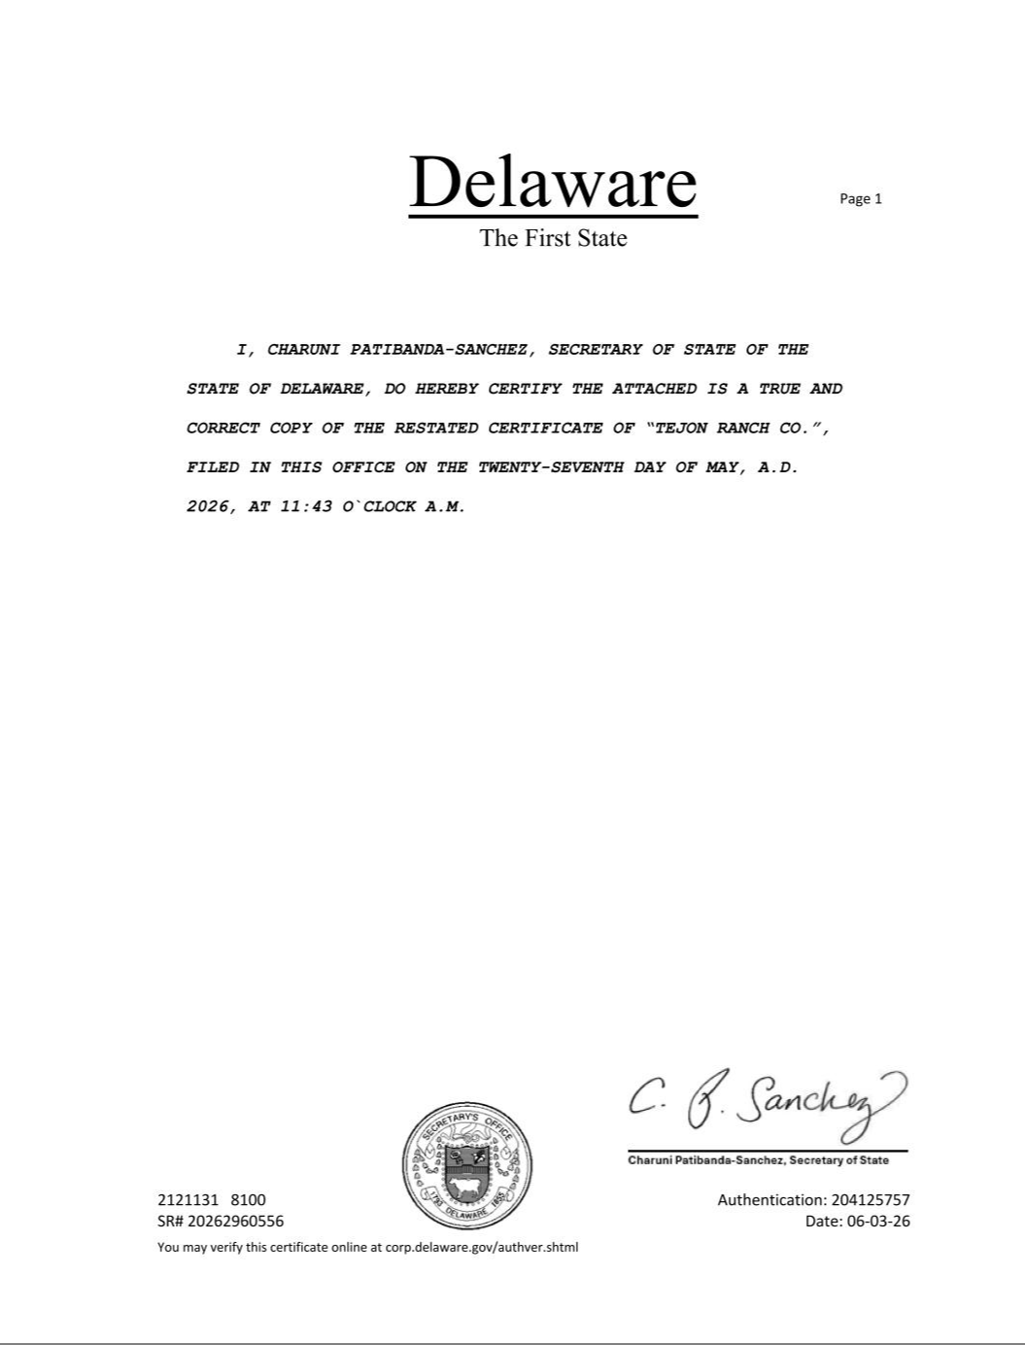

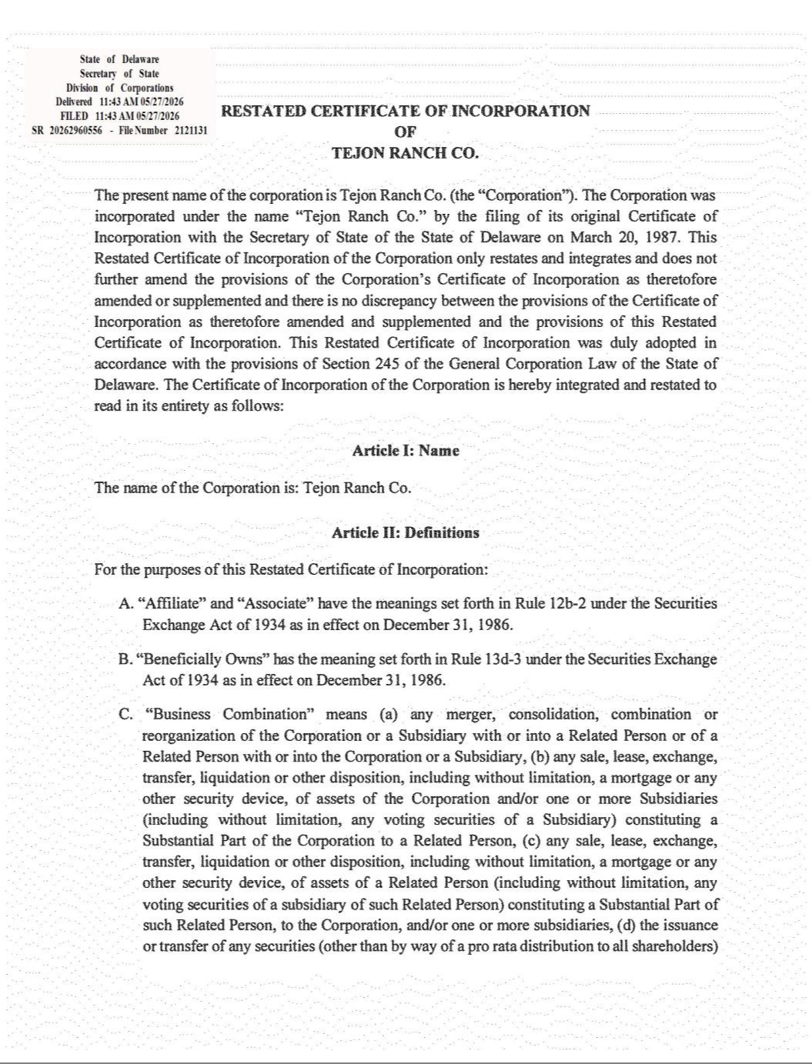

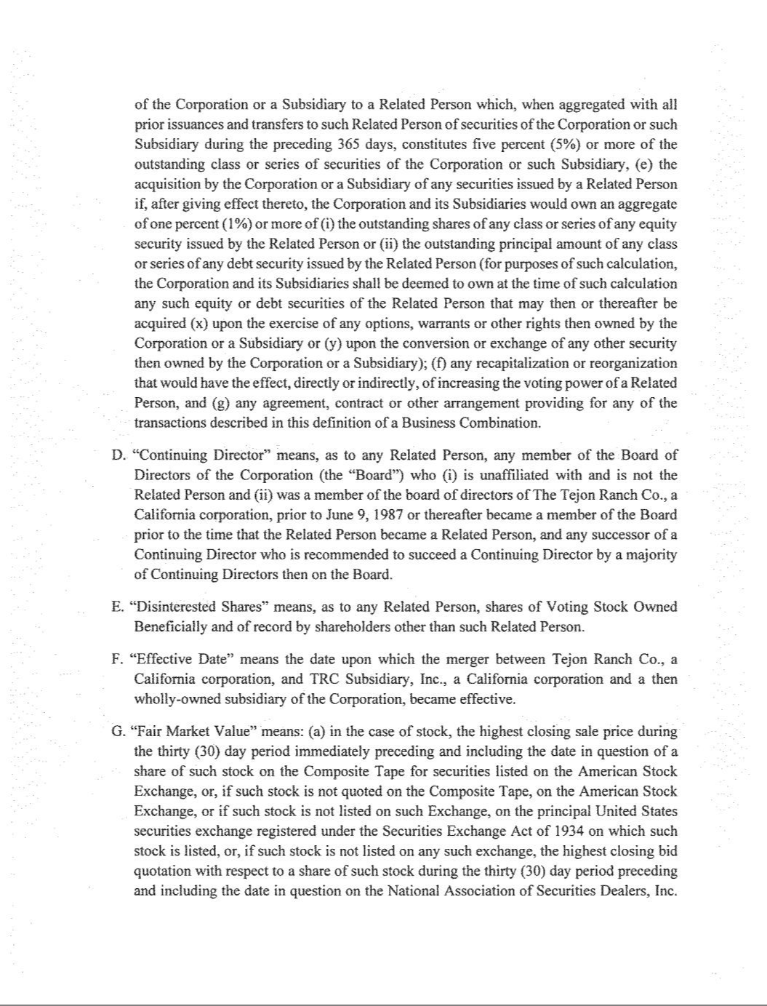

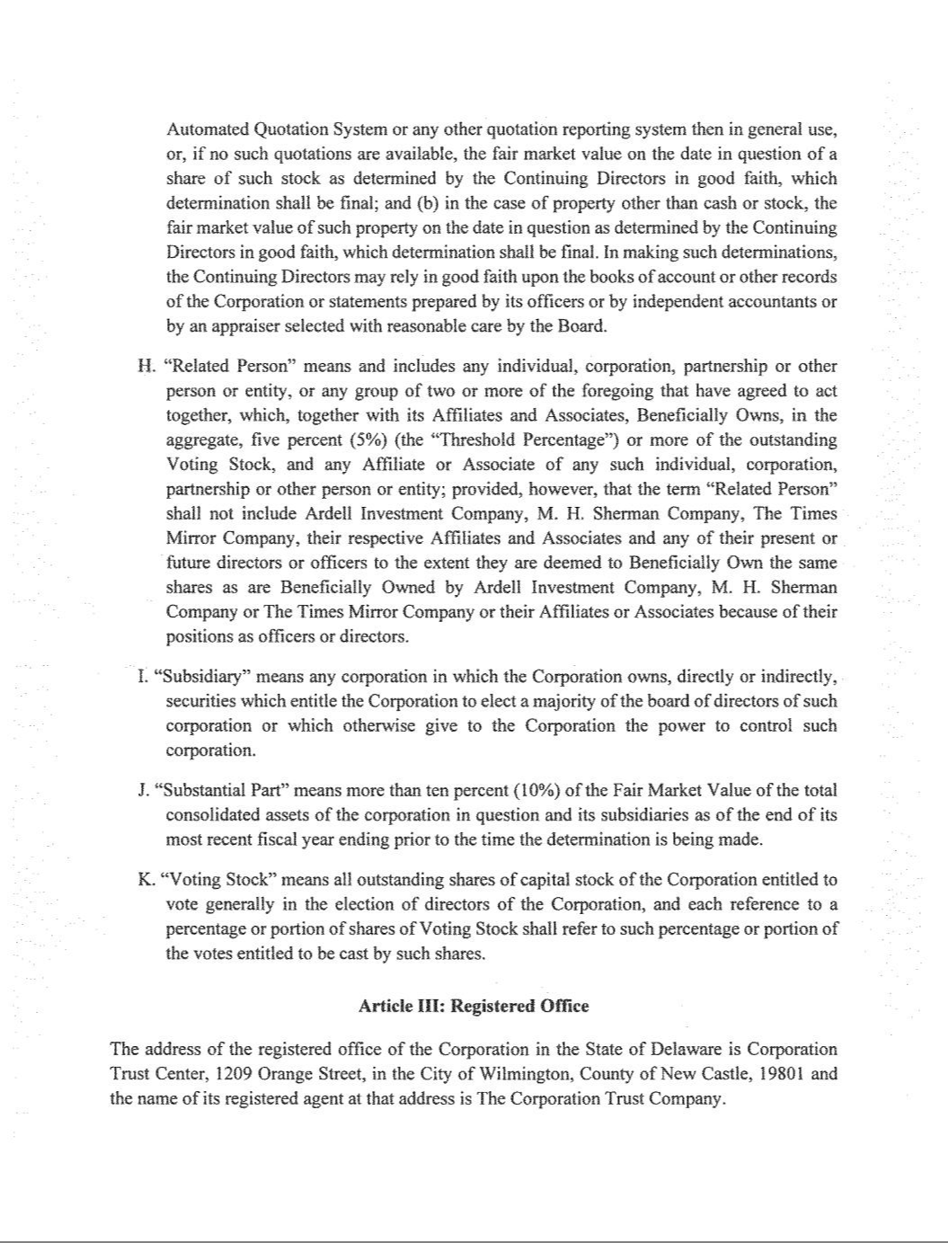

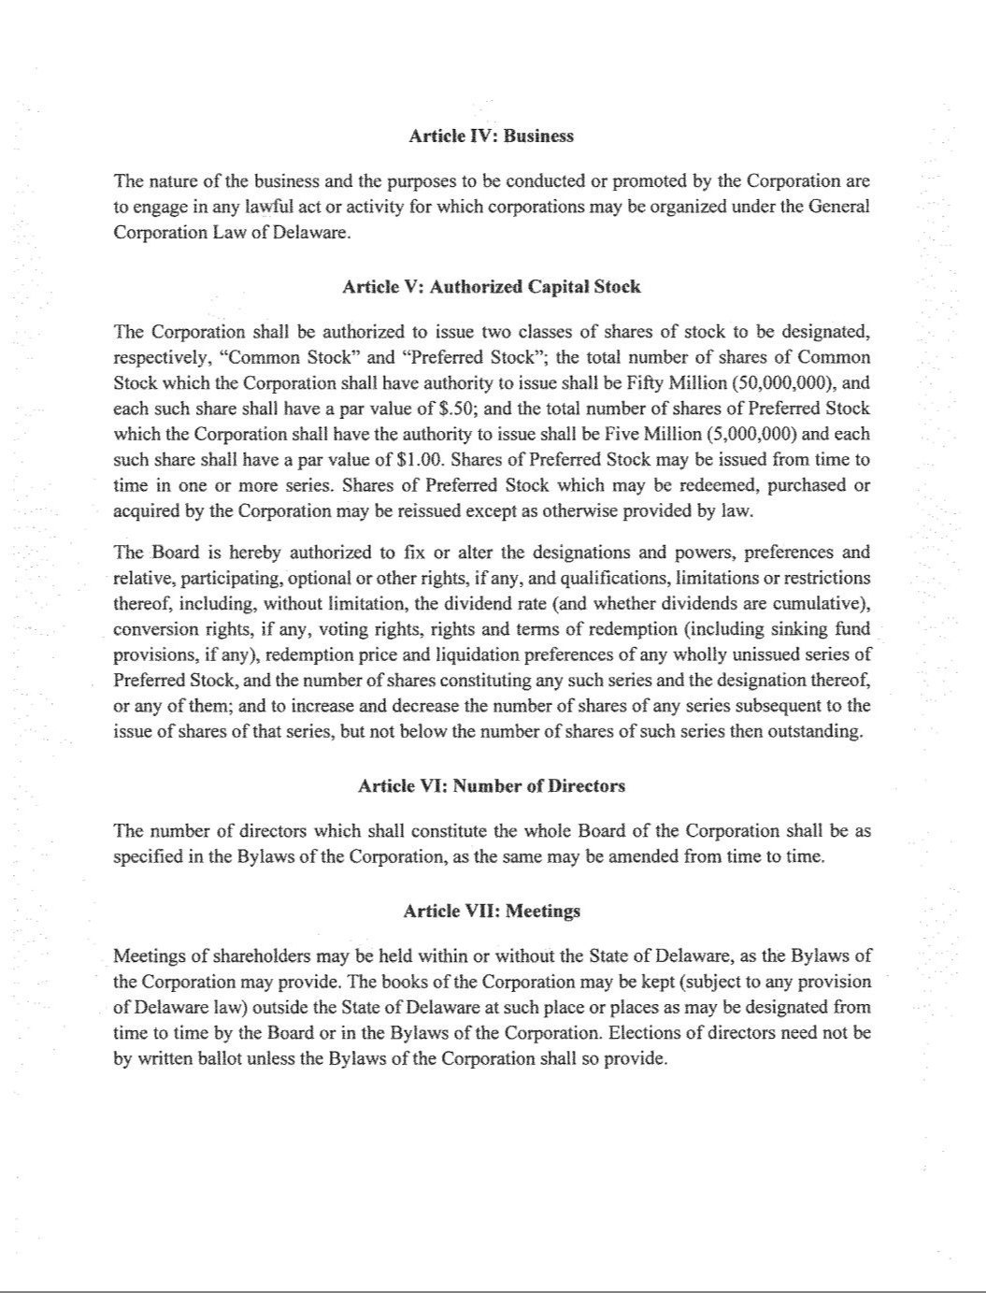

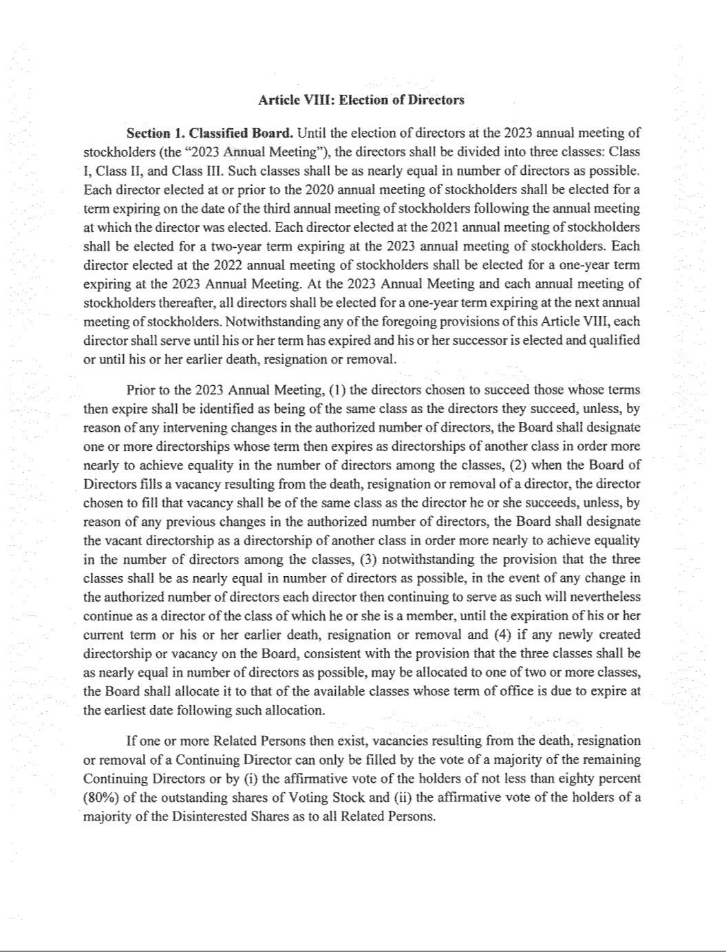

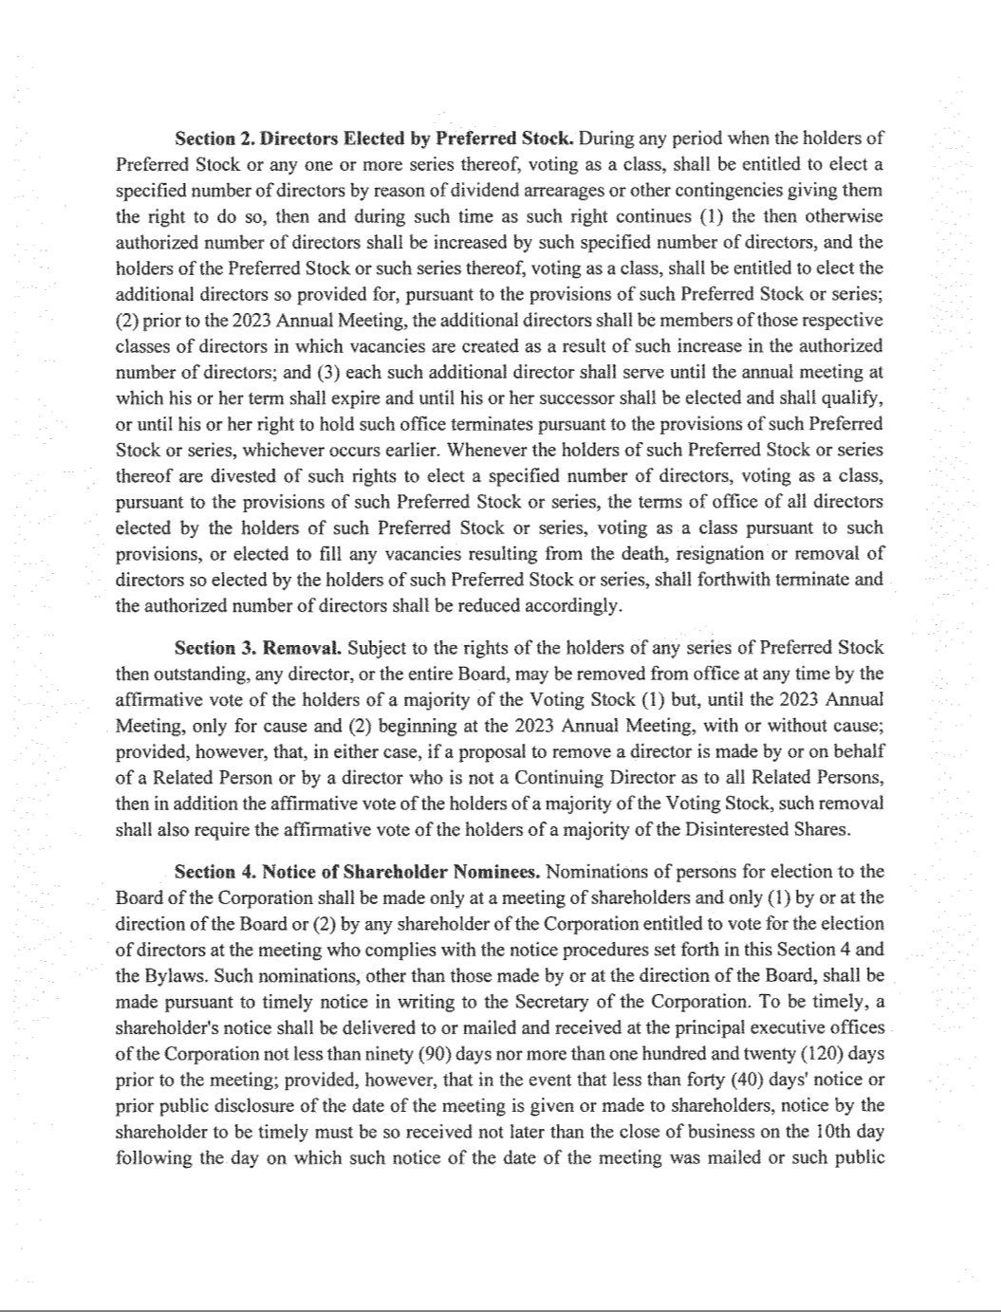

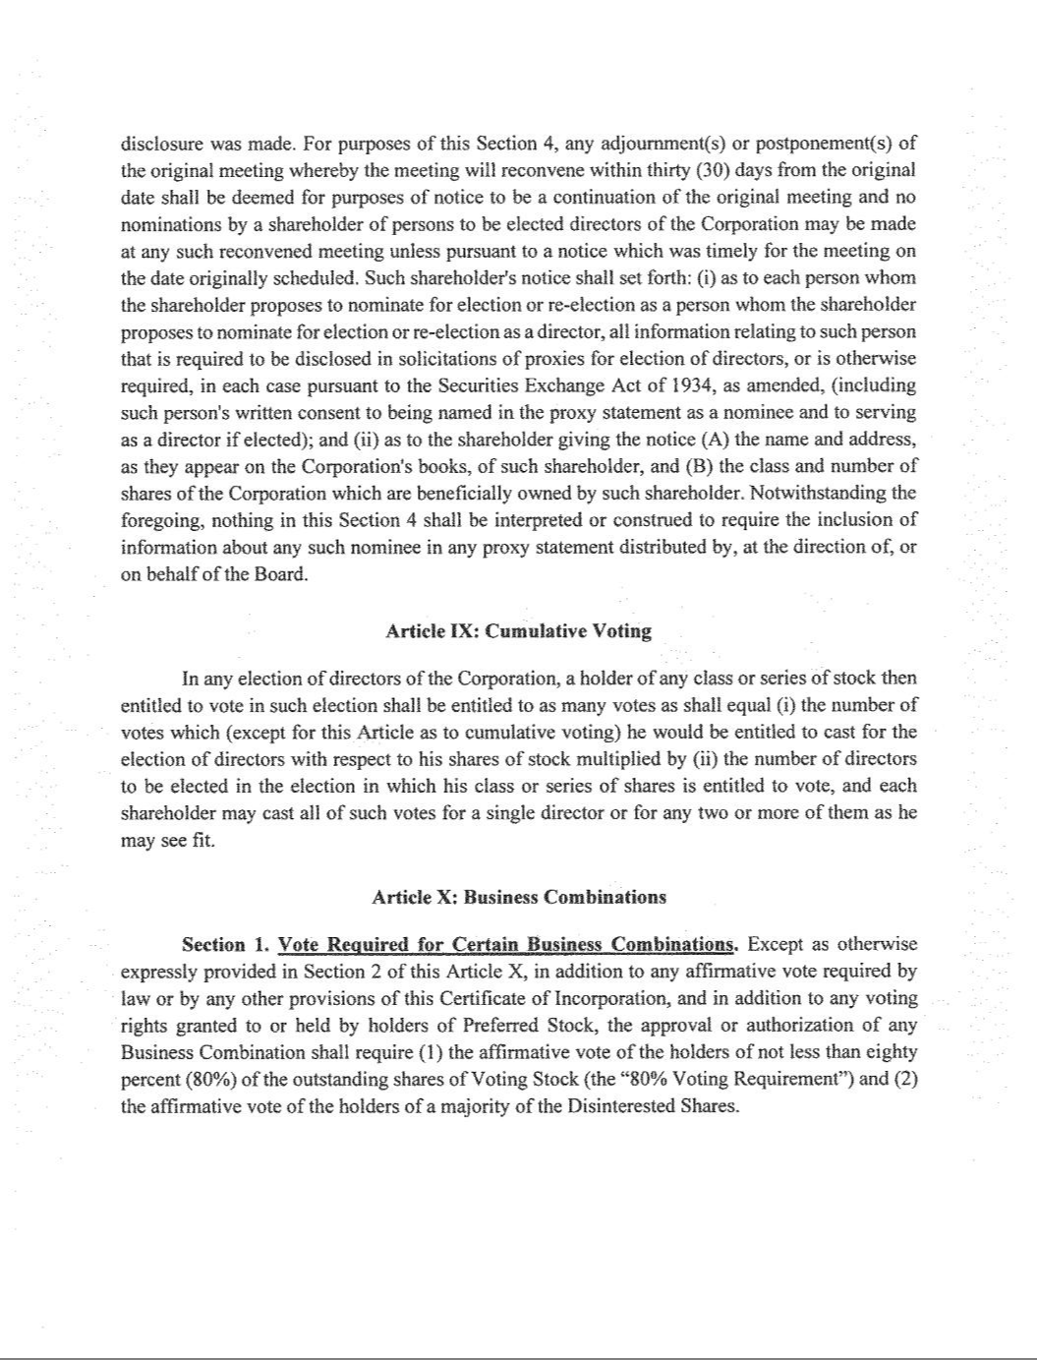

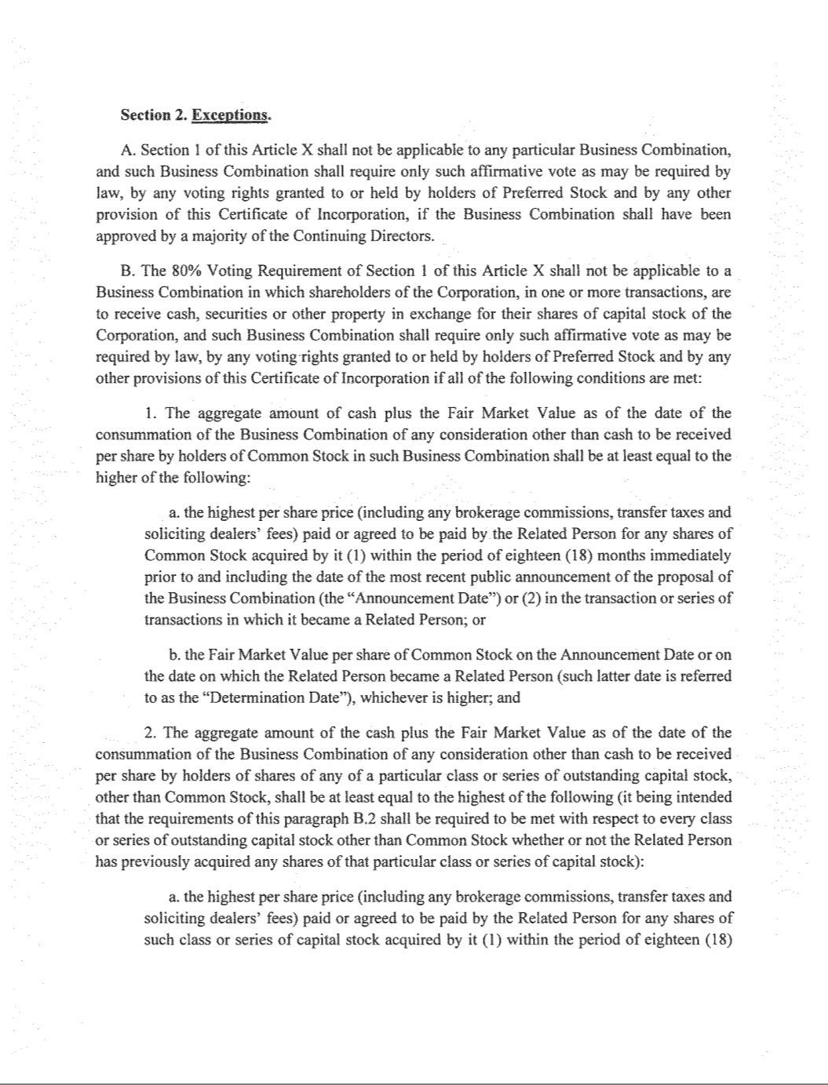

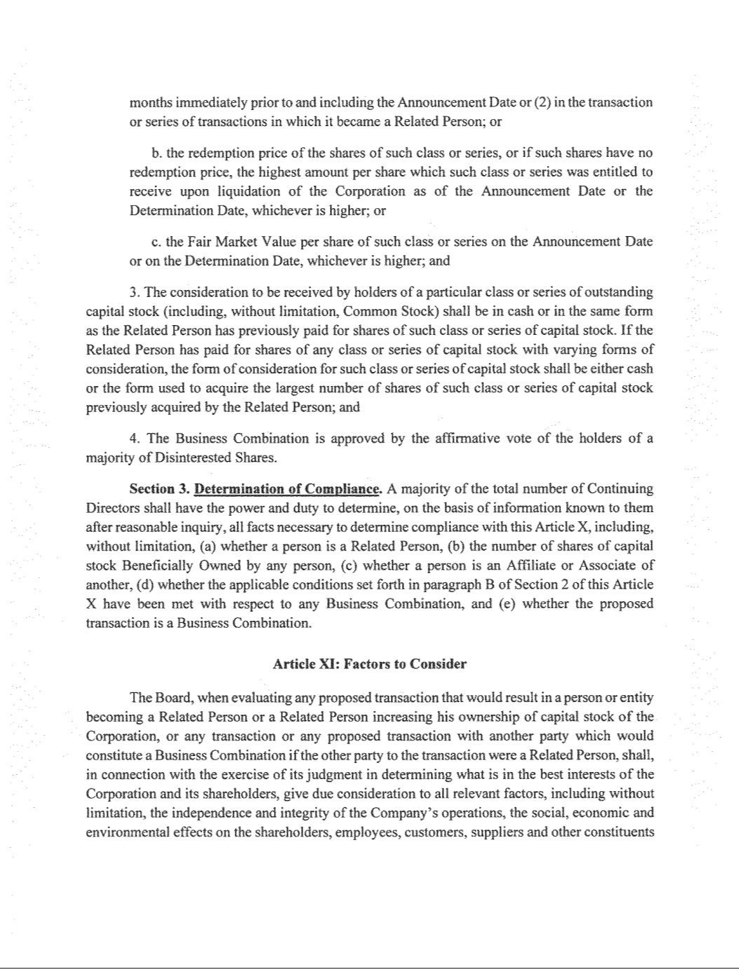

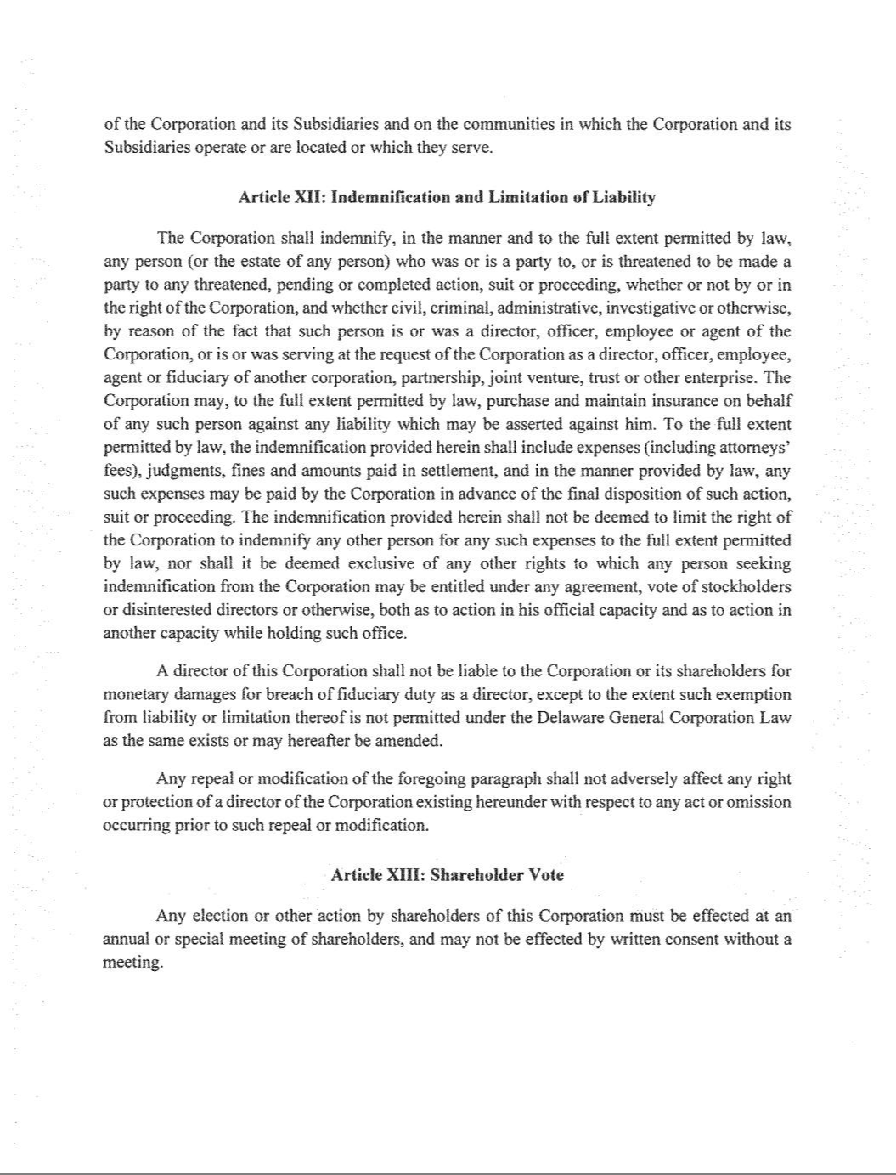

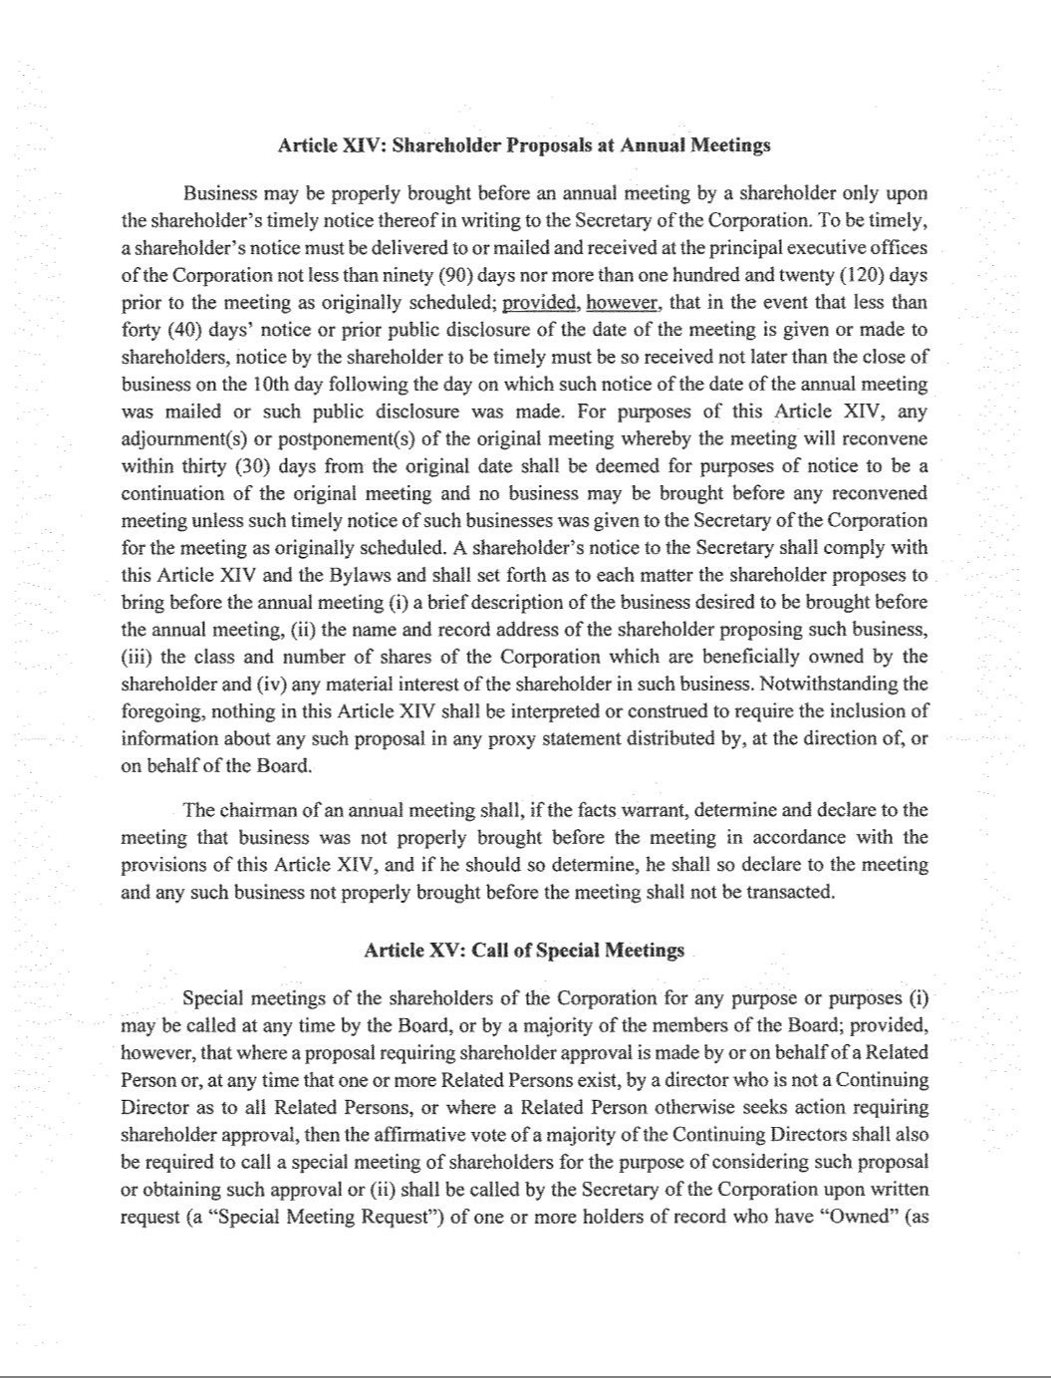

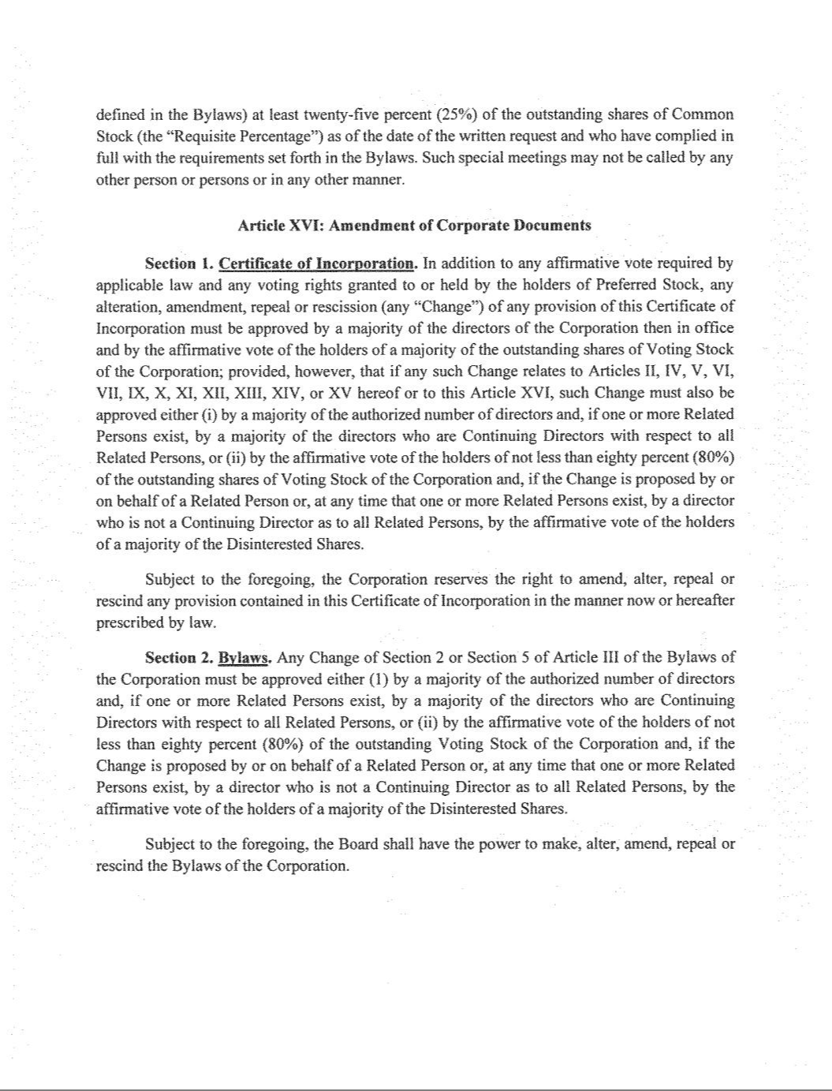

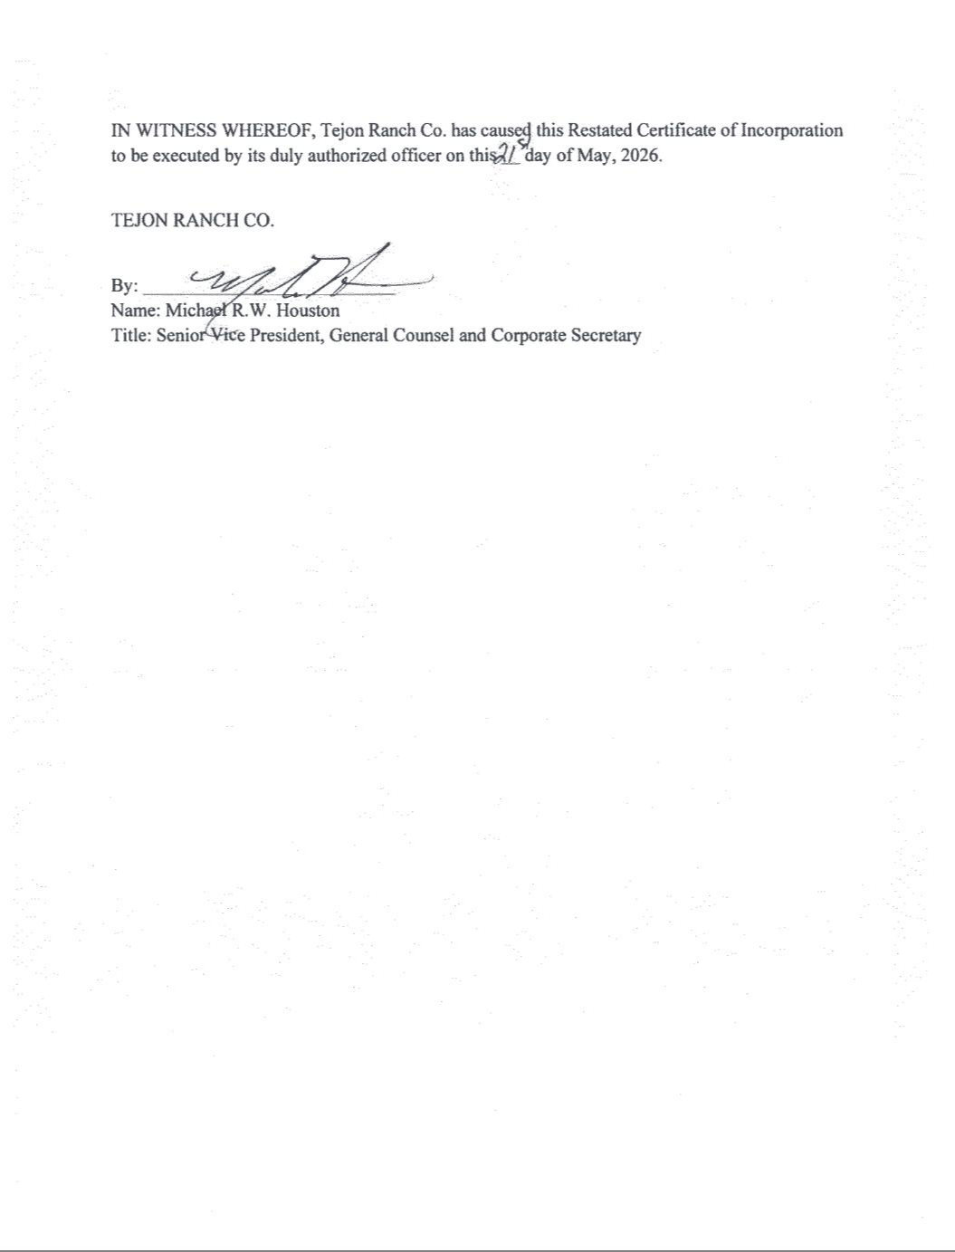

EXHIBIT 31.1

Certification of Chief Executive Officer Pursuant to

Securities Exchange Act Rules 13a-14(a) and 15d-14(a)

as Adopted Pursuant to

Section 302 of the Sarbanes-Oxley Act of 2002

I, Matthew H. Walker, certify that:

- I have reviewed this quarterly report on Form 10-Q of Tejon Ranch Co.;

- Based on my knowledge, this report does not contain any untrue statement of a material fact or omit to state a material fact necessary to make the statements made, in light of the circumstances under which such statements were made, not misleading with respect to the period covered by this report;

- Based on my knowledge, the financial statements, and other financial information included in this report, fairly present in all material respects the financial condition, results of operations and cash flows of the registrant as of, and for, the periods presented in this report;

- The registrant’s other certifying officer and I are responsible for establishing and maintaining disclosure controls and procedures (as defined in Exchange Act Rules 13a-15(e) and 15d-15(e)) and internal control over financial reporting (as defined in Exchange Act Rules 13a-15(f) and 15(d)-15(f)) for the registrant and have:

  - Designed such disclosure controls and procedures, or caused such disclosure controls and procedures to be designed under our supervision, to ensure that material information relating to the registrant, including its consolidated subsidiaries, is made known to us by others within those entities, particularly during the period in which this report is being prepared;

  - Designed such internal control over financial reporting, or caused such internal control over financial reporting to be designed under our supervision, to provide reasonable assurance regarding the reliability of financial reporting and the preparation of financial statements for external purposes in accordance with generally accepted accounting principles;

  - Evaluated the effectiveness of the registrant’s disclosure controls and procedures and presented in this report our conclusions about the effectiveness of the disclosure controls and procedures, as of the end of the period covered by this report based on such evaluation; and

  - Disclosed in this report any change in the registrant’s internal control over financial reporting that occurred during the registrant’s most recent fiscal quarter (the registrant’s fourth fiscal quarter in the case of an annual report) that has materially affected, or is reasonably likely to materially affect, the registrant’s internal control over financial reporting; and

- The registrant’s other certifying officer and I have disclosed, based on our most recent evaluation of internal control over financial reporting, to the registrant’s auditors and the audit committee of the registrant’s board of directors (or persons performing the equivalent functions):

  - All significant deficiencies and material weaknesses in the design or operation of internal control over financial reporting which are reasonably likely to adversely affect the registrant’s ability to record, process, summarize and report financial information; and

  - Any fraud, whether or not material, that involves management or other employees who have a significant role in the registrant’s internal control over financial reporting.

Dated: | November 5, 2026 | /s/ Matthew H. Walker
 |  | Matthew H. Walker
 |  | President and Chief Executive Officer

EXHIBIT 31.2

Certification of Chief Financial Officer Pursuant to

Securities Exchange Act Rules 13a-14(a) and 15d-14(a)

as Adopted Pursuant to

Section 302 of the Sarbanes-Oxley Act of 2002

I, Robert D. Velasquez, certify that:

- I have reviewed this quarterly report on Form 10-Q of Tejon Ranch Co.;

- Based on my knowledge, this report does not contain any untrue statement of a material fact or omit to state a material fact necessary to make the statements made, in light of the circumstances under which such statements were made, not misleading with respect to the period covered by this report;

- Based on my knowledge, the financial statements, and other financial information included in this report, fairly present in all material respects the financial condition, results of operations and cash flows of the registrant as of, and for, the periods presented in this report;

- The registrant’s other certifying officer(s) and I are responsible for establishing and maintaining disclosure controls and procedures (as defined in Exchange Act Rules 13a-15(e) and 15d-15(e)) and internal control over financial reporting (as defined in Exchange Act Rules 13a-15(f) and 15(d)-15(f)) for the registrant and have:

  - Designed such disclosure controls and procedures, or caused such disclosure controls and procedures to be designed under our supervision, to ensure that material information relating to the registrant, including its consolidated subsidiaries, is made known to us by others within those entities, particularly during the period in which this report is being prepared;

  - Designed such internal control over financial reporting, or caused such internal control over financial reporting to be designed under our supervision, to provide reasonable assurance regarding the reliability of financial reporting and the preparation of financial statements for external purposes in accordance with generally accepted accounting principles;

  - Evaluated the effectiveness of the registrant’s disclosure controls and procedures and presented in this report our conclusions about the effectiveness of the disclosure controls and procedures, as of the end of the period covered by this report based on such evaluation; and

  - Disclosed in this report any change in the registrant’s internal control over financial reporting that occurred during the registrant’s most recent fiscal quarter (the registrant’s fourth fiscal quarter in the case of an annual report) that has materially affected, or is reasonably likely to materially affect, the registrant’s internal control over financial reporting; and

- The registrant’s other certifying officer(s) and I have disclosed, based on our most recent evaluation of internal control over financial reporting, to the registrant’s auditors and the audit committee of the registrant’s board of directors (or persons performing the equivalent functions):

  - All significant deficiencies and material weaknesses in the design or operation of internal control over financial reporting which are reasonably likely to adversely affect the registrant’s ability to record, process, summarize and report financial information; and

  - Any fraud, whether or not material, that involves management or other employees who have a significant role in the registrant’s internal control over financial reporting.

Dated: | November 5, 2026 | /s/ Robert D. Velasquez
 |  | Robert D. Velasquez
 |  | Chief Financial Officer, Treasurer, Senior Vice President, Finance and Chief Accounting Officer

EXHIBIT 32

CERTIFICATION PURSUANT TO

18 U.S.C. SECTION 1350,

AS ADOPTED PURSUANT TO

SECTION 906 OF THE SARBANES-OXLEY ACT OF 2002

Each of the undersigned hereby certifies, in his capacity as an officer of Tejon Ranch Co. (the “Company”), for purposes of 18 U.S.C. Section 1350, as adopted pursuant to Section 906 of the

Sarbanes-Oxley Act of 2002, that to his own knowledge:

- The Quarterly Report of the Company on Form 10-Q for the period ended September 30, 2026, fully complies with the requirements of Section 13(a) of the Securities Exchange Act of 1934; and
- The information contained in such report fairly presents, in all material respects, the financial condition and results of operation of the Company.

A signed original of this written statement required by Section 906 has been provided to Tejon Ranch Co. and will be retained by Tejon Ranch Co., and furnished to the Securities and Exchange Commission or its staff upon request.

Dated: November 5, 2026

/s/ Matthew H. Walker

Matthew H. Walker

President and Chief Executive Officer

/s/ Robert D. Velasquez

Robert D. Velasquez

Chief Financial Officer, Treasurer, Senior Vice President, Finance and Chief Accounting Officer

